Fighters kill Afghan police chief
BBC News
12 August 2009
Taliban militants have killed a district police chief in an attack on a government base in the northern Afghan province of Kunduz, officials say.
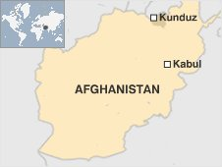
At least one other person was killed when the militants attacked the compound in Archi district.
Reports say the attackers struck before dawn with rocket propelled grenades and small arms fire.
There have been increasing levels of violence in the province of Kunduz over the past few months.
After militants launched their attack on the government compound, the police chief came out to provide assistance, district governor Shaikh Dabi told the AFP news agency.
"The Taliban ambushed him and killed him," he said.
Eyewitnesses spoke of a lengthy gun battle after the attack began.
Provincial targets
The incident comes as US and Afghan forces intensify their operations against Taliban militants in the south of the country ahead of nationwide elections next week.
On Monday, Taliban militants attacked official buildings in the city of Pul-i-Alam in eastern Afghanistan, killing five people and injuring many others.
It was the latest in a series of similar co-ordinated attacks on provincial cities in recent months.
The Taliban have vowed to disrupt the elections and have stepped up attacks in recent weeks.
But the BBC's Martin Patience in Kabul says it is likely that violence across the country would have escalated despite next week's elections.
Such attacks on provincial government compounds are designed to weaken the authority of the Afghan government, our correspondent says.
The Taliban target provincial headquarters because they are not guarded as closely as institutions in Kabul.

