Afghanistan struck by twin blasts
BBC News
13 August 2009
Two bombs in Afghanistan have killed at least 14 civilians, including several children, just days ahead of nationwide elections, officials say.
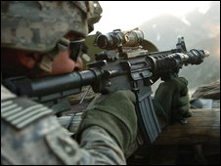
US and Nato forces are battling a rising Taliban insurgency
The blasts occurred on Wednesday in the southern provinces of Helmand and Kandahar - both regions are at the heart of the Taliban insurgency.
Nato and US troops have been battling insurgents in the south ahead of next week's presidential elections.
President Hamid Karzai has pledged to work with his rivals if he wins.
He said on Thursday that he will offer government positions to two of his top challengers, Abdullah Abdullah and Ashraf Ghani if he is re-elected.
Correspondents say that the president's move appears designed to offset any post-election tension as large parts of Afghanistan remain embroiled in the insurgency.
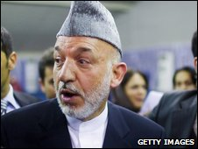
The president says he will work with his rivals if he wins
More than 100,000 international troops and 175,000 Afghan forces are deployed to provide security.
President Karzai is the leading candidate in a crowded field of 38 presidential candidates including former Foreign Minister Abdullah and former Finance Minister Ghani.
"I will invite Dr Abdullah, I will invite Ashraf Ghani, give them food and tea and give them jobs, as I did last time when I won," President Karzai said.
A spokesman for Mr Abdullah's campaign said the people, not the president, will decide who wins and forms the government.
Mr Ghani's team gave an equally lukewarm response to the proposal.
Child casualties
In the latest bomb blasts, a roadside bomb struck a minivan in Helmand, provincial government spokesman Daud Ahmadi told the AFP news agency.
"As a result, 11 civilians on board - all members of one family - were killed. Only one little girl around six years old survived," he said.
The interior ministry confirmed the blast but gave a lower death toll.
Another roadside bomb killed three children as they were playing in Kandahar on Wednesday, police said.
"All the three children are boys between six and 11 years of age," provincial police chief Mohammad Shah Khan told AFP.
On Wednesday Taliban militants killed a district police chief in an attack on a government base in the northern Afghan province of Kunduz.
The Taliban have vowed to disrupt the elections and have stepped up attacks in recent weeks.
But the BBC's Martin Patience in Kabul says it is likely that violence across the country would have escalated despite next week's elections.

