Sarkisian Visits Southland

26 September 2011

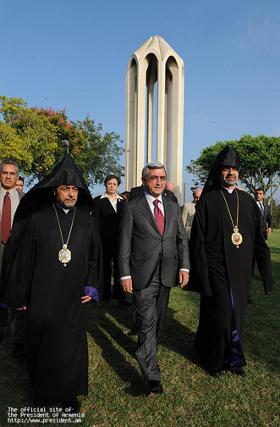
Sarkisian with Arch Derderian (left) and Arch. Mardirossian (right) at the Montebello Martyrs Monument
LOS ANGELES—President Serzh Sarkisian arrived in Los Angeles Saturday for a three-day visit, after addressing the United Nations General Assembly Thursday and a celebration of the re-establishment of Armenia’s independence in New York.
The first stop on Sarkisian’s LA stop was the Montebello Armenian Genocide Martyrs Monument, where he laid a wreath and planted a tree in memory of the Genocide victims. The president was accompanied by Western Primate Archbishop Hovan Derderian and Western Prelate Archbishop Moushegh Mardirossian.
Armenia’s Foreign Minister Eduard Nalbandian and Diaspora Minister Hranoush Hakopyan are also traveling with Sarkisian.
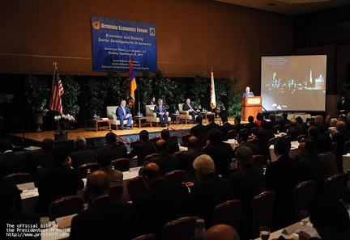
Sarkisian at the economic forum
On Sunday, Sarkisian attended the opening of an economic forum organized by the Central Bank of Armenia and Bank Association of Armenia. This event brought together representatives from the business community of Armenia and US state of California.
In his address to forum participants, the President underscored the need to make full use of Armenian Diaspora’s potential, for the benefit of Armenia’s economic growth and strengthening of the Republic of Armenia.
Sarkisian said that in the past 20 years, the full potential of the Armenia’s citizens was not used to the fullest to bolster economic growth.
“We are the masters of our shortcomings and achievements alike,” said Sarkisian, who added that it the people’s potential were used to the fullest, “we could have had more achievements.”
Sarkisian also thanked the Diaspora business community for their efforts in the last 20 years to strengthen Armenia’s economy.
“I am hopeful that, with combined efforts and in the foreseeable future, we will have a country which we will all be proud of,” said Sarkisian.
After the business forum, Sarkisian and his delegation attended Mass at the St. Leon Cathedral and Diocesan headquarters in Burbank. At a reception after the religious services, Sarkisian met with representatives of the Executive Council of the Diocese and benefactors.
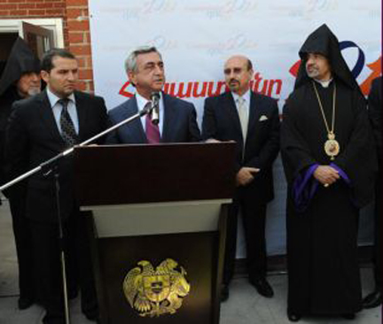
Sarkisian speaks at the Consulate opening
Later on Sunday afternoon, Sarkisian attended the opening ceremonies of the Armenia’s new Consulate General in Los Angeles on Central Avenue in Glendale.
Armenia’s Consul General to Los Angeles, Grigor Hovhannisyan was joined by Foreign Minister Nalbandian in cutting the ribbon and inviting the guests in the new consulate facility.
“The homeland is eternal, and this very building is the link connecting you to the homeland. Taking advantage of this opportunity, I would like to express thanks to the United States, which during the most difficult times for our people, allowed our compatriots the opportunity to enter the United States, to live in dignity, to develop, to integrate within society of this powerful country, and to make their historical homeland known. We are proud of you, and we will do everything so you could be proud of us,” said Sarkisian.
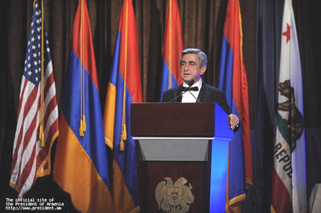
Sarkisian addresses the Independence Day banquet
On Sunday evening, Sarkisian presided over a gala banquet celebration the 20th anniversary of Armenia’s independence, prior to which he met with renowned tenor Placido Domingo.
Below is the translated text of Sarkisian’s address at the banquet, provided by the presidential press service.
Dear Compatriots,
Ladies and Gentlemen:
I am very glad to have this meeting. I am proud with you, I am proud that today we are together and would like to congratulate you all on the 20th anniversary of our common Motherland, homeland of all Armenians – the Republic of Armenia.
This great anniversary is being celebrated in different corners of the world, in every place where there is just one Armenian. These have been truly memorable and beautiful days for us all.
On September 21, the Armenian television was overwhelmed with exciting and very impressive reports from the regions of Armenia and from all over the world. One cannot help the excitement watching, for example, reports on the celebrations held by you, the LA community. One cannot help the feelings of pride and gratification watching the young men toasting to the independent homeland tell the whole world that if there is an encroachment upon the Armenian land, they will reach the defense positions in a matter of hours from a place so far away as America. One can only watch and repeat in his mind, “God bless you, guys.”
These thoughts and emotions are understandable to every Armenian wherever he is. I always experience joy when during my visits abroad I see our young people and children proudly holding up our tricolor. It means that no force on the face of the earth can ever alienate these young people from their Armenian hearth. It means that born and raised in a different country with a different language and culture, they have managed to preserve the Armenian spirit, which will most certainly bring them to Armenia.
The dream of the Armenian people became reality in 1991. For two decades now, we have been building our corner of the great world, our state – the Republic of Armenia. We have been building it by overcoming difficult and tough challenges. We have been building it in face of disaster, war, blockade, and crisis. We, young and old, have been building it through the efforts of all Armenians.
In this short period of time, we tried to lay the foundations of statehood, to consolidate democracy, to develop civil society and liberal economy, and to integrate into the international community. We tried to adopt all that is modern and good, whilst preserving our Armenian traditions. We managed not only to learn from the world, but also to share with the world the flight of our thought and the warmth of our soul.
One certainly cannot say that we have reached perfection in 20 years. However, any assessment should be comparative. Twenty years, which is a blink of an eye in history, has been a long, difficult, and exciting period of time for us; these have been years of losses, years of a quest, years of successes, and years of achievements. Today, we have a solid system of government, the army which makes us all proud, civil society that is gaining momentum, and all the institutions of a modern state. However, we cannot stop here; we continue to strengthen our state every day, every step of the way.
Dear Friends,
During the recent meeting in Yerevan with the leaders and representatives of the Diaspora organizations, I proposed the following formula: “The utmost of the Fatherland’s capabilities for the Diaspora, and the utmost of the Diaspora capabilities for the Fatherland.”
Institute of dual citizenship has already become a reality: some of you here also hold the passport of the Republic of Armenia. We have eliminated the psychological barrier that kept many Diaspora Armenians from wholeheartedly living and doing business in Armenia.
Let us take a look around: there are many Diaspora Armenians who either have returned to Armenia or have actively and directly participate in the life of our Fatherland. Clearly, it is not easy. It is not easy to leave a familiar environment and to move to an unfamiliar, seemingly imaginary Fatherland. However, we already have numerous inspiring examples. Many of our fellow Armenians have experienced the enthusiasm of living and working in our Fatherland. Unfortunately, some of them have experienced the bitterness of disappointment, too. We have to learn lessons from our inspiring experiences. However, we must first of all openly and freely discuss the reasons of bitterness. We have to discuss together because pointing out the shortcomings is only half of what it takes. It is also necessary to jointly seek ways to eliminate them and to share the glory and responsibility of success.
Actually, Armenia is not an imaginary romantic Fatherland. Armenia is an earthly place with its joys and difficulties. We have made enormous progress, but we have shortcomings that we all know very well. Who can better than our fellow Armenians help us in overcoming them?
I invite us all to engage in the open and candid dialogue. We address our kin in Diaspora as our relatives, and as relatives we have to discuss all the shortcomings.
We must discuss our issues without avoiding the share of responsibility that each of us has.
Indeed, we still face many problems. We have not yet reached lasting peace and have to spend great sums to provide for the security of our country and our people. The Turkish-Azerbaijani duo is waging a campaign against our country across the world, in all international fora, and we have to respond. Our small economy remains vulnerable to external shocks, and we are exerting great efforts to protect our businesses and to satisfy at least the basic needs of our elderly. Corruption, of course, remains one of the greatest challenges, and we are continuing to fight this phenomenon which was inherited from the Soviet era and has gained new shades in recent decades in virtually all walks of life, from education to civil works, from social security to agriculture.
All of these problems belong to us, and we are responsible for finding solutions. I do not even marginally doubt our ability to find the necessary solutions. We have the will and potential to do it. We have important historical memory, and there are lessons that we ought to learn from our own past. The creation of the Republic of Armenia was the best proof of our ability to make true our own centuries-long dream in the beginning of the last century. May 28 also proved our ability to set difficult and hard-to-reach goals and to accomplish them jointly. The roots of this strength reach the depth of centuries, and the flower of this strength blossoms and bears fruit every time we display faith in our own power, collective effort, internal accord, mutual respect, generosity, forgiveness, and confidence.
Our times are symbolized by freedom; freedom which is achieved through competing and cooperating. There is a competition between individuals and competition between businesses. There is a competition between economies and competition between states. The more competitive we are, the greater freedom we will enjoy.
As a people striving for freedom and as a nation that has achieved 20 years of free and independent statehood, we continue and will continue to compete. We compete with all in everything. The ability to succeed in this eternal competition hinges on the strength of one’s back, the feeling of a friend and sibling fighting side-by-side with you for the victory. I believe that we are covering each other’s backs in this fierce competition. We are side-by-side for creation and construction. We are side by side for defending our freedom; side by side for being even more free.
Dear Friends,
I am confident that efforts to resolve problems faced by our common Homeland will reinvigorate both Mother Armenia and the Diaspora. It will help preserve the Armenian identity in all Diaspora communities, no matter where they are. It will bring us closer to a just resolution of the Artsakh issue. It will reinforce the foundations of our independent statehood. It will fortify the roots of our eternity tree, and nurture the crown of our freedom and independence tree.
I say this with the utter conviction, because the Republic of Armenia is the only real guarantor of the sustainability of the Armenian nation. No other force will assume this responsibility for us.
Pan-Armenian gatherings of professionals are frequently organized through the Ministry of Diaspora Affairs. This enables our architects, lawyers, financial experts, and various other professional Armenians from across the globe to contribute their knowledge and experience to the resolution of the all-Armenian issues. It is a very effective and practical format that must be sustained and improved.
Armenia’s most precious asset is her worthy children, blessed with free will. Today, children of Mother Armenia are scattered throughout the world.
Representatives of the Diaspora can be among the first to support the modernization and development of our country. And I have no doubt that through our joint efforts we will lead Armenia down the best path towards new achievements and new milestones of freedom.
Armenia exists. Armenia is not a dream. It is a small but proud country in faraway mountains, which is gradually rising to her feet. It is a country that is now competing on the arena of the world’s large and powerful players. A country that encounters harsh problems, builds new vital institutions, achieves successes, and pursues new and greater goals. We all share these goals.
Armenia is the country that we all, our parents and grandparents have dreamed of. Armenia is the home for our children and grandchildren, the foundations of which we are continuously strengthening. Armenia sincerely loves all her children and never discriminates between them.
Our dream come true is 20 years old. Today, free and independent Armenia is 20 years old, and today there can be no greater pride and joy for the Armenians.
Long live Armenia! And I once again congratulate you all on this holiday.
Thank you.
© 2011 Asbarez Armenian News.

