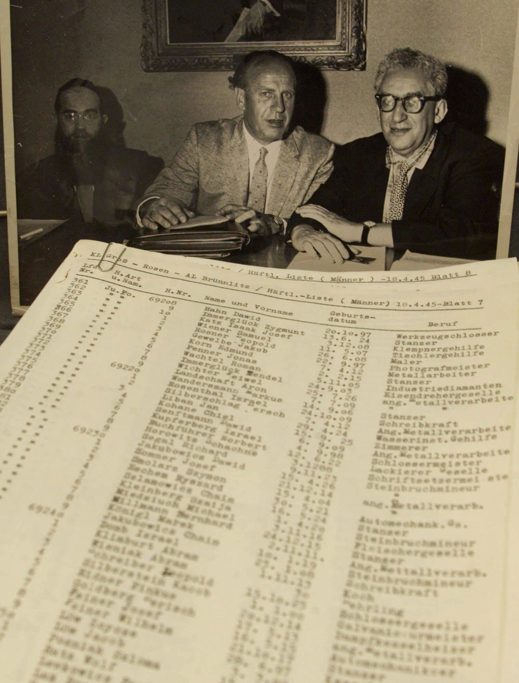
The power of lists during genocide
By Kate Shellnutt, Houston Chronicle
23 March 2010
Today, the only privately owned copy of Oskar Schindler's famous list went on sale for $2.2 million. It's being sold on a memorabilia site on behalf of an anonymous seller.
The 13-page document, written in 1945, is one of several (the others are in museums) that the German factory-owner composed during World War II, when he diverted an estimated 1,200 Jews from death in concentration camps. Schindler bribed Nazis, convincing them that the Jewish laborers on his list were too skilled and too essential to the war effort to be killed.
Thanks to Steven Spielberg's 1993 film, Schindler's List has become an iconic Holocaust tale. Some call it the most important document of WWII.
Lists can have a lot of power during authoritarian rule and government-run genocide. Schindler's list is significant because it's a rare example of a list being used for noble ends, rather than to divide and to kill.
Scholars have identified list-making as one of the initial steps in genocide planning. People in power use lists to categorize people, track them and ultimately identify who should be killed, according to Gregory Stanton, the founder and president of the advocacy organization Genocide Watch.
Today, it's what activists look out for in hopes of preventing genocide. Listing targets was a major part of the mass killings in Rwanda in 1994. The U.S. State Department reported that the Iranian government has been compiling lists of Baha'is living in the country and their professions. Iranian Baha'is have experienced decades of persecution so this move is somewhat of a red flag.
Monitoring problematic regions early-on has been seen as the best way to keep political and ethnic conflicts from escalating. I think it's the hope of many that films like Schindler's List, studies of the Holocaust and discussion of these issues will help us to better understand the nature of genocide so that we may keep it from taking place in our world once again.
Copyright 2010 Houston Chronicle.

