Australia Muslim school rejected

Tuesday, 27 May 2008
Authorities in an Australian town have rejected proposals to allow an Islamic school to be built there.
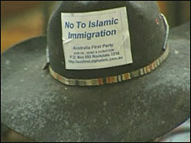
The New South Wales town does not have a large Muslim population
Councillors for Camden, a small town on the outskirts of Sydney, unanimously voted against the proposed school for 1200 pupils.
The councillors said they based their decision solely on planning grounds, citing an internal report about its environmental impact.
The proposed development had met with fierce local opposition.
Camden's authorities received some 3,200 submissions from the public about the school and only 100 in favour.
Tensions reached their height last November when two pigs' heads were left on the site of the proposed school. Pork products are forbidden for consumption according to Islamic dietary laws.
Camden's mayor, Chris Patterson, stressed that the decision to reject the proposals was not made on religious or nationalistic grounds.
"It is a site issue, clearly a site issue," Mr Patterson said after the vote.
Residents' views
Council meetings, which addressed the proposed development, regularly drew large and outspoken crowds.
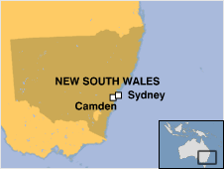
Town moves against school
A variety of local residents' views were aired at one such public meeting late last year and attended by over 1,000 people.
Some speakers focused solely on the environmental impact of locating an urban-scale school in such a bucolic setting.
One speaker implored the crowd to stick to planning issues, and not let the campaign be contaminated by racism or xenophobia.
The loudest cheers of the night greeted a speech from a local man in his late 70s, according to the BBC's Nick Bryant.
"Can I just say this without being racist or political?" the man said. "In 1983, in the streets of London, a parade by Muslims chanted incessantly 'If we can take London, we can take the world'. Don't let them take Camden."
The BBC's Nick Bryant in Sydney says Camden does not have a large Muslim population - about 150 families - so most of the pupils for the proposed school would have had to be brought in by bus from Sydney, an hour's drive away.
Andrew Wynnet of the Camden/Macarthur Residents' Group told the BBC about local concerns for the long-term demographic impact of such a development.
"The character of the town will change," he said.
Low profile
The Quranic Society, the organisation behind the proposal, has kept a low public profile throughout the process.
Its position has been that Australian parents have the right to educate Australian children wherever they wish, regardless of race or religion.
The organisation was not represented at the meeting, but it can appeal against this decision in the courts.
Camden Mayor Chris Patterson said that the society would be welcome to re-submit the application on a different site in Camden.
An internal council report had earlier recommended against construction, mainly citing traffic concerns.

© 2008 MMVIII

