June 10, 2009

Australians at Odds Over Rules for Refugees
By MERAIAH FOLEY
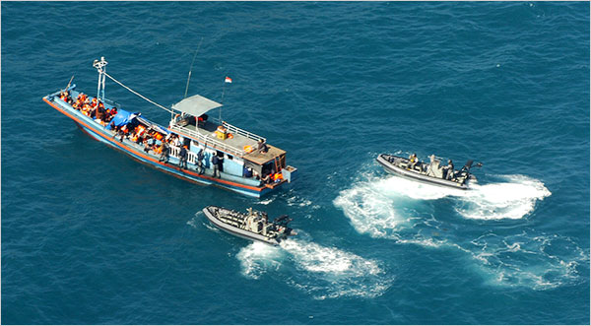
Department of Home Affairs, via Associated Press
Two launches from an Australian naval vessel intercepted a boat carrying asylum seekers in April off of Australia's shores.
SYDNEY — The Australian government, under criticism from the United Nations and others because of its harsh immigration laws, has been quietly rolling back a number of measures that kept refugees locked in prison-like detention centers, sometimes for years.
But the number of asylum seekers crossing the treacherous straits from Indonesia to Australia has surged in recent months, setting off an emotional debate about whether the relaxation of Australia’s asylum program has emboldened a new wave of illegal immigrants.
Thirteen boats carrying about 580 people have been intercepted in Australian waters since January, compared with seven boats carrying 161 people last year. Although the numbers are minute compared with the tens of thousands of refugees who converge on Europe every year, each new boatload prompts a flurry of political finger-pointing here, where immigration has long been a contentious issue.
“The number of people who come to Australia is a tiny fraction of those on the move,” said Richard Towle, the representative for Oceania at the U.N. High Commissioner for Refugees. “But this question of arrivals by boat has had a rather unfortunate history in domestic politics in Australia, which doesn’t have any relationship to the nature or size of the problem internationally.”
Australia receives about one percent of the world’s asylum seekers and is average among other industrialized nations for the number of refugees it accepts per capita. But for most of this decade, Australia has run one of the toughest asylum programs in the developed world.
Until last year, refugees who arrived without visas, including children, were held in isolated camps while they waited months or years for their cases to be heard. Successful applicants were placed on a special class of “temporary protection” visa that required them to restate their case for asylum after three years. As they waited, uncertain about whether they would be allowed to stay, these temporary refugees were not allowed to leave Australia or be reunited with their families overseas and had limited rights to employment or welfare benefits.
Harsh conditions inside the camps incited riots and hunger strikes, drawing condemnation from religious groups and human rights advocates. But opinion polls showed that most voters supported the policies, at least for a while. John Howard, the conservative prime minister of the time, made the issue a key platform of his 2001 election, claiming that Australia would be overrun by illegal immigrants without a strong deterrent.
With a landmass larger than India and Indonesia combined and a population of just 21 million, Australia has long felt vulnerable about its position as a mostly European nation on the edge of Asia, said James Jupp, the director of the Center for Immigration and Multicultural Studies at the Australian National University. “There’s a sense that we are in the wrong place,” he said, “that there are millions and millions of Asians who could swamp us completely.”
Mr. Howard’s tough immigration stance tapped into that anxiety — heightened by the 2001 and 2002 attacks on the United States and Britain — but caused Australia’s reputation “a lot of damage overseas,” Mr. Jupp said.
As the flood of refugees seeking protection in Australia and around the world receded, reaching a 20-year low in 2006, support for the policies began to wane. After defeating Mr. Howard two years ago, the center-left Prime Minister Kevin Rudd shut all but one of the detention centers, gave permanent status to those on temporary visas, and expanded the rights of asylum seekers to appeal.
The changes went largely unopposed until this year, when several boats packed with asylum seekers were intercepted in Australian waters, pushing the issue back to the fore. Seven vessels were intercepted in April, including a boat that exploded under mysterious circumstances, killing five people and injuring 44. The incident caused an uproar when a conservative politician alleged that the passengers had deliberately set the boat on fire to force the navy to take them ashore, a claim the government has declined to refute or verify.
Officials attribute the surge in asylum seekers on the global economic crisis and the turmoil in Afghanistan, Pakistan and Sri Lanka, which have produced most of the boat arrivals this year. But conservatives say the government’s immigration changes have made Australia more attractive to asylum seekers and the traffickers who bring them.
Despite the conservatives’ efforts to gain traction on the issue, a recent poll published by The Australian newspaper in April found that the public was almost evenly split on whether Mr. Rudd was doing a good job on the asylum-seeker issue, while 57 percent said they did not believe that a return to the tougher regime would stop asylum seekers from coming.
Copyright 2009 New York Times

