Wrong Formula: Bahrain races ahead with Formula One, but reverses on reform
By The Economist
21 April 2012
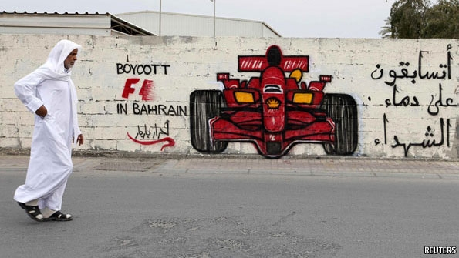
THE Bahrain Grand Prix is back. Across the tiny island kingdom, posters trumpet joy at the return of the Formula One race: “UniF1ed: One Nation in Celebration”. But although cars, crews and cameras have indeed arrived for the event from April 20th to 22nd, the slogan rings hollow. A year on from an uprising against Bahrain’s ruling family that prompted a brutally efficient military crackdown, more than 50 deaths and the cancellation of last year’s race, the atmosphere in Bahrain remains poisonous.
Activists have gleefully torched posters for the race, and vow to disrupt it however they can. Government troops, tanks and armoured cars are enforcing a forbidding cordon around the desert circuit. Night after night, riot vans sweep into villages on the outskirts of the capital, Manama. Activist ringleaders are dragged from their homes, beaten in front of their families and carted off.
The Formula One teams and drivers have slunk into Manama with little fanfare. Bahrain has paid the sport’s governing body $40m for the right to host the race. “Don’t make the mistake of thinking this is about anything but money,” says a Formula One insider.
Hoping to draw a line under last year’s crisis, the Bahraini royal family has staked its reputation on the race passing off peacefully. But even government insiders admit the bet is risky. Fighting between protesters and police continues daily in villages outside Manama. These are home to Bahrain’s Shia majority, which led the demands last year for political reform from the ruling Al-Khalifa family, which is Sunni. In recent days a young man has been shot dead and seven policemen injured, three seriously, in a petrol-bomb attack on a checkpoint. The third month of a hunger strike by Abdulhadi al-Khawaja, a human-rights activist jailed on flimsy charges, has also drawn unwanted attention.
The government is trying to have it both ways, insisting that Bahrain is safe enough to host an international sporting event while claiming it faces a terrorist threat backed by Shia Iran. The result is political inertia on both sides. Bahrain’s opposition parties have lost control of the street, caught out by the scale of the protests last year. As violence deepened, moderate voices struggled to be heard, and without a government offer of meaningful dialogue and reform, they had nothing to assuage more radical elements.
The government bought itself some credibility last year by commissioning an independent human-rights report that exposed systematic abuses by the security forces. But despite countless pledges and a multi-million-dollar public-relations campaign, the regime has made only cosmetic reforms since the report was published and done little to address the causes of the uprising. No government official has been held to account for the violence.
With protests kept at arm’s length in the villages, the relative tranquillity of central Manama has convinced many in government that the worst is truly over. In fact, the capital is too quiet. Bahrain’s economy is stagnant, despite high oil prices. Non-essential staff at foreign companies have left for the more stable climes of Dubai or Qatar. Bahrainis themselves have been quietly moving their money offshore. Tourism has collapsed. The affluent Saudis who used to flock to Bahrain at weekends to enjoy Manama’s bars and brothels have decamped to Dubai since the crisis.
In happier times the grand prix was worth $500m a year to Bahrain’s economy, but the kingdom will not get the same bounce in 2012. A boost in hotel occupancy during the week surrounding the race is not worth much. Without political stability, Bahrain has little to commend it as a business or leisure destination.
The longer the economy remains flat, the more Bahrain will be forced to lean on neighbouring Saudi Arabia for support. Afraid of leaving the door open to Iran, the Saudis will do nothing to encourage Shia participation in Bahraini rule.
Within the government itself, the cracks are evident. Bringing Formula One to Bahrain was the brainchild of the king’s son, Crown Prince Salman, an American-educated leader of the reformist faction within the regime and a lover of fast cars. Since last year, when his efforts to broker dialogue in the early stages of the crisis collapsed, the heir to the throne has been marginalised, muscled aside by hardliners loyal to his 76-year-old great-uncle, Bahrain’s prime minister of 40 years and its richest man, Sheikh Khalifa bin Salman.
Prince Salman, then, will watch the race with some ambivalence. Even within the royal court, unity remains elusive.
2012 Copyright The Economist

