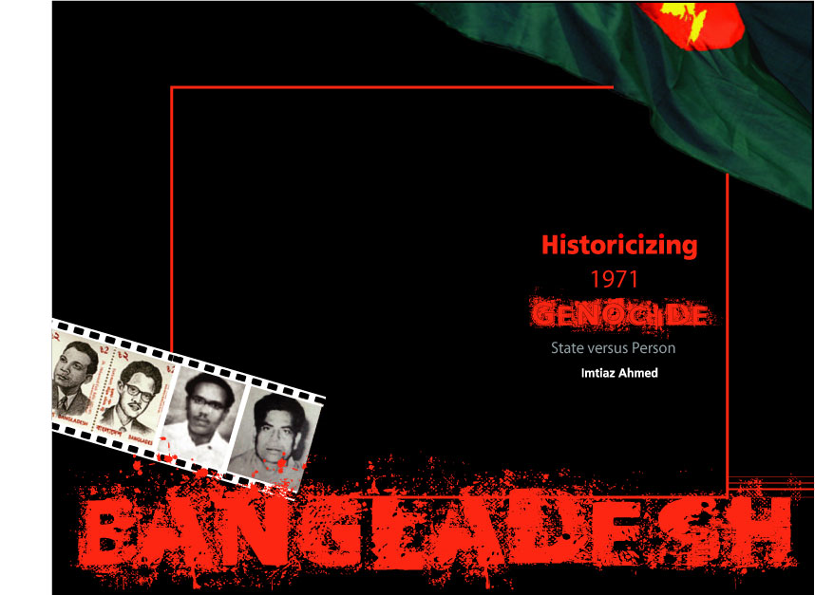
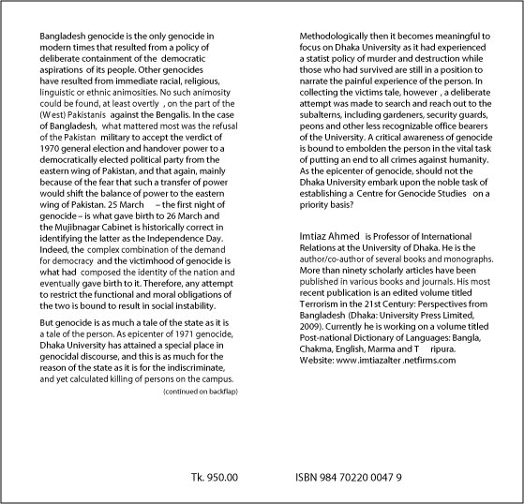
Imtiaz Ahmed

Historicizing 1971 Genocide: State versus Person

August 2009

