July 30, 2008

Thousands Gather for Karadzic Rally
By DAN BILEFSKY
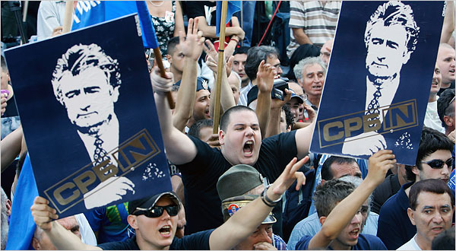
Srdjan Ilic/Associated Press
Serbian ultra-nationalists in Belgrade on Tuesday protested the arrest of the former Bosnian Serb leader Radovan Karadzic.
BELGRADE, Serbia — Thousands of far-right nationalists gathered in the Serbian capital Tuesday for a rally to protest the arrest and likely extradition of Radovan Karadzic, the former Bosnian Serb leader.
The far-right Radical Party bused in supporters from across Serbia and Bosnia to show solidarity with Mr. Karadzic, a man charged with engineering Europe’s worst massacre since World War II but who is celebrated by his supporters as a hero.
“Karadzic is a hero because he defended Serb lives during the terrible wars of the 1990s,” said Elena Pavovski, 24, a supporter of the far-right Radical Party. “Everyone knows that the war crimes tribunal in The Hague was designed to try Serbs while the war criminals who killed Serbs are set free.”
More than 3,000 riot police were deployed in Belgrade as anti-government protesters wearing T-shirts embossed with Mr. Karadzic’s image waved Serbian flags and sang patriotic songs next to a banner on Republic Square threatening Serbia’s pro-Western President Boris Tadic.
“Tadic Prepare To Be Eliminated”, the banner said.
Mr. Tadic implored the protesters to remain peaceful, determined to avoid a repeat of demonstrations last February, when thousands of demonstrators rampaged through the streets of Belgrade to protest Kosovo’s declaration of independence from Serbia, looting shops and setting part of the American Embassy on fire.
The rally is seen as a test of the new government, which is made up of Mr. Tadic’s Democrats and the Socialist party of former Serbian strongman Slobodan Milosevic, which controls the Interior Ministry and the police.
Some analysts feared that tensions could be exacerbated by the announcement Tuesday by Bosnia’s war crimes court of the sentencing of seven Bosnian Serbs to prison terms ranging from 38 to 42 years for taking part in the mass killing of Bosnian Muslims in Srebrenica, in which men and boys were herded up and executed. Many bodies were later found in mass graves with their hands tied behind their backs.
Mr. Karadzic, a former psychiatrist, has been indicted in connection with the three-and-a-half year siege of Sarajevo in 1992-1995 in which he is accused of authorizing the killing of civilians. He is also accused of masterminding the 1995 massacre of 8,000 Muslim men and boys at Srebrenica.
He evaded arrest for more than a decade, living openly in Belgrade for at least part of that time disguised as an ascetic New Age guru with a bushy beard, a mistress and a fake family in the United States.
But Ms. Pavovski, the Radical supporter, said she was unmoved, insisting she did not believe that the massacre at Srebrenica had taken place.
“Nobody has proved that a massacre took place,” she said. “Srebrenica is the product of a media war against Serbia and the Serbian people. Karadzic was fighting to defend Serbia.”
Serbian analysts said Karadzic continued to exert a powerful hold over a vocal minority of Serbs, who credited him for helping to create the Serb-run Republika Serpska, carved out of Bosnia after the American-brokered Dayton peace agreement ended Bosnia’s three-a-half year war.
They said he remained popular because the country had yet to confront Serbia’s role in the horrors of Srebrenica, 13 years after the massacre took place.
“Since Milosevic fell, few in our government have confronted the war crimes perpetrated in Serbia’s name,” said Brankica Stankovic, one of the country’s leading television journalists. “Our elites refuse to confront openly what they did for fear of being branded as traitors.”
The failure to grapple with the past, analysts said, had also been exacerbated by the skepticism among some Serbs about the United Nations tribunal in The Hague. According to legal experts, as of early this year, 45 Serbs, 12 Croats and four Muslims have been convicted for war crimes. More Croats than Muslim have been indicted for war crimes, but several were acquitted due to insufficient evidence.
Mr. Karadzic supporters wearing “No to Hague Tyranny” buttons Tuesday said they were incensed by the recent release of high-profile suspects accused of war crimes against Serbs, including Naser Oric, a Bosnian Muslim indicted for failing to prevent the murder and torture of Serb captives in Srebrenica during the Bosnia war of 1992-1995, and Ramush Haradinaj, an ethnic-Albanian former Kosovo Liberation Army commander who was indicted on including the murder of Serbs, Albanians and Gypsies during the 1998 conflict in Kosovo.
Marlise Simons contributed reporting from The Hague.
Copyright 2008 The New York Times Company

