Bosnia’s Continuing Chaos

The killing may have subsided, but the mess in the Balkans lingers on.

BY LOUISE ARBOUR | NOVEMBER 18, 2009
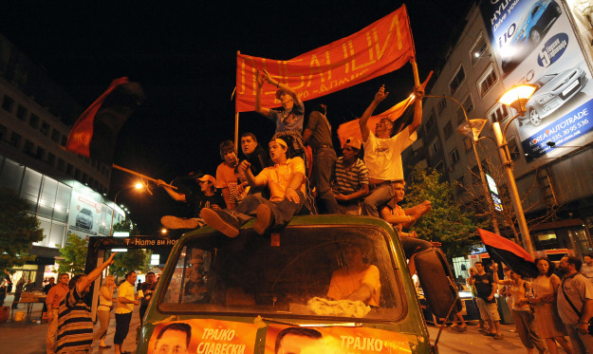
ROBERT ATANASOVSKI/AFP/Getty Images
Fourteen years after its brutal war ended, Bosnia is today in political, if not literal, turmoil. Half of the country is deadlocked in a feud with the international governor, the High Representative. And a meeting this week of the Peace Implementation Council, setup in 1995 to monitor the peace accord, could prove decisive in moving forward. With the status quo unviable, the council will have to decide between reinforcing the existing, international executive authority in Bosnia or transitioning to a new, forward-looking approach based on ever-increasing integration into the European Union and NATO.
The trouble started back in September. Bosnia is divided into two main political-territorial parts, and the Serb half, Republika Srpska, rejected a series of decisions imposed by the Office of the High Representative, Bosnia's international governor. Some were technical and innocuous, but others -- relating to control over the electric monopoly -- were controversial. In theory, the High Representative can impose virtually any law without review by national authorities. But this crisis shows his practical ability to enforce decisions has been weakened or even curtailed. The Serbs have since threatened to pull out of common Bosnian institutions if the High Representative imposed any other laws. There is no obvious way out of this confrontation, and further escalation would threaten Bosnia's hard-won stability and viability as a common state.
Rather than backing the High Representative as they have done in the past, the United States and the European Union launched talks in October between Bosniak, Bosnian Serb and Bosnian Croat leaders to break the impasse. At the "Butmir talks" -- so called because they are taking place at the Butmir military base near Sarajevo -- Washington and Brussels presented a package of constitutional reforms. These are part of a broader attempt to move the country toward EU and NATO membership, thus stabilizing it and allowing the Office of the High Representative to close.
Ideally, Bosnia's leaders would accept the EU-U.S. proposal in its entirety. It is a good compromise and the most that can be hoped for under trying circumstances. But time is running out. The High Representative's conflict with Republika Srpska has been frozen for two months as the Butmir talks have been ongoing. But it will not stay frozen for much longer, as Bosnia's parties gear up for what promises to be a tense campaign leading to next year's general elections. If negotiations achieve little or only partial agreement on the proposed reforms, as now looks likely, the international community will be left with only two choices.
The first option would be to strengthen the Office of the High Representative. That may require sacking obstinate Bosnian political leaders -- something the High Representative has the right to do but has not done in years. The trouble with this option is that the office has no public support among Serbs, meaning that enforcing decisions might entail a very real show of force, potentially from the small peacekeeping mission still in Bosnia. Forcing tough political choices would also entrench Bosnia's position as an international protectorate, where ultimate political responsibility lies with international rather than democratically elected leaders. It would buy stability at the expense of a big step backward in Bosnia's viability as a state.
A more forward-looking approach would be to reinforce the Bosnian state, close the Office of the High Representative, and put in place new, strong stabilizing measures based on close EU engagement coupled with continual U.S. and NATO involvement.
The EU has long been eager to take on new responsibilities in Bosnia. A new special representative should have a stronger mandate that enables the envoy to call out parties and persons who are in noncompliance with the Dayton Agreement, barring them from further EU benefits. The EU will equally need to be the guarantor of the Dayton Peace Agreement, seeing the process through to final implementation.
What makes this arrangement different from the current High Representative is executive power -- which the new EU representative would lack. He or she would be there to facilitate Bosnia's political process, and make decisions on the disbursement or restriction of EU financial aid to Bosnia. Such a mechanism would ensure that political pressure would remain while still giving Bosnia's leaders something they have never really had before: responsibility for their country.
At the same time, the U.N. Security Council should renew the mandates of both EUFOR and NATO for at least one more year, endorsing their authority to maintain Bosnia's security under the Dayton Peace Agreement. In addition, both the EU and NATO should invite Bosnia to apply for membership and spell out the conditions for joining both organizations.
Meanwhile at Butmir, the EU and United States should work toward getting agreement on the urgent reforms necessary for Bosnia's next stage in EU integration: candidacy status. These include authorizing the state to make commitments to the EU and implement obligatory EU reforms, including ensuring that the constitution is compliant with the European Convention of Human Rights and improving the state's administrative and legislative capacity.
There is no viable middle ground here between these two options. The current situation -- an endless stalemate -- risks bringing the state to a standstill and derailing its EU ambitions. Keeping the High Representative's office in its present form, with broad authority but without the ability to enforce it, is dangerous. It's time for a new approach. Full Bosnian responsibility, reinforced by the EU and NATO, offers the best insurance against fragmentation and stagnation and the best chance to for Bosnia to become the mature and normal state its citizens deserve.
Louise Arbour is president of the International Crisis Group.

Copyright 2009 Foreign Policy

