Family wants Ratko Mladic declared 'legally dead'
by BBC News
25 May 2010
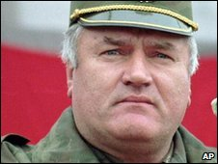
Ratko Mladic, 68, is Serbia's most wanted fugitive
The family of the fugitive ex-Bosnian Serb army chief, Ratko Mladic, is seeking to have him declared officially dead, according to Serbian media.
If approved, the declaration would allow Mladic's wife to collect a state pension and sell his property.
Mladic is wanted by the International Criminal Tribunal for the former Yugoslavia on war crimes charges in connection with the 1992-95 Bosnia war.
Mladic - on the run since 1995 - faces charges including genocide.
In an interview with the Vecernje Novosti newspaper, the Mladic family lawyer said such a request could be made when a missing person was over 70 and there had been no reliable information on his whereabouts for more than five years.
Milos Saljic said he would submit a motion to the Serbian courts this month arguing that Mladic has poor health and has not been seen in years. Mladic is only 68.
Mr Saljic said the family were pursuing the motion "because of the prosecution they are facing".
Rasim Ljajic, the head of the Serbian National Council for Co-operation with the ICTY (International Criminal Tribunal for the former Yugoslavia), said the actions of the family "mocked the state".
He told the newspaper that the legal action would in no way influence the effort to track down the country's most wanted fugitive.
UN court officials believe Mladic is hiding in Serbia.
The capture of Mladic is considered a pre-condition for Serbia joining the EU.
Copyright 2010 British Broadcasting Corporation

