Thousands retrace flight from Srebrenica
by Rusmir Smajlilhodzic, Agence France-Presse
9 July 2010
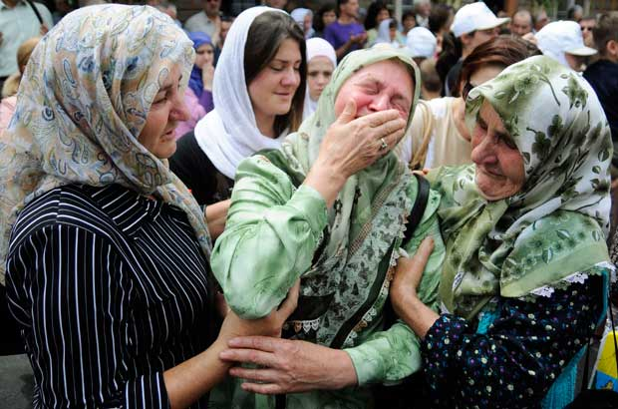

A woman cries beside trucks loaded with the coffins of 775 newly identified victims of the 1995 Srebrenica massacre in front of the Presidency Building in Sarajevo, Bosnia & Herzegovina, July 9. Each year, bones are matched to a name and buried in a mass funeral on July 11. Photograph by: Dado Ruvic, Reuters.
KAMENICA,, Bosnia-Hercegovina - Thousands of people on Friday commemorated the 1995 Srebrenica massacre by tracing the path taken by Muslim men and boys as they fled advancing Bosnian Serb forces.
Although between 10,000 and 15,000 tried to escape on foot through the forests to Muslim-held territory, nearly 8,000 men and boys from the enclave were captured and systematically killed in the days after the fall of Srebrenica on July 11, 1995.
"For me this is a kind of pilgrimage I make every year to thank God for saving my life," said 37-year-old Sefik Begovic as he walked in a group of men in the Nezuk valley.
The three-day, 105-kilometre (65-mile) march in the opposite direction, from Tuzla to Srebrenica, started on Thursday and will arrive at the Potocari cemetery and memorial centre near Srebrenica on Saturday evening.
Around 5,000 people participated in the memorial walk this year to mark the 15th anniversary of the massacre, the worst single atrocity on European soil since World War II.
The flight began hours before the arrival of the Bosnian Serb forces in Srebrenica, which had been designated a UN safe area. At the head of the column were some 3,000 to 4,000 armed men while the rest were unarmed civilians.
"It was total chaos, we were in the throws of panic from the first night," said survivor Hilmo Mustafic.
Sabit Cvrk, 48, said he walked with eleven other men, including one who was wounded when their group was bombed.
"We only walked at night, were horribly scared, the ambushes followed one after another. We prayed to God not to fall into the hands of the Bosnian Serb forces," he told AFP, dressed in the wartime uniform of the Bosnian Muslim army.
After two days making their way through the densely wooded, mountainous terrain, the column of men was cut in two by Bosnian Serb forces at Kamenicke Stijene.
It was here that walker Sadik Omerovic saw his younger brother and his father for the last time.
They were among the several thousand men who were captured and later killed.
"The hardest moment for me was when I arrived in Muslim-held territory," he said.
"I cried tears of joy because I survived and tears of sorrow because I didn't see my father and my brother among the other survivors who arrived," he added.
Those who were captured by the Bosnian Serb forces were taken to various execution sites around the town.
The victims were shot and interred in mass graves, then reburied haphazardly later in more than 70 sites in a bid to cover up the evidence.
The lucky ones arrived in Muslim-held territory five days after setting off, although some took over a month to reach safety.
Hilmo Mustafic, 43, walked with the Bosnian wartime flag with golden fleurs-de-lis accompanied by his two teenage daughters from the United States where the family now live.
"I want to tell my children how this happened so they will remember," said Mustafic, who blasted the international community and the wartime Bosnian Muslim leadership "who did nothing to help us" at the time.
The Srebrenica massacre is the only episode of the ethnic conflicts that followed the breakaway from Serbia of other members of the Yugoslav federation in the 1990s to have been deemed a genocide by the UN war crimes court and the International Court of Justice, the UN's top court.
Further along at the head of the march several young men carried Islamic flags and cried "Allah Akbar" (God is Great), despite calls of the march organizers to refrain from provocation as the walkers passed Serb villages.
Shortly afterwards, three or four shots are heard, probably Serb villagers shooting in the air, marchers said, as Bosnian Serb police officers stood guard at points close to Serb villages.
© Copyright (c) AFP

