Bosnia approves new central government, ending 16-month deadlock
By The Guardian
10 February 2012
New prime minister Vjekoslav Bevanda expresses hope that country can make progress towards EU accession
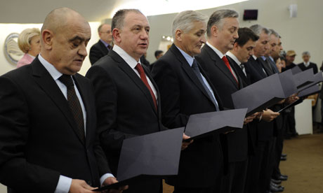
Members of Bosnia and Herzegovina's newly appointed Council of Ministers after a new central government was approved. Photograph: AFP/Getty
Bosnia's parliament approved a new central government on Friday, ending 16 months of deadlock between Serb, Croat and Muslim leaders that left the economy floundering and stalled reforms needed to revive Bosnia's bid to join the European Union.
The country had been paralysed since an inconclusive parliamentary election in October 2010 until rival political parties agreed in late December on the makeup and agenda of a new cabinet.
Bosnia was split into two autonomous regions - the Muslim-Croat Federation and the Serb Republic - at the end of the 1992-95 war, since when a weak central government has tried to reconcile the demands of two entities held together in a highly decentralised union.
The Serb Republic is fiercely protective of its autonomy, while Bosnia's Muslims want a more unified state with greater power and funding for the central government.
"The formation of the government is a positive step but it is not enough," said Srecko Latal, an analyst with the Brussels-based International Crisis Group thinktank.
"This government will have a difficult task dealing with a long list of obligations that have been long delayed." The government was voted in by 26 votes to 7 with one abstention.
The new prime minister, Bosnian Croat economist Vjekoslav Bevanda, said the government's priorities would be adopting a state budget for 2012 and a general fiscal framework for 2012-14.
Both are conditions for Bosnia to gain access to much-needed funds from the IMF and the European Commission, frozen until now because of the political impasse.
Bosnia has struggled to attract foreign investors or tackle a crippling unemployment rate.
Bevanda, seen as a moderate, said he hoped Bosnia would make more progress towards EU accession. "We are one step away from applying for EU membership," he told a news conference. "This will be the year of the European Union in Bosnia."
Some analysts predicted more politicking and obstruction by ethnically divided parties.
"It cannot get any better as long as party leaders are pulling strings behind the scenes," said Svetlana Cenić, an economist and former finance minister in Bosnia's Serb Republic.
"He will have to work with people chosen for him by others, while his authority will be very weak."
© 2012 Guardian News and Media Limited or its affiliated companies. All rights reserved.

