Indian Tribes of Brazil

July 22, 2003

Survival International

Indian Tribes of Brazil
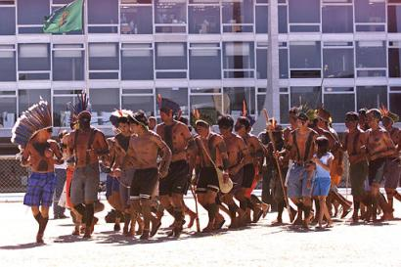
Indians from several tribes of Brazil perform a ritual during a protest in front of the presidential palace in Brasilia, Brazil, Tuesday, July 22, 2003.
The Indians were demanding the resignation of the president of the National Foundation of the Indian (FUNAI) and an audience with the Brazilian president Luiz Inacio Lula da Silva.
BRASILIA, BRAZIL--Before the arrival of Europeans in 1500, Brazil was home to an estimated population of anything between five and 13 million people in at least 1,000 tribes. Five hundred years of exposure to disease, violence and dispossession wiped out the vast majority of this indigenous population. Today, there are around 350,000 Indians in Brazil in over 200 tribes, who live scattered all across the country. Between them they speak a huge number of languages, from a variety of language families; 110 of the tribal languages of Brazil have less than 400 speakers. Brazil's tribes range in size from the Guarani and Yanomami, who number tens of thousands, to tribes such as the Akuntsu and Kanoê, who number only a few dozen.
Brazil's tribal peoples live in a wide range of environments – tropical forests, grassland, scrub forest and semi-desert – and have a wide range of ways of life. Their experience of contact with European invaders and their descendants also varies widely: some, such as the Guarani in the dry south, have been in contact with white people for 500 years; others encountered them far more recently; and some tribes are effectively uncontacted – the majority of the world's uncontacted tribes, probably more than 50, live in Brazil. Most tribes live by a mixture of hunting, gathering, and growing plants for food, medicine and to make everyday objects. Probably only the uncontacted Awá and Maku are completely nomadic, living entirely by hunting and gathering in the Amazon.
In the 500 years since Europeans arrived in Brazil, the tribal peoples there have experienced genocide on a huge scale and the loss of much of their land. Today, their land is still taken over for ranches or industrial projects, or invaded by miners and settlers – and they are still being killed, whether by diseases encountered when their lands are invaded, by starvation as they are driven from their hunting grounds, or by the hitmen who are employed by ranchers and 'landowners' to keep Indians away. There remains an endemic racism towards Indians in Brazil that makes all this possible – in law they are still considered minors. The most important thing for tribal peoples in Brazil is control over their lands – Brazil is one of only two South American countries that does not recognise tribal land ownership. If Brazil's tribes were recognised as the owners of their land, it would give them some real protection against the individuals and businesses that take over their land, destroying their livelihood and often destroying them.

Awá
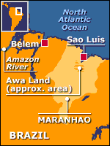
Population: Probably around 300 left
The Awá are often called Brazil's last truly nomadic tribe. Their home is in the devastated forests of the eastern Amazon. Some now live in government established posts, but many live a nomadic lifestyle without any known contact with outsiders. They are in severe danger of being wiped out altogether.
The Awá abandoned a settled lifestyle for a nomadic one in around 1800, in order to escape violent attacks by European invaders. Over the last 15 years, many have been contacted by the government Indian agency and now live in villages established by the government. All provide for themselves by hunting and gathering, and those who are nomadic are highly mobile, living in bands of no more than 20-30 people. As they travel, they keep the embers of their fires lit, relighting the fire as they arrive in each place.
Throughout the last 100 years, the Awá have been the victims of vicious and systematic extermination attempts by ranchers and settlers. Many of those who are in contact with outsiders are the survivors of massacres and are severely traumatised – and we know that many more of the nomadic Awá are survivors of the same and similar attacks. They will continue to be vulnerable as long as their land has no protection. In 1982, Brazil undertook to demarcate all Indian territories in the region as a condition of a World Bank loan for an industrial project, and World Bank money was put aside for this. Yet even now, the Awá area has not been demarcated – and the increasing encroachment by industrial projects, ranchers and settlers is exposing the surviving Awá to violence and disease.

Guarani
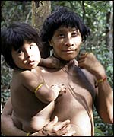
Population: around 80,000
The Guarani are a part of the Tupi group of peoples in South America. There are many different groups, even within each of the countries where they live. They were one of the first peoples contacted after the European arrivals in South America around 500 years ago. There are around 40,000 Guarani in Paraguay, where Guarani is an official language along with Spanish. In Brazil, there are around 30,000 Guarani, making them the country's most numerous tribe. Other Guarani live in neighbouring Bolivia and Argentina.
The Guarani are a deeply spiritual people. Although there are different sub-groups of the tribe, all share a religion which emphasises land above all. Land is the origin of all life, and is the gift of the 'great father', Ñande Ru. Every community has a prayer house, and a religious leader, the cacique, whose authority is based on prestige rather than formal power. The Guarani believe that the 'land without evil' is the resting place of the soul after death – over the centuries many Guarani have embarked on great journeys in an attempt to find the land without evil in this life.
The Guarani in Brazil are suffering terribly from the theft of almost all their land. They experience this theft as an offence against their religion as well as a destruction of their way of life and livelihood. Thousands of them now live crowded onto tiny plots of land increasingly hemmed in by ranches and plantations – the land is not enough for them to support themselves as before through hunting, fishing and farming. Instead they are exploited as cheap labour by the ranchers and plantation owners. The Guarani-Kaiowá in Brazil suffer particularly from this, and it has led to severe depression. Three hundred and twenty Guarani-Kaiowá committed suicide between 1986 and the beginning of 2000, the youngest suicide being only 9 years old.

Yanomami
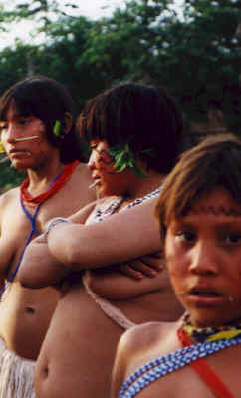
12,000 to 14,000 in Venezuela (1991 AP); 1,500 to 2,000 in Brazil; 13,500 to 16,000 total. Orinoco-Mavaca area. The Eastern dialect is in the Parima Mountains, east of Batau River, Western dialect in Padamo River basin; Ocamo, Manaviche, and upper Orinoco rivers; and south of the Orinoco River up to headwaters of Marania and Cauaburi rivers, and a number of large villages in the Siapa River area in southern Venezuela.
The Yanomami are one of the most numerous forest dwelling peoples in South America. Their home is in the Amazon rainforest, among the hills around the border between Brazil and Venezuela. We cannot know for certain how long they have lived in their lands, but it is probable that they have been there since the first peoples arrived in South America, anything up to 50,000 years ago.
Each Yanomami community lives in a huge communal house called a 'yano', which can house up to 400 people, although it is usually fewer. They build these in a large ring shape – the centre is a wide open space for dancing and ceremonies, and each family has its own hearth under the covered part around the edge. The family sleeps in hammocks around their fire. The Yanomami provide for themselves partly by hunting, gathering and fishing, and largely by growing crops in large gardens cleared from the forest. As Amazonian soil is not very fertile, a new garden is cleared every two or three years. They grow around 60 crops, of which about 20 are for food, and the rest for medicine, making everyday objects, or ritual purposes. No hunter ever eats the meat that he has killed, instead sharing it out among friends and family; in return he will be given meat by another hunter.
During the 1970s and 1980s, the Yanomami suffered hugely from Brazilian goldminers invading their land. The miners shot them, destroyed their villages, and exposed them to diseases to which they had no immunity. Twenty percent of the Yanomami died in just seven years. After a long international campaign, Yanomami land was finally demarcated as the 'Yanomami Park' in 1992 and the miners at last expelled. But the Indians still do not have proper ownership rights over their land – Brazil refuses to recognise tribal land ownership, despite having signed an international law guaranteeing it – and there are many within the Brazilian establishment who would like to see the Yanomami area reduced and opened up to mining and colonisation. The army is also stepping up its presence in the area, and has plans to build more barracks.
Continuous active genocide including the senseless massacre in September, 1993, An estimated 23 persons died, mostly women and children. Sixty two percent of Yanomami tested positive for new strains of malaria introduced by garimpeiros (gold miners) which have brought every conceivable disease known to modern man, from the common cold (Yanomami have no immunity to combat our most common ailment) right up to and including AIDS.

Makuxi
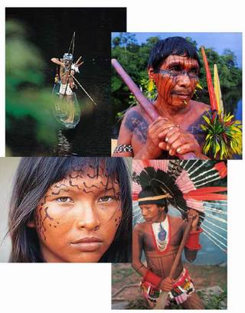
Population: around 24,000
The Makuxi are a hunting and farming people living in a hilly region known as the 'Guyana shield', on the border between Brazil and Guyana. The Makuxi believe that they and the neighbouring Ingarikó tribe are descended from the children of the sun, who left for their descendants the gift of fire but also disease and the hardships of nature.
Makuxi land is a spectacularly beautiful region of mountains, tropical forest and savanna, where they raise cattle. During the long dry summer months, they hunt, fish in any rivers that are not dried up, and visit neighbouring villages. This is also when they build and repair their houses, which they make from wood, clay and palm leaves. The winter, from May to September, is a period of very heavy rain, making many of their summer activities impossible. Makuxi communities vary greatly in size, and are based on ties of marriage and family – when Makuxi marry, the couple live in the bride's family's village. Extended families hunt together, but each household grows its own crops for personal use.
The Makuxi have endured vicious violence and the theft of their land since colonisation in the 18th century. Today, they suffer particularly from invading ranchers and gold miners who not only destroy their land, and expose them to disease, but also treat them with extreme brutality – some ranchers, for example, employ hitmen to intimidate and murder the Makuxi. The Brazilian government has so far failed to comply with its own constitution by officially recognising and protecting Makuxi land, and many powerful politicians side with the ranchers and miners. The Indians are now facing a new threat from the Brazilian army, which is seeking to militarise their area, building barracks and moving in troops. This will expose the Makuxi to more disease.

Kanamari Indians
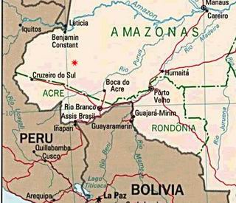
Population: 643 (1999)
Economy: Agriculture and Rubber
Today: Deculturalized due to Extreme Alcohol
First contacts reported a culture very old and a tribe rich in song, dance, and traditions.
One of the few tribes that used permanent facial tattoos and were noted for their ability as Curandeiros or Medicinal Healers.
In less than 50 years, they have traded their past for alcohol. The effect physically and culturally has been devastating.
Alcohol was introduced by the rubber companies and was used to keep the Kanamari in debt and enslaved.

Kaxinawa Indians
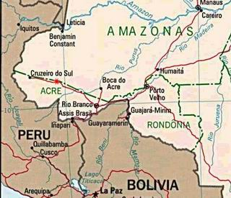
Area: Acre, Brazil
Population: 2,700 (1999)
First Contact: 1900
Economy: Rubber
They "migrated" from Peru, date unknown. Huni Kuin is their true name meaning the 'Real People'. Contacts before 1948 were made but these groups were in semi-permanent villages and were still returning to Peru. During the "Rubber Era" the Kaxinawa were used brutally for rubber collection in a system that even the young and strong did not survive.
The Kaxinawa have suffered constant violent genocide from the very first contact. The entire group was forced into slave labor to work for rubber producers. In 1951 the Kaxinawa suffered a genocide that exterminated 75-80% of the group. During 1955 to 1968 there were only 400 to 500 persons left.

Marubo Indians
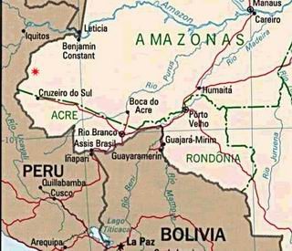
Population: 700 (1999); (300 in 1960)
Many Marubo became directly involved in the rubber trade, locked into debt by the rubber traders. The trade had the effect of breaking up the traditional communities. Every family lived alone to collect their rubber. Economy took precedence over the social and religious ties of the community. The rubber economy collapsed in 1938. By this time, the rubber industry had reduced the Marubo to near extinction.
Today, they are one of the guiding forces of the indigenous movement in Brazil. Presently, they are fighting to stop a new highway as well as gas and oil exploration on their lands.

Maku Indians
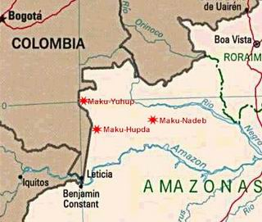
The Maku Indians reside in the Northwestern part of the Brazilian Amazon close to the Peruvian border.
They are one of the last groups of nomadic tribal peoples in the Amazon. It is only a question of a decade or two before their traditional trekking lifestyle is eroded into the sedentary agricultural village life. This drastic cultural change is happening under the influence of the Western culture. They use long blowguns with darts dipped into the curare poison to hunt in the forest canopy, mostly for monkeys. The blowguns are made from the straight trunks of the Stilt Palm, sometimes inserting one tube inside another until the length can reach 8 feet. Their quivers are made of bark cloth with a protective flap to cover the darts.

Matis Indians
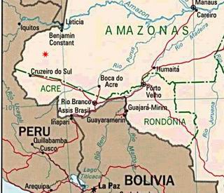
Area: Vale do Javari, Brazil
Population: 123 (1999)
Economy: Hunting and Fishing
Early explorers confused the Matis as belonging to the Mayoruna or Marubo. There is little chance that the Matis had avoided earlier contact. Their facial ornaments are a mystical homage to the Jaguar. The blow gun used by the Matis is accurate up to thirty meters. They can kill a hummingbird in flight that has a defense reaction of 1/20th of a second. Due to minimal contact, there is very little known about the Matis. Small masks are used in a ritual for children. This tradition was stopped for many years as the Matis felt their population dwindling. Recently they started to produce them again.
The Matis are masters of curare. Of the Amazon groups that use it, each have their own magical method for making this venom.
Curare arrived in the Old World on the tongues of a thousand legends and tales. First known as "Wourali", it was brought to Queen Elizabeth by Sir Walter Raleigh in 1584. It was Charles Waterton (1782-1865) who introduced curare to our medical world. Today the synthetic is used on a daily basis as an anesthesia around the world. It is one of the greatest contributions and gifts given by the Amazon Indians.

Tenharim Indians
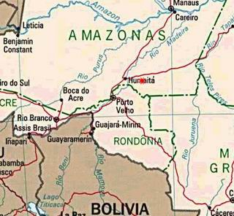
Area: Amazonas, Brazil
Population: 250 (1999)
Economy: Hunting - Fishing
Master "Plummets" in their ability to combine color and textures with small feathers. Small bamboo tubes are made for "Indian Paco Robbanne" - small flowers dried and crushed into a fine powder and sprinkled on the body after a bath in the river. This give the smell of the original flower, a type of ecological perfume. The Tenharim are known as "Boca-Negra" or "Black Mouth" due to their corporal painting designs. They were first encountered due to the TransAmazonica highway.

Tikuna Indians
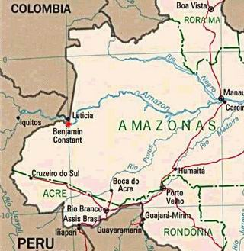
Area: Alto Solimones, Columbia-Brazil frontier
First Contact: 1532
Population: 20,000+
Economy: Fishing and Agriculture
The Tikuna, also spelled Tukuna or Ticuna, reside in the Brazilian Amazon rain forest near the borders of Peru and Columbia.
There are over 70 established Ticuna aldeias (villages) in the Alto Solimones, in the area of the rivers Santo Antonio do Ica and Solimones River. There is also a population in Columbia. The Ticuna were one of the first major tribes of the Amazon to be contacted by the early conquistadors. They are one of the last large population groups left in Brazil. Even with over 400 years of contact, the Ticuna Nation has managed to preserve their personal identity through their native language, traditional religions, rituals, and cultural art forms. They have survived the constant threat of violent extermination and forced integration policies by Western society. The Ticuna are a very artistic tribe whose talents include basketry, wood and stone sculpture, and mask making. They also make bark cloth which is a natural fiber, paper-like fabric which they often paint. This fabric is often incorporated into many things such as masks and dolls as well as painting on it as on canvas or paper. They are one of the few Amazon tribes that paint just for the worth of the painting itself as opposed to painting as decoration on a utilitarian object.

Tukano (Tucano) Indians
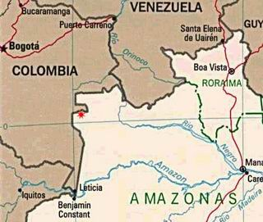
Area: Columbia: Upper Papurí River and tributaries. Tucanoan, Eastern Tucanoan, Northern; Brazil: Rio Negro - Amazonas;
Tropical forest. Riverine, hills. Altitude: 200 to 250 meters.
Population: 2,000 in Colombia (1991); 3,500 in Brazil (1995); 5,500 total
Economy: Hunting and Fishing; Swidden agriculturalists
They are dominated by various religious mission groups bent on total acculturation for the Tucano. There are violent attacks against them and there are new strains of Malaria.
Father of a group of various sub-nations that live in the upper Rio Negro area called Tucano (Tukano). This group's culture is a virtual melting pot. It is common practice for the men to take wives from other groups. The mother will remain with her native language and children will learn as many as five languages living in a mixed community. The Tucano have been affected severely by their exposure to the national society. They are very involved in their self-determination, defense of their territory, and autonomy.
Ceramic design has developed into a precise visual language with which to communicate cultural ideas and values. They have two distinct categories of design. One is predominately abstract geometrical pattern, lines, dots, parallel lines, circles, circle spirals, triangles, and diamond shapes. There are also figurative motifs of frogs, birds, lizards, bats, fishes, and snakes, often repeated. At times they combine these designs together, producing a distinctive art which is both sophisticated and meaningful.

Waimiri-Atroari Indians
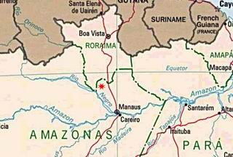
Area: Amazonas, Brazil
Population: 374 (1986 - annual reduction 20%) (784, on September 1998)
In 1992 they were in judicial battle to realize their part of the Hydroelectric Project promises. In 1999 the Programa Waimiri Atroari is considered a model project and a valid solution for the indigenous situation in the Amazon Basin.
The Waimiri-Atroari Indians live in deep in the Amazon Rain forest of Northern Brazil. This nation was in constant open warfare for over 300 years. When first contacted by the early spice hunters, their territory was one of the most feared and impenetrable in the Amazon. They finally surrendered to "pacification by a government agency" in 1977 to make way for the Pan American Highway and a hydroelectric project. At the time of their surrender their population was around 3000. In 1968 a Catholic priest and 7 nuns were discovered dead in Waimiri territory. The number of Waimiri killed in retaliation was never released.
Source: www.survival-international.org, www.indian-cultures.com
Copyright 2006 Dismal World

