Worldwide protests against Amazon mega-dam
by Survival International
22 August 2011
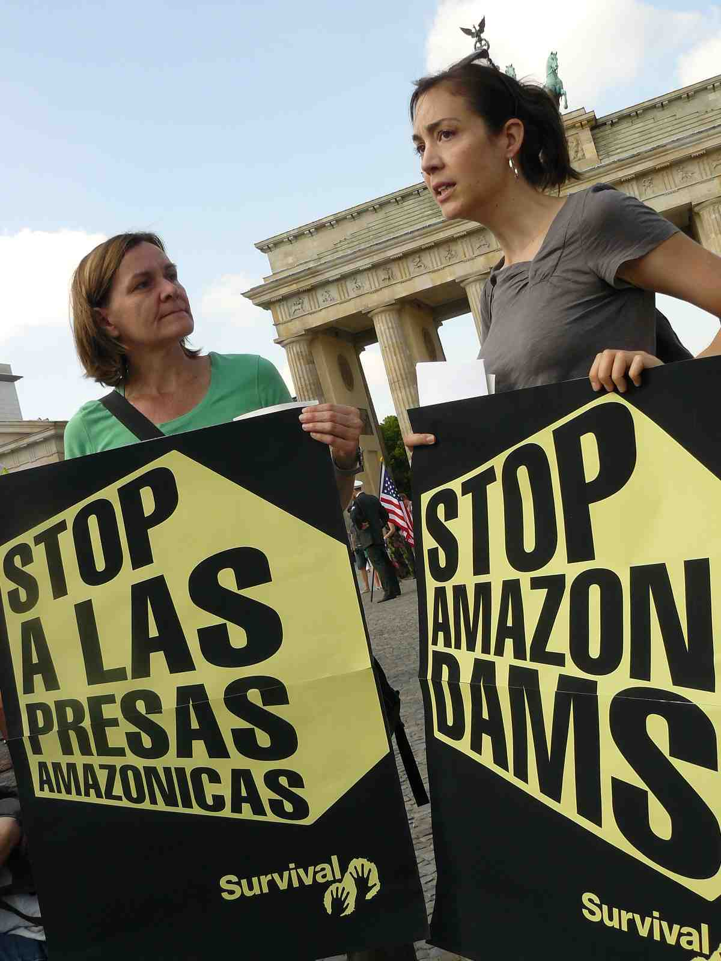
Thousands of people protested against
the Belo Monte dam in cities worldwide
over the last few days. © Survival
Thousands of people have taken to the streets in dozens of cities worldwide, to protest against the Belo Monte mega-dam being built in the Brazilian Amazon.
Groups across Brazil called on Brazil’s President Rousseff to halt the construction of the destructive dam on the Xingu river. Their message is being echoed by demonstrators in Australia, Canada, Iran, Mexico, Turkey, the United States, and at least nine other countries.
Survival International supporters delivered letters (pdf,184 KB) to the Brazilian embassies in Berlin, London, Paris and Madrid, expressing their concerns for the indigenous peoples living in the area.
The international actions follow widespread outrage as the construction of the dam has begun despite numerous human rights and environmental violations, and massive opposition from the local population.
The dam will devastate vast areas of land, upon which numerous tribal people, including highly vulnerable uncontacted Indians, depend for their survival.
The Kayapó Indians of the region have warned that if the dam is built, the Xingu could become a ‘river of blood’.
Indigenous spokeswoman Sheyla Juruna has recently remarked that the indigenous people ‘are not against development… but there are other ways of generating energy… We consider the river our home… If the government continues to insist on Belo Monte, there will be war’.
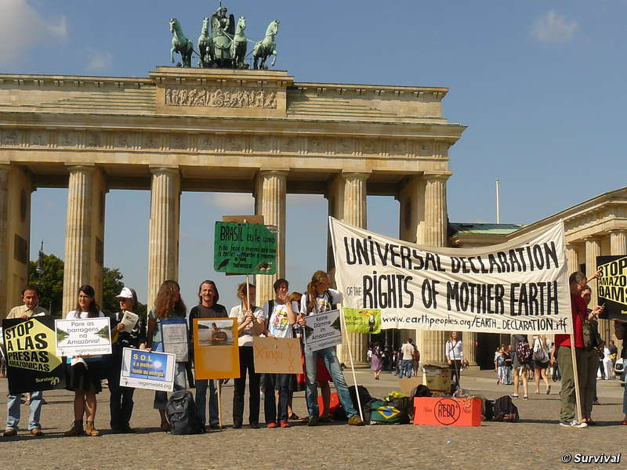
Protesters rallied behind Amazon Indians
against the Belo Monte dam. © Survival
Earlier this year, Survival supporters joined Amazonian Indians in their protest outside the London office of Brazil’s state development bank BNDES, which is providing much of the funding for the Belo Monte project.
Survival’s Director, Stephen Corry, said today, ‘It’s gratifying to see so much international support for the Indians of the Xingu river – if only their own government would show similar care. The Brazilian state development bank should not finance projects that ride roughshod over the Indians’ right to the ownership of their land and resources’.
Pictures of the protests are available for download.
To read this story online: http://www.survivalinternational.org/news/7602
Copyright 2011 Survival International

