A Sour Mood, Civil strife beckons again
By The Economist
10 March 2012
BUJUMBURA | from the print edition
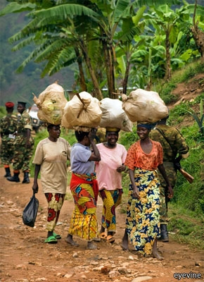Small country, big burdens
NOT long ago Burundi was considered a modest success in one of Africa’s most violent regions. Under foreign prodding, a civil war that had lasted nearly a decade was brought to a close in 2000. By 2003 all the main protagonists seemed ready to accommodate each other. Former rebels joined the national army, and their leaders took off their uniforms in favour of civilian garb. UN peacekeepers, at one time nearly 6,000-strong, kept things steady enough to allow most of them to leave by the end of 2006; just over 100 are still there. Squashed against the chronically lawless vastness of eastern Congo, little Burundi seemed a miracle of calm.
No more. The mood has again turned sour. Opposition forces that renounced violence are regrouping menacingly on the country’s border. In the past eight months unknown assailants have attacked Burundian towns and villages, killing scores of civilians. In September 39 people were slaughtered in one attack on Gatumba, an hour’s drive from the capital, Bujumbura. The government of President Pierre Nkurunziza has blamed people with ties to the former rebels. Those it has arrested say that the state’s own agents perpetrated the killings to create a pretext for hammering the opposition.
That is certainly what has happened. Human-rights groups say that some 300 opposition members have been killed since July, and dozens arrested. The government has lashed out at independent media and charged civil-society activists and lawyers with inciting terror. Yet Burundi’s leaders also refuse to admit there may be a rebellion afoot. Foreign donors and diplomats know not to utter the “R-word”—rebels—when they meet government officials.
The trouble really began in 2010, when the opposition boycotted elections which it said were flawed but which international observers judged to be passably fair. Without any challengers, the ruling National Council for the Defence of Democracy and the Forces for the Defence of Democracy, known by its mouthful of French initials as CNDD-FDD, won the presidency with 91% of votes cast. It now has almost equally crushing majorities in both houses of parliament.
Much of the opposition has retreated to exile or into the bush. A particular worry is the National Liberation Front, whose leader, Agathon Rwasa, is believed to be based in eastern Congo. Troops loyal to him have begun to team up with other militias and rebel groups there. In recent months two other new armed movements in exile have proclaimed their intention to overthrow the government.
So far these fledgling groups lack organisation, manpower and vision. But in the lawless forests of Congo even ragtag rebels can do a lot of harm. “It doesn’t take much to mount a credible activity in the DRC,” says Filip Reyntjens, an expert on the Great Lakes Region at the University of Antwerp. “If you have 200 guys and a Kalashnikov, you have a rebellion.”
Fearing another civil war, an array of peace-minded figures, including Catholic clergy, members of the non-violent opposition and a former head of state, Sylvestre Ntibantunganya, have called for dialogue. The government says it would talk if the opposition returned from exile.
But many doubt the government’s sincerity. Burundi ranks among the poorest of countries, but officials enjoy rich pickings. Transparency International, a Berlin-based lobby, says it is the most corrupt country in the region. And the rebels happily earn money from Congolese gold-trafficking and protection rackets. “The rebels have another life in Congo,” says a Western diplomat wary, in the current jumpy climate, of talking to a foreign journalist. “It’s an open question whether they want one here, back in Burundi.”
Copyright © The Economist Newspaper Limited 2012. All rights reserved

