Stanton Discusses Genocide at CU Chapel
By Hillary C. Wright, student news writer, Campbellsville University
October 16, 2009
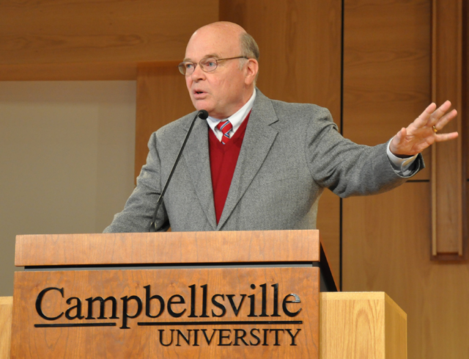
Dr. Gregory H. Stanton speaks at Campbellsville University’s Chapel service recently. (Campbellsville University Photo by Bayarmagnai “Max” Nergui)
Stanton Speaks on Genocide and its Effect on the World at Campbellsville University Chapel Service

CAMPBELLSVILLE, Ky. – “Never underestimate your own ideas…Yours in fact may change the world,” Dr. Gregory H. Stanton said at Campbellsville University’s Chapel Oct. 7.

Stanton spoke about genocide and its affect on the world. He also talked about his journey in Cambodia.

Stanton is research professor in Genocide Studies and Prevention at George Mason University in Arlington, Va., the founder and president of Genocide Watch (www.genocidewatch.org), the founder and director of the Cambodian Genocide Project, and is the founder and chair of the International Campaign to End Genocide. He is the vice president of the International Association of Genocide Scholars.

“I believe genocide goes back to the beginning of the human race,” Stanton said.

“Genocide is created by human will and it is human will that will have to apply to defeat it. For the victims, genocide is very personal. People who commit genocides try to depersonalize their victims. Their stories crushed my soul,” he said.

Stanton told the crowd to “Welcome failure and learn from it.”

“I have faith that we will overcome the fight against genocide against justice,” Stanton said.

Stanton also spoke at a Kentucky Heartland Institute on Public Policy (KHIPP) event Oct. 6 discussing “Genocide and the World Today,” and was a guest on Campbellsville University’s “Dialogue on Public Issues” hosted by John Chowning, vice president for church and external relations and executive assistant to the president. The show will air on WLCU TV-4, Comcast Cable Channel 10, Sunday, Oct. 18, at 8 a.m.; Monday, Oct. 19, at 1:30 p.m. and 6:30 p.m.; and Wednesday, Oct. 21, at 1:30 p.m. and 7 p.m.

Campbellsville University is a private, comprehensive institution located in South Central Kentucky. Founded in 1906, Campbellsville University is affiliated with the Kentucky Baptist Convention. Listed in U.S.News & World Report’s 2010 “America’s Best Colleges,” CU is ranked 23rd in “Best Baccalaureate Colleges” in the South and fourth in “up-and-coming” schools in the south. CU has been ranked 17 consecutive years with U.S.News & World Report. The university has also been named to America’s Best Christian Colleges® and to G.I. Jobs magazine as a Military Friendly School. Campbellsville University is located 82 miles southwest of Lexington, Ky., and 80 miles southeast of Louisville, Ky. Dr. Michael V. Carter is in his 11th year as president.

Posted on Friday, October 16, 2009 by Ashley Zsedenyi

