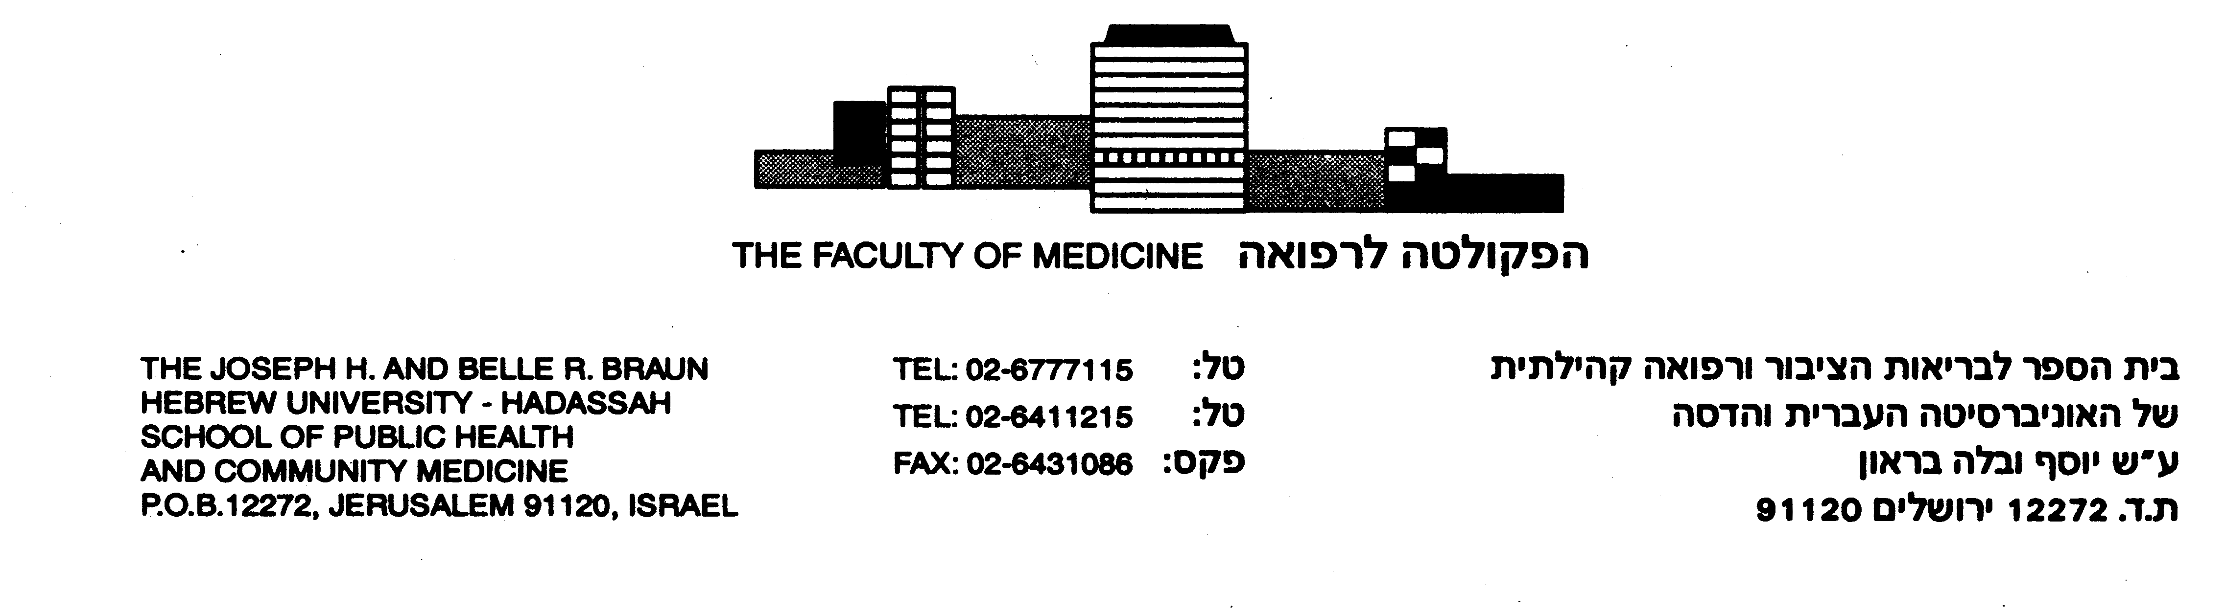
The Precautionary Principle: A Brief for the Genocide Prevention Task Force
By Dr. Elihu Richter and Dr. Gregory Stanton
A primary mission of the new Task Force on Genocide Prevention should be to develop and apply public health-based models for the control of preventable diseases to the prediction and prevention of genocide. Genocide and politicide are the ranking cause of preventable violent death since World War II, with over 70 million dead, more than from all wars combined. Today, we need to include genocidal terror as part of the spectrum of genocidal massacres.
We call for applying the "Precautionary Principle" to make genocide prevention effective, with special emphasis on an international network for surveillance of hate language and prosecution of incitement to commit genocide. The Precautionary Principle states that when there is uncertainty concerning the possibility of the occurrence of a major catastrophic event, the costs of inaction far outweigh those of anticipatory preventive action. The Precautionary Principle shifts the burden of proof from those suspecting a catastrophic risk to those denying it. In everyday terms, the Precautionary Principle states that it is better to be safe than sorry.
Until now, the 1948 Convention on the Prevention and Punishment of the Crime of Genocide has resulted in some punishment but no prevention. Its implementation has been rooted in post hoc criminal law, which bases action on proving criminal intent after the genocidal event, using forensic and documentary evidence. Because it is based on proof of intent after the event, international criminal law by definition cannot be relied upon as a tool to prevent and stop genocide
The Precautionary Principle should be the fulcrum for a paradigm shift from reactive to proactive response. The Precautionary Principle states that when there is doubt about a risk, there should be no doubt about the need for its prevention. This principle is now part of many international conventions guiding Environmental Law, especially in the European Union, and has been endorsed by the International Association for Genocide Scholars. In genocide prevention, as in environmental health and disaster prevention, the case for action in applying the Precautionary Principle is the catastrophic ethical cost of delaying prevention — which, as in natural disasters, can be measured in massive loss of human lives.
We propose to advance the focus of genocide law and preventive activity from proof of intent after the event to prediction and prevention. The Rome Statute of the ICC, which specifies that incitement to commit genocide is a crime against humanity, is the already available platform for making this advance. The proposal to indict the President of Iran for incitement to commit genocide is a case study of applying the Precautionary Principle. Incitement to commit genocide is the classic predictive indicator and promoter of genocide.
Genocide and genocidal terror result from human choice. Their prevention requires human choice, intelligence and strategic action. There is now a consensus among genocide scholars that certain indicators predict and promote impending genocide: past genocide or politicide followed by impunity; war or political upheaval; an authoritarian regime; ethnic exclusivity in the ruling elite; aggressively exclusionary ideology; lack of trade and information openness; and indifference to atrocities by the international community. Most importantly, incitement and hate language are predictors and promoters of genocide and genocidal terror.
Extreme competition of groups for limited resources may contribute to genocidal agendas, but high competition is more often a consequence, rather than a cause, of conflict. Contrary to conventional viewpoints, poverty and so-called Malthusian pressures by themselves are not triggers for genocide, although with global climate change and increasing populations, competition for resources may become a greater factor, as seems to have occurred in Darfur, where desertification exacerbated conflicts between nomadic shepherds and settled farmers.
Gregory Stanton’s "Eight Stages of Genocide" (Classification, Symbolization, Dehumanization, Organization, Polarization, Preparation, Extermination, Denial (see www.genocidewatch.org/8stages.htm)) summarizes many of these ideas and their practical implications for policymakers. At all eight stages in the genocidal process, opportunities for prevention, intervention or mitigation exist.
Prevention of genocide needs to build upon the 2002 Statute of the International Criminal Court, the 2004 Declaration of the Stockholm International Forum on the Prevention of Genocide, UN Security Council Resolution 1674, and the 2005 World Summit Outcome which declared the "responsibility to protect" targeted groups.
The core of a program for prevention of genocide and genocidal terror should be based on applying public health models for prediction and prevention which specify surveillance, prevention and control of early genocidal conditions and proactive interventions keyed to early predictors. Based on the lessons of the Armenian Genocide, the Holocaust, former Yugoslavia, Rwanda, Darfur, and many other genocides, it is clear that state sponsored incitement and hate language are highly specific early warning signs that should be the trip points for preventive legal action, instead of waiting for prosecution after genocide is over.
A variety of proactive rather than reactive tools must be developed to address early genocidal conditions and to respond to genocidal threats. The Precautionary Principle also states the case for creation of a rapid deployment police response and rescue force, whose graded interventions would be triggered by the preventive indicators of impending genocide. Preventing genocide and genocidal terror by addressing its predictors, initiators and promoters will protect human life, the primary human right.

Prepared by: Elihu D. Richter, MD, MPH, Genocide Prevention Program, Center for Injury Prevention, Hebrew University and Gregory H. Stanton, J.D., Ph.D., President, Genocide Watch, and President, the International Association of Genocide Scholars

