UN troops planned for Ivory Coast
by Sky News
20 January 2011

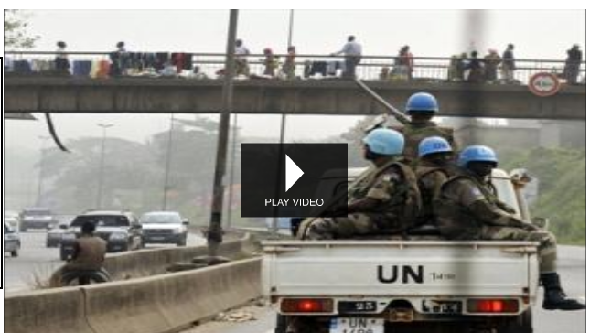
Click to view video online

The UN Security Council ordered more troops to Ivory Coast as African leaders admitted they had failed to get strongman Laurent Gbabgo to handover power.

Gbagbo has ruled the cocoa-rich country for a decade and has rejected pressure to step aside despite losing November presidential elections to Alassane Ouattara, internationally recognised as the new leader.

The UN Security Council ordered 2,000 extra troops to the country after local commanders said they feared clashes with Gbagbo's forces who are laying siege to the Abidjan hotel serving as Ouattara's headquarters.

Gbagbo's troops have surrounded the hotel for weeks and the Security Council insisted the blockade 'be lifted without delay'.

And as the crisis dragged on, UN experts said they feared conditions could be in place for a wave of genocide and crimes against humanity.

African Union mediator Raila Odinga, the prime minister of Kenya, earlier returned empty-handed from a new mission to Abidjan and was told he would not be welcome back.

Odinga said Gbagbo was not even prepared to discuss quitting power and had twice broken a promise to lift the blockade on Ouattara's temporary headquarters.

'Mr Odinga failed in his mission and we are no longer prepared to receive him here in Ivory Coast. We reject Mr Odinga', Gbagbo's foreign minister Alcide Djedje told a press conference.

Odinga launched his second direct mediation attempt in a month in Abidjan on Monday with a proposal for talks between the rivals, in a bid to persuade Gbagbo to step down with the offer of an amnesty and end a seven-week standoff that has left scores dead and raised fears of civil war.

The UN decision to deploy 2,000 extra troops is a response to fears of local UN commanders of a growing showdown with Gbagbo, who has demanded several times that UN forces leave. The new deployment would take the UN force up to about 11,500 troops.

West African regional military chiefs meanwhile met in Mali to put the final touches to an armed intervention plan to remove Gbagbo by force.

'Time is running out for an amicably negotiated settlement,' Odinga warned after arriving in Ghana.

Economic Community of West African States (ECOWAS) commanders see Nigeria at the head of a military intervention force and foresee the deployment of combat troops and attack helicopters, a participant told AFP.

Ouattara, who has called for intervention to oust Gbagbo, said the plan was well-advanced.

He is recognised as winner of the November 28 presidential election by the Ivory Coast's voting authority and the international community.

But Gbagbo has refused all offers to give up the presidency, including exile and immunity from prosecution for crimes against humanity.

'Negotiations suit him, and they're increasingly choking Alassane Ouattara, who remains locked up at his headquarters' at the Golf hotel, said Alioune Tine, head of human rights group RADDHO, speaking from Dakar.

Gilles Yabi of the International Crisis Group agreed: 'It's too early to say whether Gbagbo is winning in this war of attrition but it is clear he's playing for time. This is a strategy he has used in the past.'

Two UN envoys said they were 'gravely concerned' about the risk of genocide, crimes against humanity, war crimes and ethnic cleansing in Ivory Coast.

'We are disturbed by allegations that the armed forces and militia groups that back opposing camps in the current political crisis are recruiting and arming ethnic groups,' said the advisors, Francis Deng and Edward Luck.

'We fear we are on the brink of something that could be very ugly and very destructive but we are not there yet,' Luck said, appealing for restraint.

The Ivory Coast military remains loyal to Gbagbo and a diplomat at the United Nations recently indicated that for military intervention to have any chance of success, ECOWAS would have to line up about 20,000 troops although it only has about 3,500 at its disposal.

Former colonial power France has warned against armed intervention because of the risk of high casualties.

Switzerland applied more pressure on Gbagbo on Wednesday, freezing his assets after similar steps taken by the European Union and the United States.
Copyright Australian News Channel Pty Ltd

