Ivory Coast massacre kills 1,000

By CBC News

2 April 2011
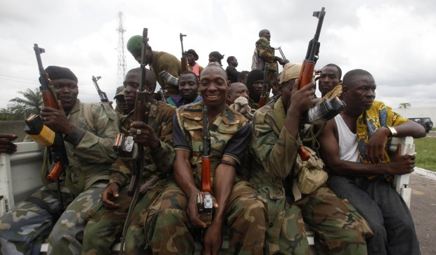
Credit: Emmanuel Braun/Reuters
Forces loyal to Ivory Coast presidential claimant Alassane Ouattara ride on a pickup truck in Abidjan on Thursday.

Soldiers loyal to democratically elected president Alassane Ouattara return from fighting to an operating base near Abidjan on Wednesday. (Rebecca Blackwell/AP)
Soldiers loyal to Alassane Ouattara drive by a checkpoint at one of the principal entrances to Abidjan on Tuesday. (Rebecca Blackwell/Associated Press)
Men captured by forces loyal to Alassane Ouattara sit in a gas station service bay, alongside a checkpoint serving as an operating base at a main entrance to Abidjan, Wednesday. (Rebecca Blackwell/AP)
A civilian, left, travelling with peacekeepers, reacts after finding a friend badly injured by heavy fighting in Abidjan on April 5. (Emmanuel Braun/Reuters)
A tank burns by the roadside after heavy fighting in Ivory Coast's main city Abidjan, Tuesday. (Emmanuel Braun/Reuters)
A soldier loyal to Ivory Coast presidential claimant Alassane Ouattara joins a firefight in Abidjan on April 4. (Emmanuel Braun/Reuters)
Pro-Ouattara fighters prepare for the so-called final assault in front of the Golf Hotel in Abidjan on April 5. (STR/AFP/Getty)
Fire and smoke billow from the Akouedo military camp in Abidjan on April 4, after a United Nations helicopter reportedly fired on the camp. (AFP/Getty)
Forces loyal to Ivorian presidential claimant Alassane Ouattara gather outside Abidjan on April 3. (Emmanuel Braun /Reuters)
Pro Ouattara forces rest outside Abidjan on April 3. (Emmanuel Braun/Reuters)
Soldiers of Ivory Coast's rival leaders battled for the presidential palace, military bases and state TV in Abidjan, in a conflict that has killed 800 people in one town alone. (Emmanuel Braun/Reuters)
Forces loyal to UN-recognized president Alassane Ouattara prepare to head to the Ivory Coast main city of Abidjan, April 2, 2011. (Emmanuel Braun/Reuters)
Aid agencies are reporting mass killings in the Ivory Coast city of Duekoue, captured by fighters supporting UN-recognized president Alassane Ouattara this week.
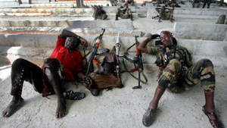
Credit: Emmanuel Braun/Reuters
Forces loyal to presidential claimant Alassane Ouattara rest about 20 kilometres north of Abidjan on Friday.

The Red Cross on Saturday said at least 800 civilians were killed in inter-ethnic violence in a single neighbourhood of the city in recent days, while the Roman Catholic charity Caritas said the number exceeded 1,000.
Red Cross spokeswoman Dorothea Krimitsas said delegates from the Ivorian Red Cross had visited Duekoue on Thursday and Friday to gather evidence and saw a "huge number of bodies."
"We are shocked by the brutality and scale of this act," said Dominique Liengme, head of the International Committee of the Red Cross delegation in the African country.
Caritas spokesman Patrick Nicholson said workers with his agency visited the city on Wednesday. He said they saw victims who died of gunshot and machete wounds.

International recognition
Alassane Ouattara's victory with 54 per cent of the vote in November's election was recognized first by the country's electoral commission and then by the United Nations, which pored over thousands of tally sheets before certifying the results. He has been recognized by governments around the world, and leaders from U.S. President Barack Obama to French President Nicolas Sarkozy have made personal appeals to Laurent Gbagbo to step down.
It's not clear whether the armed group trying to install Ouattara as president was involved.
The mass killing brings the confirmed death toll from violence since the presidential election last November, in which Ouattara was the internationally recognized winner, to 1,300 people.
More than a million people have fled their homes because of fighting between forces loyal to Ouattara and those siding with former president Laurent Gbagbo, who refused to relinquish power and is believed to be still inside the presidential palace in the main city, Abidjan.
Gunfire and explosions continued to ring out near the palace Saturday morning as fighters loyal to Ouattara continued to surround the site. They have been halted at Gbagbo's doorstep by the Republican Guard, Gbagbo's most elite and loyal troops.
However, most of Gbagbo's top military commanders have deserted him and observers say he won't be able to hang on for much longer.
Meanwhile, local youths armed by Gbagbo in anticipation of the rebel attack are now marauding in the streets of Abidjan.
Residents say they are afraid to leave their houses. Stores and homes are being ransacked across the city, though it's unclear whether the looters are acting under orders or simply taking advantage of the power vacuum in the streets.
Copyright 2011 CBC News

