Genocide Watch: Côte d'Ivoire
By Genocide Watch
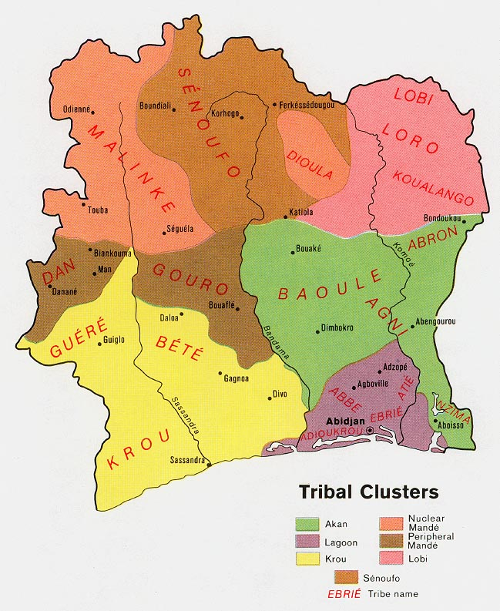
14 February 2012
Although the civil war of 2002 came to an end in 2004, Côte d'Ivoire has ever since been divided between north and south. The split is along religious and ethnic lines. The north is predominantly Muslim and populated by Senufo, Mandé (Malinké, Dan, Gouro, Dioula), and Lobi groups, while the south is majority Christian and populated by Akan (Baoulé, Agni, Abron), Laguné (Ébrié, Adioukrou, Abbé, Atié), and Krou (Krou, Bété, Guéré) groups. These groups lived peacefully together during the Presidency of Félix Houphouët-Boigny from 1960 through 1993, a physician and Baoule chief who later served in the French Parliament, led Cote d’Ivoire’s peaceful move to independence, and maintained an open-border policy toward workers from Mali and Upper Volta (Burkina Faso.) “Le Vieux”, as he was affectionately called, was a master at balancing regional interests within Côte d’Ivoire. He maintained close relations with France. Dr. Alassane Ouattara was Prime Minister 1990 – 1993.
Following Houphouët-Boigny’s death, a policy of “Ivoirisation” was instituted by his successor, Henri Konan Bédié. Distinctions between so called "native" or "pure" Ivoirians (Ivoirité) and immigrants or settlers – even those descended from several generations of immigrants who came from the north, in particular Mali and Burkina Faso (Burkinabés) – caused rising ethnic tensions. Classification of the population was also reflected in inequality in land ownership, with southern groups owning many of the south’s rich cocoa, coffee, and palm oil plantations, while hiring northerners as laborers. In 1995, the tensions turned violent when Burkinabés were killed in plantations during ethnic riots.
This classification had a political impact in the Presidential elections of 1995, when Alassane Ouattara was precluded from running for President because of false charges that he had been born in Burkina Faso (He was actually born in Dimbokro), and that one of his parents was also born in Burkina Faso, violating a new electoral law designed to prevent Ouattara from running. Fully 26 percent of the population in Côte d’Ivoire was descended from Burkinabé immigrants, who were no longer allowed to run for office or even to vote. All opposition parties boycotted the 1995 election and Konan Bédié won.
A military coup ousted Konan Bédié on 24 December 1999. Ouattara returned five days later and hailed Konan Bédié’s ouster as “not a coup d’état,” but “a revolution supported by all the Ivorian people. A new constitution was approved by referendum in July 2000, but it kept the restrictive bar against anyone running for President unless both of their parents were Ivorian born, and Ouattara again was disqualified from the 2000 presidential election. Robert Guéï claimed victory with 33 percent of the vote, but street demonstrations forced him to hand over the Presidency to Laurent Gbagbo, who received 59 percent of the vote.
Ivorian troops from the north mutinied on 19 September 2002. They launched attacks in many cities, including Abidjan, and by midday had taken full control of the northern half of the country. On the first night of the uprising former president Robert Guéï was killed. Alassane Ouattara took refuge in the French Embassy. The French government had been alerted to the probability of ethnic conflict in 2001 when Prévention Génocides, a member of the International Alliance to End Genocide, produced a film about the danger of the Ivoirité ideology, Poudrière Identitaire, (http://www.paperblog.fr/4296290/cote-d-ivoire-poudriere-identitaire-documentaire/) showed it on Ivorian national television, and to French foreign policy makers.
French forces based at Port-Bouët, Côte d’Ivoire quickly intervened and formed a cordon sanitaire between the northern and southern forces. Guillaume Soro led the northern Patriotic Movement of Côte d'Ivoire (MPCI) later to be known as the Forces Nouvelles de Côte d'Ivoire/New Forces, based in Bouake. Southern forces were led by the National Army (FANCI), also called loyalists and The Young Patriots: nationalist groups aligned with President Laurent Gbagbo.
French military forces were sent within the framework of Operation Unicorn and under UN mandate (UNOCI), 3000 men in February 2003 and 4600 in November 2004; and the CEDEAO, White helmets, also came under UN mandate.
Genocidal massacres occurred during the civil war, such as at Duékoué, where 2000 civilians were slaughtered. Many other crimes against humanity were perpetrated by both sides.
A peace agreement finally brought the war to a halt in 2004, but the country remained divided. President Gbagbo was President of the south. Guillaume Soro led the north.
After years of postponement, the presidential elections in October and November 2010 were the trigger leading to another eruption of violence. Incumbent president Laurent Gbagbo was defeated by the opposition leader, Alassane Ouattara, who originates form the north. But Gbagbo refused to give up power and barricaded himself into the Presidential house. This resulted in bloody post-election violence in which at least 3,000 persons died. Atrocities were committed both by the Ivorian army loyal to Gbagbo and the Forces Nouvelles de Côte d'Ivoire –later the Republican Forces– of Ouattara.
Laurent Gbagbo was captured in April 2010. The pre-trial chamber of the International Criminal Court authorized an investigation of the violence in Côte d'Ivoire on October 3, 2011. An arrest warrant for Laurent Gbagbo was issued a few weeks later. He is charged with crimes against humanity, in particular murder, rape and other sexual violence, persecution and other inhuman acts in the context of a widespread or systematic attack directed against the civilian population within the meaning of article 7 of the Rome Statute. He has been extradited to the ICC in the Hague, where he awaits trial.
The prosecutor of the ICC is still investigating the role played by other members of the Gbagbo government as well as members of Ouattara's government.
The crimes that took place in Côte d'Ivoire in the aftermath of the elections may be qualified as genocidal massacres, though they were not a full genocide. The arrest warrant issued by the ICC explicitly mentions that the assaults were often directed at specific ethnic or religious communities – national groups were also targeted, namely migrants from West-African countries. Furthermore, the attacks were the result of an organizational policy of Laurent Gbagbo and his forces. The murders, rapes, persecutions and other inhuman acts were thus committed with the intent to partially destroy ethnical, religious and national groups in the south of the country.
The root causes of the eruption of violence in Cote d’Ivoire have not been resolved, in particular the deeply rooted polarization in Côte d'Ivoire. The establishment of the Dialogue, Truth and Reconciliation Commission represents a welcome but insufficient initiative.
Therefore, Côte d'Ivoire is rightly at stage 5, Polarization, of Genocide Watch's stages of genocide as early warning signs point in the direction of potential genocidal massacres.
- Genocide Watch urges upon the government of Côte d'Ivoire to investigate, prosecute and punish atrocities committed by both sides, including the Duékoué massacre. The Republican Forces of Ouattara need to be vetted, and perpetrators punished.
- Genocide Watch calls upon the government of Côte d'Ivoire to emphasize and develop transcendent national institutions, in education, music, sports, security, and common celebrations of both Muslim and Christian holidays at the community level.
- Genocide Watch recommends that a deep root cause of the tensions be addressed, conflicts relating to land rights and labor rights for plantation workers.
- Above all, the ideology of Ivoirité with its false distinction between "native" and immigrated Ivoirians should be abolished.
Relevant information should be sent to Ivorycoast@genocidewatch.org.

