Harsh lessons from the past hold key to healing
Holly Pham, The Phnom Penh Post
2 July 2009

A new official history textbook which outlines atrocities committed under the Khmer Rouge is designed to help open up conversations and critical thinking.
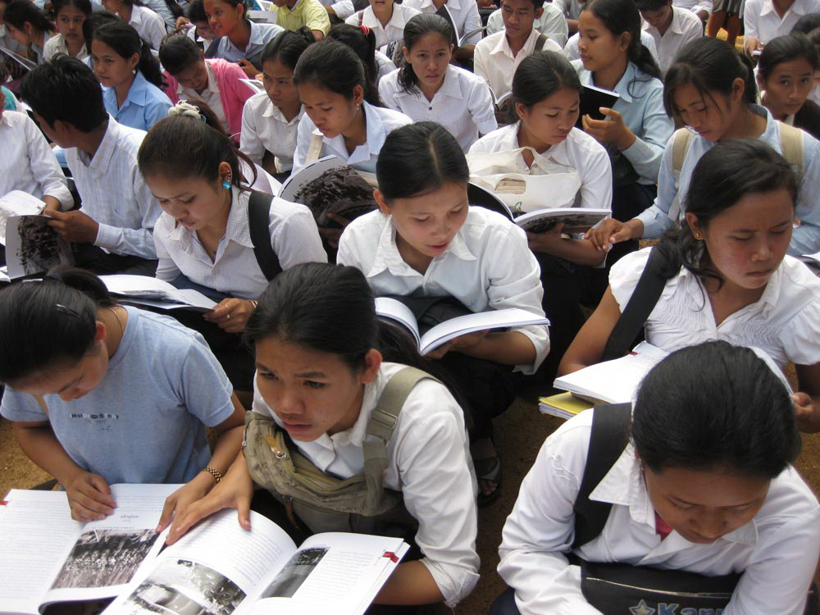
Students peruse their first copies of the school textbook A History of Democratic Kampuchea.

Decades after the fall of the belligerent Khmer Rouge, the Cambodian government is still dragging its feet in educating people about the genocide.

The knowledge gap in education about the genocide drove author Khamboly Dy to write A History of Democratic Kampuchea, Cambodia's latest official history textbook, recently approved by the Ministry of Education.

Understanding the past, however horrendous, is the first step towards restoring humanity and identity of a nation, said Youk Chhang, director of Documentation Center of Cambodia (DC-Cam).

Sharing this belief, 48 Cambodian and international experts have committed to the Genocide Education Project, in collaboration with the Ministry of Education, to teach children in Cambodia the history of Democratic Kampuchea.

"We want Cambodia to get out of the ‘survivor' identity and become educators," Youk Chhang told the Post.

A national conference to train teachers across Cambodia how to teach about the genocide, based on the new history book, is taking place at the Senate Library from Monday to July 7.

The endeavour is a first, yet a crucial one for the nation to move on.

"Only through understanding the past sufferings could we as a nation begin to heal and reconcile," Kamboly Dy said.

The new history book serves to trigger conversations about teachers' and students' own experiences with the genocide. This approach aims to develop students' critical thinking while accommodating personal perceptions and unintended traumas.

"It's so difficult to find a ground that we can all agree on," said Youk Chhang.

"Some of the teachers are survivors, some born after the Khmer Rouge. They perceive this differently. The teachers who lived under the Khmer Rouge tend to be more emotional while the ones born after KR might lack historical understandings.

“We're concerned that that could lead to emotional teaching and perhaps could provoke anger among students who could be children of former Khmer Rouge," he said.

Setting itself apart from the usual chronological approach, the 200-page textbook contextualises Cambodian history through comparative studies with other massacres in modern times: Rwanda, Iraq and the former Yugoslavia.

"We want to help students connect what happened in the past with what's happening in the present," Kamboly Dy said.

The new book also incorporates activities to put its content in perspective, such as active reading, group discussions, guest lectures, theatre arts and field trips. Kamboly Dy said such action-based teaching generates open conversations and develops valuable thinkers.

Compared with 15 years ago, young people tended to come forward more visibly nowadays, according to Youk Chhang.

He said he believed the genocide tribunal plays the key role in facilitating this dynamic.

"The tribunal set a very important foundation to lift this off the ground and it's up to Cambodians to use it," he said. "This project would have been difficult without the tribunal being established in Cambodia."

The international attention cultivated by the Extraordinary Chambers in the Courts of Cambodia has also contributed to a more open society in Cambodia, he said. "Media coverage and open discussions in the past 15 years have warmed up everybody and made people want to be in charge of their own history," he added.

Youk Chhang said the project should become self-sufficient within the next three years.

In the meantime, DC-Cam will maintain its support by providing resources, trainings, monitoring and evaluations.

DC-Cam has published and distributed 1 million copies of A History of Democratic Kampuchea to students from grades 9 to 12 across Cambodia.

A pdf copy is also available online for international readers.

The book has been translated into English, and versions in Chinese, French, Japanese, Thai and Vietnamese are coming up December this year, Kamboly Dy said.

Copyright © 2006-2009 The Phnom Penh Post. All Rights Reserved.

