Tribunal charges Khmer Rouge "First Lady" with genocide
Jared Ferrie
PHNOM PENH
Mon Dec 21, 2009 7:15am EST
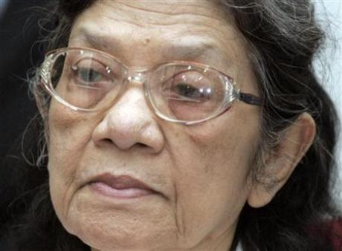

PHNOM PENH (Reuters) - A U.N.-backed Cambodian war crimes court on Monday charged a fourth top Khmer Rouge cadre with genocide, broadening the scope of a long-awaited trial of the ultra-communist "Killing Fields" regime's top ranks.
World
Ieng Thirith, 78, had already been accused of "murder, imprisonment and other inhumane acts" for her role as social affairs minister in a regime blamed for the deaths of 1.7 million people.
The new charges relate to the slaughter of Cambodia's ethnic Vietnamese and Cham Muslim minorities during the 1975-1979 Khmer Rouge era. The tribunal on Monday also charged her with torture and religious persecution.
Ieng Thirith, a former Shakespeare scholar known as the "Khmer Rouge First Lady", was arrested in November 2007 with her 85-year-old husband and ex-foreign minister Ieng Sary.
The French-educated Communist revolutionaries had lived under a government amnesty granted to Ieng Sary in 1996.
They were the closest associates of Pol Pot, the Khmer Rouge leader who died in 1998. Ieng Thirith's sister, Khieu Ponnary, was married to Pol Pot.
The Khmer Rouge-era president, Khieu Samphan, was dealt an additional charge of genocide on Friday. Similar charges of genocide were also issued for "Brother Number Two" Nuon Chea and Ieng Sary last week.
They have also been charged with war crimes and crimes against humanity, along with two other former leaders.
Experts on the Khmer Rouge have been critical of the additional charges, which they said would bog down a trial already criticized for taking too long.
Many of the defendants were in poor health and could die before they see a courtroom, while some cases were already so complex and politicized that they may not even go to trial, the experts said.
The first trial of a senior Khmer Rouge cadre, Kaing Guek Eav, better known as Duch, came to an end three weeks ago. He was accused of overseeing the torture and murder of more than 14,000 people as head of the notorious Tuol Sleng prison.
A verdict in that case is expected by March.
Copyright 2009 Reuters

