Fighting Rages for Second Day in Chad’s Capital
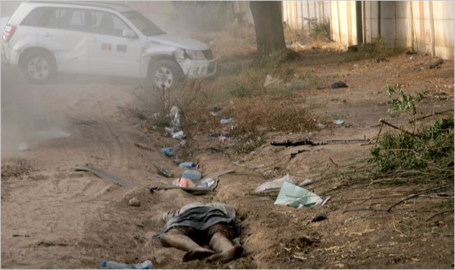
Sonia Rolley/Agence France-Presse — Copyright 2008 Getty Images
The Chadian government fought rebels on Sunday for control of the capital, Ndjamena, where bodies have been left in the streets.
By LYDIA POLGREEN
Published: February 4, 2008
Fighting raged for a second day in the capital of Chad on Sunday, with the government making an all-out attempt to beat back rebels who had overrun the capital on Saturday, Chadian officials said. The country’s president, Idriss Déby, remained defiant in the presidential palace and directed counterattacks, the officials said.
The Chadian military struggled to regain control of the capital, Ndjamena, using tanks and helicopter gunships, officials said. Rebels fought back with automatic weapons, truck-mounted machine guns and artillery, witnesses said. French military officials said there was open fighting across the city, and news agency photos showed bodies in the streets.
On Sunday evening, the interior minister, Mahamat Bashir, said the capital was “entirely under control.”
“The savage mercenaries are fleeing, and our forces of defense and security are at their heels,” he said on Radio France International. “They tried to attack, but they were pushed back with the last energy, and we put them off-track once again.”
Chad’s minister of mines, Gen. Mahamat Ali Abdallah Nassour, said earlier that Chadian rebels and Sudanese forces had attacked the eastern border town of Adré. Speaking on R.F.I., he called the attack a “declaration of war” by Sudan.
A rebel spokesman, Henchi Ordjo, said that Adré had been “liberated” and that rebels had also captured the northern town of Faya Largeau, Reuters reported.
Another rebel spokesman, Abderaman Koulamallah, said that Mr. Déby was trapped at his presidential palace, surrounded by tanks and armored vehicles, and that the rebels controlled the rest of the capital after two days of fierce fighting, The Associated Press reported.
Neither rebel claim was able to be independently verified.
Diplomats and analysts in the region worried that the escalating violence could lead to a civil war in Chad and a war between Chad and Sudan. Either possibility would be devastating to a region that was already suffering one of the world’s gravest humanitarian crises, with more than 2.5 million Sudanese and Chadians displaced by the conflict in Darfur and its reverberations in Chad.
“It is a very tense moment, and nobody knows how this will play out,” said David Buchbinder, a researcher for Human Rights Watch who specializes on Chad.
The French military evacuated more than 500 foreigners from Ndjamena, flying them to Libreville, Gabon, and it provided protection to the American ambassador, Louis J. Nigro Jr., and the German ambassador, Helmut Rausch, a French Foreign Ministry spokesman said. The State Department reported Sunday evening that the American Embassy had “sustained indirect fire,” but there were no reports of American casualties. Karl Duckworth, a spokesman, said that all American officials had been accounted for and that 100 had been evacuated.
Mr. Nigro and a small staff remained at the airport to help Americans leave, he said.
About 1,000 foreigners remained in Ndjamena, several hundred of them at five French military camps and the rest at their homes, according to French officials.
Thousands of Chadians have fled to neighboring Cameroon, crossing the Chari River in cars and on foot, Chadian officials said.
The French government said that Mr. Déby planned to remain in the capital, and that there had been no discussion with French officials about evacuating him.
With telephone lines down in the capital and state radio off the air, little concrete information was available about the state of battle. Reports trickled out from aid workers and witnesses using satellite phones, French military officials in communication with their forces in the country and government and rebel officials speaking outside of the country.
“Small arms continue to fill the air with sounds of battle,” wrote an American aid worker, Gabriel Stauring, who was trapped in Le Méridien Chari hotel, on a blog updated via satellite phone. “Every so often we can hear a helicopter and then their guns firing upon the rebels who have now taken almost the entire city.”
A French national who had been evacuated told R.F.I. that “things shook, there were a lot of shots, bullets whizzing by.”
French officials said the fighting eased after dark on Sunday, as it had the previous night. They said the number of casualties among Chadian troops, rebels and civilians was unclear.
Fighting has prevented many people from getting to hospitals, and a cellphone blackout has made getting casualty estimates all but impossible. Several civilian targets have come under attack, including Le Méridien in Ndjamena, where about 50 foreigners were extricated by French soldiers and taken to a military base to be evacuated.
The aid group Doctors Without Borders said that it had treated 50 wounded people in the past two days, mostly civilians, and that the Chadian Red Cross had sent 150 more victims to other hospitals in the capital.
In El Fasher, Sudan, the United Nations Special Representative for Darfur, Rodolphe Adada, said in a statement that aid workers in the region had been attacked and that the attacks had “led to the crippling of humanitarian activities” there. He said that most of the United Nations staff had been evacuated from the town of Guéréda in eastern Chad.
Mahamat Assileck, a spokesman in Paris for the Union of Forces for Democracy and Development, one of the three rebel groups, told Agence France-Presse on Sunday that the fighters planned to attack the Ndjamena airport within the next 24 hours.
President Nicolas Sarkozy of France, which has colonial ties to Chad, said the 1,500 French troops in Chad were not taking part in the fighting, although the Chadian government said French forces protecting the airport allowed it to be used as a base for Chadian helicopters.
In Brussels, European Union officials decided Sunday to delay sending a peacekeeping force to Chad. Last month, the union said it would send 3,700 troops to Adré to protect civilians from the violence spreading from Darfur.
The United Nations secretary general, Ban Ki-moon, called for an immediate cessation of hostilities and said in a statement that he was “profoundly alarmed by the dangerous situation in Chad.”
Eric Pfanner contributed reporting from London, Basil Katz from Paris, and Ginger Thompson from Washington.
Copyright 2008 The New York Times Company

