Thousands Flee Fighting in Chad’s Capital
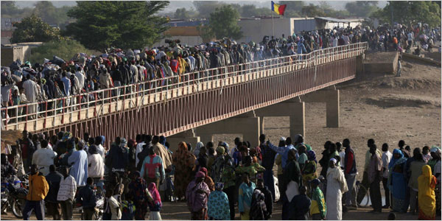
Emmanuel Braun/Reuters Chadians escaped into Cameroon fleeing fighting in Ndjamena.

By LYDIA POLGREEN and NICK CUMMING-BRUCE
The New York Times
February 5, 2008
NDJAMENA, Chad — Shelling and small arms fire erupted here in this capital on Monday, the third day of fighting between government troops and rebel forces, as thousands of residents fled the city in fear, the United Nations said.
The Security Council demanded an immediate end to the violence, urging nations in the region on Monday to help thwart the rebels’ “attempt to seize power by force.”
The fighting has raised the specter of deeper chaos in one the most war-scarred and fragile regions of the world. United Nations officials are particularly worried that the instability in Ndjamena could threaten major relief efforts elsewhere in the country.
Chad has become a temporary home to nearly a quarter of a million refugees from the conflict in the Sudanese region of Darfur, and tens of thousands more refugees from the Central African Republic, according to the United Nations.
Beyond that, almost 200,000 Chadians have been displaced by fighting, much of which has spilled into the country from Darfur, making for a vast pool of desperate people who depend heavily on international aid.
“They are at the end of a very tenuous aid lifeline that flows through Ndjamena,” said Ron Redmond, a spokesman for the United Nations High Commission for Refugees. “We are extremely concerned about the impact on that aid pipeline of extended instability.”
A rebel army intent on deposing President Idriss Déby entered Ndjamena on Saturday, after days of battle a few dozen miles outside the city. The government has fought back in an all-out attempt to defeat the rebels, a coalition of three groups that have taken shelter in Sudan for the past few years.
The government had earlier claimed that it had beaten back the rebels and that they had withdrawn from Ndjamena. The rebels said they had made a strategic retreat to allow civilians to flee. Fighting resumed Monday.
As gun battles have erupted around the presidential palace and across the city, the Chadian military has struggled to regain control of Ndjamena, using tanks and helicopter gunships, officials said. The rebels have fought back with automatic weapons, truck-mounted machine guns and artillery, witnesses said.
The United Nations refugee agency evacuated most of its non-local staff from Ndjamena to neighboring Cameroon over the weekend on flights operated by the French military. On Monday, the United Nations High Commission for Refugees said that its staff was reporting that the situation in Ndjamena was now too dangerous for civilians to move about the city.
Doctors Without Borders said in a statement Monday that it had treated 70 wounded people in the capital over the weekend, but the group noted that many hundreds of other wounded people were reported to be in other hospitals in the city.
The group also said that it had been unable to reach many hospitals since roads were being blocked by the “masses of people” fleeing the city. It estimated the number of refugees in the tens of thousands.
Ndjamena residents fleeing the city were pouring into Cameroon, Mr. Redmond said, adding that United Nations workers were headed to Kousseri, a town in Cameroon linked by bridge across the Chari River to Ndjamena, to prepare for the arrival of more refugees.
The Cameroon Red Cross has opened a former transit center to receive refugees in Kousseri, and the United Nations agency will reopen a field office there, Mr. Redmond said.
The United Nations agency had sent two truckloads of supplies from Cameroon’s capital, Yaoundé, to Kousseri but they will take at least two days to make the journey of more than 600 miles, Mr. Redmond said.
Tensions have long been high between Chad and Sudan, which share a porous border along the war-ravaged region of Darfur. Chad accuses Sudan of arming rebels seeking to overthrow Mr. Déby, who has ruled Chad since he took over in a military putsch in 1990.
Sudan, meanwhile, accuses Chad of harboring and helping the Sudanese rebels who have been fighting the government and its allied militias in Darfur, a conflict that has killed at least 200,000 people and displaced more than two million.
The latest violence in Chad has forced the postponement of the deployment of a 3,700-member European Union force aimed at stabilizing the tense borders between Chad, Sudan and the Central African Republic.
Chad is one of Africa’s most unstable nations, its history a litany of military coups, foreign incursions and brutal dictatorship. Mr. Déby seized power from Hissène Habré, who is believed to have tortured and killed tens of thousands of people during his eight-year rule.
Mr. Déby planned his insurgency while living in Darfur, just as Mr. Habré before him seized power from a base in Darfur.
Mr. Déby was re-elected president in 2006 after pushing through a constitutional amendment to lift a two-term limit. Opposition politicians boycotted the election.
Several rebel movements are seeking to push Mr. Déby from power. One of them is led by Timane Erdimi, a nephew of Mr. Déby.
Lydia Polgreen reported from Ndjamena and Nick Cumming-Bruce from Geneva. Graham Bowley contributed reporting from New York, and Warren Hoge from the United Nations.
Copyright 2008 The New York Times Company

