May 18, 2008
Op-Ed Columnist

Fed Up With Peace
By NICHOLAS D. KRISTOF
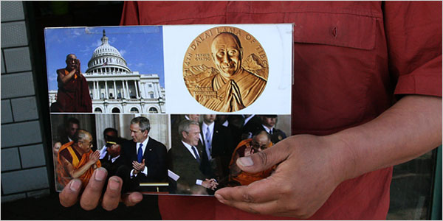
Nicholas D. Kristof/The New York Times
A herdsman showed a treasured, though illegal, photo of President Bush meeting the Dalai Lama.
XIAHE, China
A Tibetan monk, recently out of jail and still in pain from beatings by the police, said he reveres the Dalai Lama but also regards him as a political failure.
“We think the Dalai Lama has been too peaceful,” he said. “There is a big discussion now about whether we should turn to violence.”
Another monk at Labrang Monastery here in Xiahe on the Tibetan plateau put it this way: “For 50 years, the Dalai Lama said to use peaceful means to solve the problems, and that achieved nothing. China just criticizes him.”
“After he’s gone,” the monk added, “there definitely will be violent resistance.”
This impatience seems widespread among young Tibetans, and the rioting and protests across ethnic Tibetan areas of China in the last couple of months may be a turning point. Unless the Tibet question is resolved, we may see a Tibetan equivalent of the Irish Republican Army or Hamas.
A harsh crackdown is under way in greater Tibet, as I found when I slipped into these Tibetan areas in the back of a car with local license plates. China’s heavy hand is adding to the antagonisms: the authorities are beating monks, confiscating pictures of the Dalai Lama, and forcing monks to attend “patriotic study” classes — up to two hours a day, six days a week — full of propaganda praising the Communist Party and denouncing the Dalai Lama.
“That just turns us against China more than ever,” one monk said.
The gulf between Tibetans and the Han Chinese ethnic majority has never been greater. The television images of Tibetans in Lhasa attacking Chinese civilians — devoid of any context of decades of repression — left many Chinese more hard-line than the Communist Party.
“Most of us think that the policy toward Tibetans has been too soft,” said a Han Chinese man in Qinghai Province who often travels in Tibetan areas. “They get all kinds of special preferences, but they’re just not as hard-working, and they drink too much. And then after we help them so much, they riot against us. So most of us think the policy toward Tibetans should be stricter.”
The recent uprising by Tibetans underscores the utter failure of Beijing’s policies in Tibet. But it also reflects the failure of the Dalai Lama and of America.
The Dalai Lama has played a waiting game, but as China gains global power — and as more Han Chinese flood into Tibet — that has been a losing strategy. The Dalai Lama has won acclaim internationally, but that acclaim triggers the deep Chinese sensitivity to foreign bullying and thus has antagonized the audience that may count the most: China.
The Dalai Lama missed opportunities by neglecting outreach by General Secretary Hu Yaobang in 1981, by spurning an invitation to China in 1989 and by announcing the choice of the Panchen Lama in a way that Beijing felt insulting. When the Dalai Lama and those around him refer to “genocide” or claim roughly one-quarter of China as Tibet, they undercut Chinese moderates.
As for the United States, it may have made things worse. Melvyn Goldstein of Case Western Reserve University, whose book “The Snow Lion and the Dragon” remains the best introduction to Tibet, writes that the United States has hurt the interests of Tibetans: its symbolic gestures have encouraged unrealistic Tibetan dreams of independence, and Washington has neglected the serious diplomatic work — both with China and with the Dalai Lama — that might actually improve the lives of Tibetans.
Both China and the Dalai Lama exaggerate, and the historical evidence about Tibet is contradictory. One can make a good case that Tibet has been a part of China at least since 1720. One can also make a good case that Tibet became independent around 1911. The evidence is simply mixed.
A deal to resolve the Tibet question is still attainable. The Dalai Lama would have to put aside claims to vast areas outside the present “Tibet Autonomous Region,” and he would have to accept much less political autonomy than he wants. China would have to ease religious controls and allow the Dalai Lama to return as a spiritual leader. Most important, Beijing would have to end Han Chinese migration to all Tibetan areas, to preserve their Tibetan character.
The upshot would be a Tibet that would be under China’s thumb, but with greater religious freedom — and with real hope of remaining authentically Tibetan through this century. And China would improve its international image and avoid the risk of Tibetan terrorism.
President Bush would do far more for the Tibetan people if, instead of just being photographed with the Dalai Lama, he assigned a top-notch diplomat like Christopher Hill to explore such a compromise.
Time is running out, however, for at this rate, Shangri-La may become a breeding ground for terrorists.
Copyright 2008 The New York Times Company

