July 8, 2009

Clashes in China Shed Light on Ethnic Divide
By EDWARD WONG
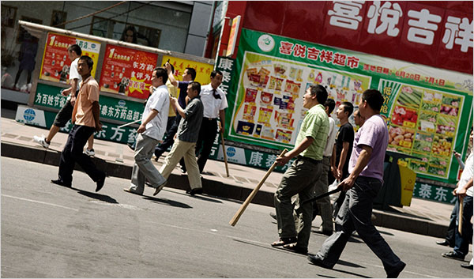
Gilles Sabrie for The New York Times
Han Chinese men armed with sticks walked toward a Uighur neighborhood in Urumqi on Tuesday
URUMQI, China — Some women glared through their black veils at the paramilitary troops encircling them. Others held identity cards of missing relatives in the air. Fists raised, tears in their eyes, they demanded the release of sons and husbands seized by the police after Muslim Uighurs rioted in this western regional capital days earlier.
And as the group of several hundred Uighur women beseeched journalists on a government-sponsored tour here on Tuesday, they gave voice to broader concerns at the heart of the deadliest ethnic violence to strike China in decades.
“They don’t respect our lifestyle,” said one woman, a 26-year-old who gave her name as Guli. “We want our dignity. We just want fairness, and we want equality.”
A wide variety of government policies here in the western desert region of Xinjiang, a lightly populated area that covers about a sixth of China’s total landmass, has for years led many of the area’s 10 million Uighurs to believe their culture and livelihoods were under assault by the Han Chinese, the dominant ethnic group in China, according to local residents, foreign scholars and recent studies of the area.
The policies include limits on religious practice, the phasing out of Uighur-language instruction in schools and the reinforcement of better economic opportunities for the Han, from businesspeople to migrant workers.
Uighurs are the largest ethnic group in Xinjiang, but Han migration, encouraged in part by government incentives, is quickly changing the demographics here: census figures show that Han made up 40 percent of the population in 2000, a huge leap over the 6 percent in 1949. Under the Chinese Communist Party, Han have always held the power in Xinjiang. Wang Lequan, the party secretary of the region, is a Han whose hard-line policies have inspired systems of control in other ethnic minority regions of China, including Tibet.
“Fundamentally, the relationship between Uighur and Han is one of colonized to colonizer,” said Nicholas Bequelin, a China researcher at Human Rights Watch who has written about policies in Xinjiang.
That dynamic may have laid the foundation for the riot on Sunday in which 156 people were killed and more than 1,000 injured when angry Uighurs attacked Han civilians and battled with security forces across the city. Government officials declined Tuesday to give an ethnic breakdown of the dead. The riot began as a protest over government handling of a brawl between Uighur and Han factory workers in southern China.
On Tuesday afternoon, thousands of Han Chinese armed with sticks, shovels, pipes and meat cleavers tried to march to the Uighur quarter to exact revenge for those Han civilians who were killed on Sunday. Paramilitary troops fired tear gas at the mob, but not before the first wave got into a brick-throwing battle with Uighurs perched on rooftops near Erdaoqiao Market, where the rioting began on Sunday.
Many Han Chinese say the Uighurs, like China’s 55 other ethnic minorities, actually enjoy generous advantages under government policies. Uighur women, for example, can give birth to more than one child without having to pay a fine, unlike the Han. Uighur students have extra points added to their scores when taking the standardized tests that determine university placement.
But on issues that go to the heart of Uighur identity, the government takes a strict line, many Uighurs say.
The vast majority of Uighurs are Sunni Muslims, but the practice of Islam is tightly circumscribed. Government workers are not allowed to practice the religion. Imams cannot teach the Koran in private, and study of Arabic is allowed only at designated government schools. Two of Islam’s five pillars — the sacred fasting month of Ramadan and the pilgrimage to Mecca, the hajj — are also closely managed: students and government workers are compelled to eat during Ramadan, and passports of Uighurs have been confiscated to force them to join official hajj tours.
Three years ago, in its annual report on international religious freedom, the State Department singled out Xinjiang for criticism in a section on China: “Officials in the Xinjiang Uighur Autonomous Region tightly controlled religious activity, while elsewhere in the country, Muslims enjoyed greater religious freedom,” the report said.
On Tuesday, Abudurehepu, a religious leader in Xinjiang who supports the government, said at a news conference here that “our religious freedom is respected,” noting that Xinjiang had more than 2,000 mosques.
He also said that “the party and the government have been doing very well on ethnic policy, like having Uighur kids going to Uighur-language schools.”
In fact, the government is phasing out the use of the Uighur language in schools. Many Uighur parents know the importance of having their children learn Mandarin Chinese, but they are upset over the disappearance of their native language from the education system. There are some bilingual schools, but those generally relegate the Uighur language to a marginal role.
A 2009 Amnesty International report on threats to Uighur identity charts the recent history of the erosion of the Uighur language in education, beginning with a policy in the 1990s that eliminated Uighur as a language of instruction at the university level. Today, at Xinjiang University in Urumqi, only Uighur poetry classes are taught in Uighur, the report says. In 2006, the government began carrying out policies that make Chinese the main language of preschool instruction.
Since the central government adopted a “develop the west” campaign in the past decade, Xinjiang’s economy has grown quickly, and living standards on the whole have risen. But many Uighurs complain about high unemployment and the growing income gap with Han Chinese, who control the largest industries in Xinjiang: oil, agriculture and construction. They give many more contracts and jobs to other Han.
“Uighurs feel cut out of this process,” said a former resident of Kashgar, an oasis town near China’s western border where more than 200 protesters gathered on Monday.
The bingtuan, vast farms started by the military in the 1950s to employ demobilized troops, are among Xinjiang’s biggest moneymakers. But Mr. Bequelin, the human rights researcher, said more than 90 percent of employees at bingtuan were Han.
Chinese officials deny that government policies contribute to ethnic unrest. They place blame for the tensions on outside figures like the Dalai Lama or, in the case of the latest Xinjiang riots, Rebiya Kadeer, a Uighur businesswoman and former political prisoner who lives in Washington.
On Tuesday, as thousands of Han armed with makeshift weapons tried to attack the Uighur quarter, the party secretary of Urumqi climbed atop a car and pleaded with them to go home.
“Strike down Rebiya!” yelled the official, Li Zhi.
Jonathan Ansfield contributed reporting from Beijing. Huang Yuanxi contributed research.
Copyright 2009 The New York Times Company

