July 9, 2009

Exile in the U.S. Becomes Face of Uighurs
By ERIK ECKHOLM
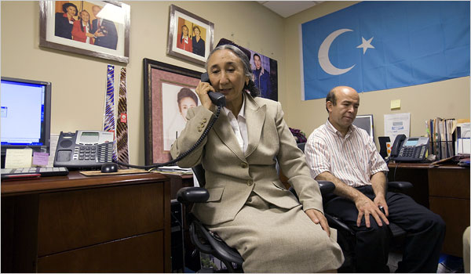
Stephen Crowley/The New York Times
Rebiya Kadeer, a Uighur exile leader, in her Washington office Tuesday with Omar Kanat of the Uighur American Association.
WASHINGTON — As the global face of resistance to what she calls the worsening Chinese repression of the Uighurs, Rebiya Kadeer is displaying the tenacity and sense of destiny that drove her improbable climb inside China in decades past, from laundry girl to famed business mogul.
The Beijing government that hailed her as a model citizen in the 1990s, before imprisoning her for stealing state secrets and sending her into exile in the United States in 2005, vilifies her as the unseen hand behind protests that erupted Sunday in the Uighur homeland of western China.
“All the difficulties in my life prepared me for the tough times we face now,” said the woman, who is happy to be called the “Mother of the Uighurs,” in an interview on Tuesday.
In a plain wool suit and a traditional Uighur cap topping waist-length pigtails, Ms. Kadeer, 62, veered from impish humor and warmth — she leapt to pump the hand of a reporter who described visiting her childhood town — to intense, hand-waving condemnations of Chinese perfidy.
The walls of her small office in downtown Washington are covered with photographs of meetings with President George W. Bush and Laura Bush, and pictures of several of her 11 children, two of whom are now in prison in China. They were sentenced to long terms after she came to the United States and resumed work for Uighur rights.
The week’s events have catapulted Ms. Kadeer to a new level of global recognition, a prominence that seems belied by the few modest rooms here where she and a few aides press their cause with telephones, the Internet and passion.
This week, several office and personal phones rang incessantly, with reporters from around the world seeking a word. Still, it became clear that the Uighurs, long downtrodden and little known in the West, enjoy little of the glamour of their neighbors, the Tibetans. When Ms. Kadeer led a march to the Chinese Embassy on Tuesday, no more than several dozen supporters, mainly fellow exiles, showed up.
If she was disappointed, she gave no sign. In the interview and in her autobiography, “Dragon Fighter,” which came out this year, Ms. Kadeer described her survival through famine, persecution during Mao’s Cultural Revolution and then — as she threw herself into black-market trading of cloth, underwear and other items — the repeated seizure of her goods and money by corrupt or overzealous officials.
She claims that she had, from the beginning, an irrepressible devotion to Uighur self-determination. In her eyes, even her start in life brought an omen. Money and luck were running out in the mining settlement where her father hoped to strike it rich, she wrote, in a story that may be too good to investigate.
In accordance with tradition, her father went to bury the bloody birth linens. As he dug a hole, he suddenly shouted, “Gold!” From that moment on, she wrote, her parents said, “You don’t belong to us; you belong to the people.”
What is indisputable is that from early on she was a determined and shrewd businesswoman willing to sell goods from a sack at the side of the road when necessary, buying and selling thousands of sheepskins or logs when she saw the chance. As China’s economy opened up in the 1980s, she expanded into real estate and flourished. By the 1990s she was running trading companies all over Central Asia, had built a famous women’s bazaar and then a seven-story department store in Urumqi, the capital of the region of Xinjiang, and ran a charity for Uighur women.
Her career had personal costs. In an unthinkable violation of Uighur custom, and angering her relatives, she traveled for months at a time, leaving young children with a working husband or relatives. “Of course it was difficult for me as a woman to leave my children,” she said. “But I found out that money is very important to the destiny of a nation, and I decided to find that money.”
Five of her children are now in the United States, and have been working computers and phones night and day this week, she said. Another five, including the two in prison, remain in China, and one lives in Australia.
In the mid-1990s, as Chinese officials heralded her as an example of ethnic success and even made her a member of the national legislature, she tried to work for change and never lost sight of her political dream, Ms. Kadeer said.
“I was sincere in my interactions with the Chinese government. I was hoping to solve the problems of the Uighurs,” she said. “I still believe we can solve the problems.”
But she started speaking out about Uighur grievances and she kept ties with her husband, by then a dissident living in the United States. In 1999 she was imprisoned.
Ms. Kadeer dismisses Beijing’s charge that she planned last Sunday’s protests.
She is more than happy, however, to tell how she and the two organizations she heads, the Uighur American Association and the World Uighur Congress, both of which receive financial support from the National Endowment for Democracy, mobilized exile groups around the world to protest an episode in Guangdong Province in late June.
Chinese officials say that two Uighur workers were killed by a small group of Han Chinese, who have been detained; Ms. Kadeer says, with evident sincerity, there is evidence that a mob killed up to 60 Uighurs while the police did nothing. But her version has not been independently verified, and Chinese authorities accuse exiles of exaggerating the matter to incite anti-Chinese feelings.
The world congress, based in Munich, has just one paid staff member but is in touch with some 51 exile groups around the world. Ms. Kadeer said that by June 30 she had called all of those groups to encourage demonstrations outside Chinese embassies.
The rumors about mass killings in Guangdong were one trigger for Sunday’s protests, but Ms. Kadeer challenged Beijing authorities to release the transcript of a call she made to a brother in Urumqi on Saturday in which, she said, she urged him not to become involved in any demonstrations.
“Instead of blaming me, the Chinese government should start listening to the complaints of the Uighur people and choose dialogue,” Ms. Kadeer said.
Her fame and force of personality have given the Uighurs a huge lift, but some exiles wonder about her domination and future leadership.
“I’ve been looking for someone like me who can take over,” she said on Tuesday. For now, she said, “The people will not let me stop because my goal is their liberation.”
“Until I lose my consciousness, I’ll stay on as the leader.”
Copyright 2009 The New York Times Company

