July 20, 2009

Countering Riots, China Rounds Up Hundreds
By ANDREW JACOBS
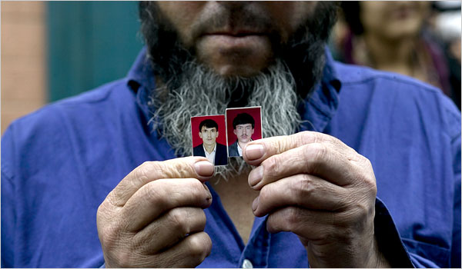
Katharina Hesse for The New York Times
Nurmen Met held photographs of his sons, 19 and 21, who he said had been taken by riot officers as they entered the public bathhouse his family owns.
URUMQI, China — The two boys were seized while kneading dough at a sidewalk bakery.
The livery driver went out to get a drink of water and did not come home.
Tuer Shunjal, a vegetable vendor, was bundled off with four of his neighbors when he made the mistake of peering out from a hallway bathroom during a police sweep of his building. “They threw a shirt over his head and led him away without saying a word,” said his wife, Resuangul.
In the two weeks since ethnic riots tore through Urumqi, the regional capital of Xinjiang, killing more than 190 people and injuring more than 1,700, security forces have been combing the city and detaining hundreds of people, many of them Uighur men whom the authorities blame for much of the slaughter.
The Chinese government has promised harsh punishment for those who had a hand in the violence, which erupted July 5 after a rally by ethnic Uighurs angry over the murder of two factory workers in a distant province. First came the packs of young Uighurs, then the Han Chinese mobs seeking revenge.
“To those who have committed crimes with cruel means, we will execute them,” Li Zhi, the top Communist Party official in Urumqi, said July 8.
The vow, broadcast repeatedly, has struck fear into Xiangyang Po, a grimy quarter of the city dominated by Uighurs, Turkic-speaking Muslims who have often had an uneasy relationship with China’s Han majority. Uighurs are the largest ethnic group in Xinjiang, but in Urumqi, Han make up more than 70 percent of the 2.3 million residents.
It was here on the streets of Xiangyang Po, amid the densely packed tenements and stalls selling thick noodles and lamb kebabs, that many Han were killed. As young Uighur men marauded through the streets, residents huddled inside their homes or shops, they said; others claim they gave refuge to Han neighbors.
“It was horrible for everyone,” said Leitipa Yusufajan, 40, who spent the night cowering at the back of her grocery store with her 10-year-old daughter. “The rioters were not from here. Our people would not behave so brutally.”
But to security officials, the neighborhood has long been a haven for those bent on violently cleaving Xinjiang, a northwest region, from China. Last year, during a raid on an apartment, the authorities fatally shot two men they said were part of a terrorist group making homemade explosives. Last Monday, police officers killed two men and wounded a third, the authorities said, after the men tried to attack officers on patrol.
“This is not a safe place,” said Mao Daqing, the local police chief.
Local residents disagree, saying the neighborhood is made up of poor but law-abiding people, most of them farmers who came to Urumqi seeking a slice of the city’s prosperity. Interviews with two dozen people showed vehement condemnation of the rioters. “Those people are nothing but human trash,” one man said, spitting on the ground.
Still, the police response has been indiscriminate, they said. Nurmen Met, 54, said his two sons, 19 and 21, were nabbed as riot officers entered the public bathhouse his family owns. “They weren’t even outside on the day of the troubles,” he said, holding up photos of his sons. “They are good, honest boys.”
Many people said they feared that their family members might be swallowed up by a penal system that is vast and notoriously opaque. Last year, in the months leading to the Beijing Olympics, the authorities arrested and tried more than 1,100 people in Xinjiang during a campaign against what they called “religious extremists and separatists.”
Shortly after the arrests, Wang Lequan, the region’s Communist Party secretary, described the crackdown as a “life and death” struggle.
Uighur exile groups and human rights advocates say the government sometimes uses such charges to silence those who press for greater religious and political freedoms. Trials, they say, are often cursory. “Justice is pretty rough in Xinjiang,” said James Seymour, a senior research fellow at the Chinese University of Hong Kong.
In a sign of the sensitivities surrounding the unrest, the Bureau for Legal Affairs in Beijing has warned lawyers to stay away from cases in Xinjiang, suggesting that those who assist anyone accused of rioting pose a threat to national unity. Officials on Friday shut down the Open Constitution Initiative, a consortium of volunteer lawyers who have taken on cases that challenge the government and other powerful interests. Separately, the bureau canceled the licenses of 53 lawyers, some of whom had offered to help Tibetans accused of rioting last year in Lhasa, the capital of Tibet.
Rights advocates say that if the trials in Xinjiang resemble those that took place in Tibet, many defendants will receive long sentences. “There is a lot of concern that those who have been detained in Xinjiang will not get a fair trial,” said Wang Songlian, a research coordinator at Chinese Human Rights Defenders, an advocacy group.
Residents of Xiangyang Po say police officers made two morning sweeps through the neighborhood after the rioting began, randomly grabbing boys as young as 16. That spurred a crowd of anguished women to march to the center of Urumqi to demand the men’s release.
But none of the detainees has come home, the residents say, and the authorities have refused to provide information about their whereabouts.
“I go to the police station every day, but they just tell me to be patient and wait,” said Patiguli Palachi, whose husband, an electronics repairman, was taken in his pajamas with four other occupants of their courtyard house. Ms. Palachi said they might have been detained because a Han man was killed outside their building, but she insisted that her husband was not involved. “We were hiding inside at the time, terrified like everyone else,” she said.
Although it was impossible to verify the accounts of the residents, as Ms. Palachi spoke, more than 10 people gathered to share similar accounts.
Emboldened by the presence of foreign journalists, the group decided to walk to the local police station to confront the police again. “Maybe if you are with us, they will give an answer,” said Memet Banjia, a vegetable seller looking for his son. “Probably they will say nothing and the next day we will disappear, too.”
But the meeting with the police was not to be. As the residents approached the station house, a squad car roared up and the crowd melted away. The foreigners were ordered into the car and driven to the station house. After an hour’s wait, a pair of high-ranking security officials arrived with a lecture and a warning.
“You can’t be here; it’s too unsafe,” one of them said as he drove the foreigners back to the heavily patrolled center of the city. “It’s for your own good.”
Zhang Jing contributed research.
Copyright 2009 The New York Times Company

