July 23, 2009

China Fears Ethnic Strife Could Agitate Uighur Oasis
By ANDREW JACOBS
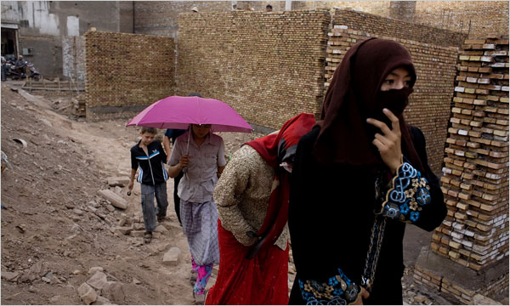
Alan Chin for The New York Times
The oldest section of Kashgar, in the Xinjiang region of western China, is the heart of Uighur culture, but it is being razed for modernization projects.
KASHGAR, China — Ali the tour guide seemed nice enough and his English flowed with grammatical perfection — a useful attribute in a city where most people speak a Turkic language that sounds nothing like Chinese.
“Sure, I will take you wherever you want to go, but first I have to call my friend and see if he will drive us,” Ali said, turning away. After a quick exchange, he hung up the phone and politely announced that his friend was actually a government minder who would soon be arriving to guide the would-be clients away from any potential trouble.
The destination his “friend” had in mind? The airport, where the reporters, subject to a ban on foreign journalists, would be escorted onto the next flight out of town.
“Sorry,” Ali said as the journalists prepared to flee in a taxi. “But if I didn’t make that call, I would get in big trouble.”
Kashgar, the ancient Silk Road oasis and backpacker lure, has been besieged by fear since ethnic rioting about two weeks ago claimed at least 197 lives in Urumqi, the capital of this northwestern expanse known as the Xinjiang Uighur Autonomous Region. Although the two cities are separated by about 700 miles of punishing desert and snow-draped mountains, the authorities are especially anxious about potential unrest in Kashgar, a city of 3.4 million that is 90 percent Uighur, a Muslim minority that has long had a mercurial relationship with the Han Chinese who govern Xinjiang.
The authorities have good reason to be skittish. Last August, at least 16 military police officers were killed in an attack here, unnerving the government just as dignitaries and athletes were arriving in Beijing for the 2008 Olympics. The police called it a terrorist strike by two Uighur men armed with explosives and machetes, though some witnesses later challenged that version of events.
In the early 1990s, Kashgar was also the scene of bombings and demonstrations; at least 21 people were killed and thousands were arrested during one particular army crackdown. The city has long been a crucible for Uighur self-determination, even if nationalist aspirations were never the same after a Chinese warlord vanquished the newborn East Turkestan Republic, a short-lived nation that called Kashgar its capital for a few months in 1933.
Although it is rapidly being bulldozed in the name of modernization, Old Kashgar and its ancient dusty warrens remain the heart of Uighur culture and a beguiling draw for tourists. To China’s leadership, however, the city is also an incubator for those seeking to create a Uighur homeland by the borders of Pakistan, Afghanistan and a handful of other predominantly Muslim countries whose names end with “stan.”
This time around, Kashgar has been relatively quiet. During the turmoil in Urumqi, a crowd of 200 people tried to protest outside the city’s Id Kah Mosque, the largest in China, and were quickly dispersed by the police.
But while journalists in Urumqi can roam with relative freedom, the few foreign reporters who made it to Kashgar were promptly hustled out of town.
“The situation may look calm now, but it could change at any second,” a local government official told Mark MacKinnon, a writer for The Globe and Mail, a Canadian newspaper, as he and his colleagues were sent to the airport.
The uncertainty and sense of isolation have been only magnified by the blocking of access to the Internet and shutdown of text messaging and international phone service that has severed communications in Kashgar and the entire region. The blackout has been especially challenging for export companies, banks, factory owners and academics, and some of them say they have been told that Internet and phone service will be curtailed until at least October, when China celebrates the 60th anniversary of the Communist revolution.
“I’m expecting a group of Swiss tourists next week, but I have no way of knowing whether they’re still coming,” said one beleaguered tour operator.
Like Urumqi, which has been flooded with soldiers since July 5, Kashgar is patrolled by young men in military camouflage, many of whom ride through the city day and night, their green army trucks draped with ostensibly calming slogans like “National Separatists Are Our Enemy.”
But the government’s most effective weapon against potential trouble is largely unseen: the neighborhood committees made up of appointed Uighur cadres and citizens who, driven by fear or ambition, are ready to do the government’s bidding.
“You have to be careful because informers are everywhere,” said Ismail, a secondary school teacher who used only one name for his own safety. He said his brother had been detained after publicly criticizing plans to tear down the old mud-and-straw homes that, until recently, flanked Kashgar’s historic mosque. “I would not trust anyone if I were you,” he said.
His words were not hyperbole. By late last week, hotel clerks, tour guides and taxi drivers had been instructed to be on the lookout for pesky foreign journalists. A woman employed by a state-owned tourism company told of a meeting during which her boss warned that people caught assisting reporters would lose their jobs — as would members of their immediate families.
The campaign appeared to be extremely effective. When his passengers asked to be taken to a rural county known for its unemployed and disaffected residents, one Uighur driver called the police and then warned other drivers against helping the passengers escape.
After several close encounters with the authorities, the foreigners made it to the well-irrigated countryside that forms a lush buffer between Kashgar and the vast Taklimakan Desert stretching 590 miles to the east. In one town, a group of old men hacking at the soil spoke rapturously about the pace of modernization that had made farming, and their lives, much easier.
“We have electricity, fertilizer and motorbikes now,” one of the men said.
Later, after some gentle prodding, the farmers allowed that life was not without difficulties. One man, pointing to a row of unfinished brick houses, said local officials had demolished the villagers’ old homes and promised that the government would pay for the construction of new ones.
“The homes they’re building are half as large, and now we have to pay half their cost,” he said as his neighbors nodded with disgust. “We don’t have that kind of money.”
The men continued on for a while, speaking animatedly as the tour guide’s face registered a kaleidoscope of troubled expressions. Their ranting done, the guide, a graduate student best left unidentified, paused before declining to render their words into English.
“I’m sorry,” he said. “But it’s better for everyone if I just pretend I didn’t hear that.”
Zhang Jing contributed research.

Copyright 2009 The New York Times Company

