March 27, 2008

660 Held in Tibetan Uprising, China Says
By DAVID BARBOZA
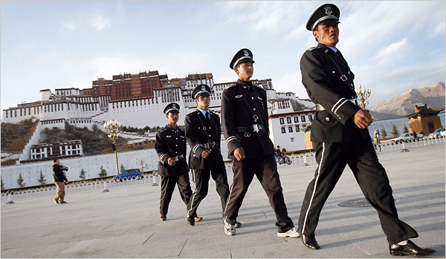
Andy Wong/Associated Press
Chinese security officers on patrol in Lhasa on Wednesday.
SHANGHAI — China said Wednesday that 660 people implicated in Tibetan protests and riots in western China over the past two weeks had surrendered to the authorities.
The announcement was part of the government’s effort to quell continuing unrest in the area, which includes Tibet and adjoining provinces with large Tibetan populations. It is the worst outbreak of anti-Chinese violence in 20 years.
It was unclear from the announcement how many of the 660 had surrendered voluntarily and how many would be formally charged with criminal offenses. Nor was it clear whether all were ethnic Tibetans.
The unrest, which began with a March 14 riot in Lhasa, the capital of Tibet, has already cast a pall over preparations for the Olympic Games in Beijing this summer and energized human rights advocates and others who contend that China’s rule over the area has been harsh and that Tibet should be independent.
But the Chinese government has reacted furiously to the riots and to international criticism of its handling of Tibet, saying the violent uprising was instigated by the Dalai Lama, Tibet’s spiritual leader in exile, and by Tibetan separatists. The government says 19 people were killed and more than 600 wounded in the violence.
“This riot was deliberately manipulated by the Dalai Lama clique, and our government has taken legal actions to return Lhasa and other places to normality,” Qin Gang, a spokesman for the Chinese Foreign Ministry, said Wednesday, according to a government statement. “The Dalai Lama is not purely a religious person. For a long time, he wore a religious coat and held the banner of peace while trying to separate China and destroy social stability and national unity.”
The Tibetan government in exile, based in neighboring India, has disputed the Chinese government’s figures, saying at least 140 people have died in demonstrations in the region.
On Thursday, about 30 monks disrupted a government-managed tour by foreign reporters to Lhasa, screaming that there was no religious freedom and that the Dalai Lama was not to blame for the recent violence, according to The Associated Press, which is represented on the tour.
The 15-minute outburst came as the journalists were being shown around the sacred Jokhang Temple.
“Tibet is not free! Tibet is not free!” yelled one young Buddhist monk, who then started crying.
Government handlers shouted for the journalists to leave and tried to pull them away during the protest.
Tibet and neighboring provinces with large Tibetan populations are now under tight military control, with roadblocks and house-to-house searches for suspects. But there have been daily reports of protests and sporadic violence in some regions, people in those areas say.
This week, the Chinese government issued a “most wanted” list with the names of 53 people who it says took part in antigovernment protests, according to the official Xinhua news agency.
The Dalai Lama, who fled Tibet in 1959 and settled in India, has insisted in recent weeks that he had no role in the violent protests and that he does not favor independence for Tibet. He has also said he opposes an Olympics boycott, and he recently offered to resign if Tibetans in western China continued to engage in violence.
Shortly after the March 14 riot, the government began forcing foreign journalists out of Lhasa. Government blockades have also prevented foreign journalists from reaching Tibetan areas in neighboring provinces.
Inside China, the state-owned media are publishing and broadcasting images of Tibetans burning and looting Chinese shops in Tibet and attacking ethnic Han Chinese. The images and reports have helped inflame anger at Tibetans among the Chinese.
To sway international opinion, China invited 26 foreign journalists for a three-day government-supervised trip to Lhasa starting Wednesday to see the damage and interview victims of the riots. Some American news organizations were invited to send representatives. The New York Times was not.
On Wednesday, the reporters on the tour received a detailed schedule for the trip and shown a video about the riots, said one journalist in the group.
For more than a week, however, about 20 journalists from China’s state-controlled media have been allowed into Tibet and other largely Tibetan areas.
The Chinese media have been driving home Beijing’s message: that Tibetan separatists acted as terrorists, while the government responded with restraint in quelling the riots, and that innocent Chinese were the victims of looting, burning and assault.
Chen Yang contributed research.
Copyright 2008 The New York Times Company

