Diplomats Visit Tibet Amid Anxiety Over Unrest
March 30, 2008
By DAVID BARBOZA
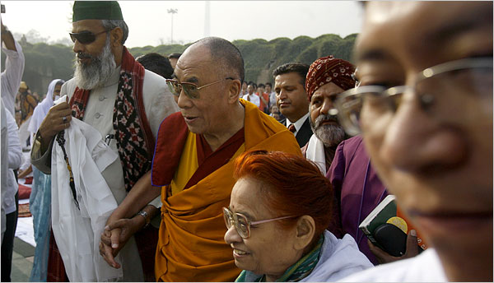
Manpreet Romana/Agence France-Presse — Getty Images
The Dalai Lama, the Tibetan spiritual leader, arrived Saturday at a memorial to Gandhi in New Delhi for a public interfaith meeting to pray for people killed in recent uprisings in the Tibet area.
SHANGHAI — A group of foreign diplomats, including an official from the United States, completed a two-day visit to Tibet on Saturday. There were conflicting reports of renewed pro-independence protests there and a possible weapons cache and mass arrests at a Tibetan monastery in southwestern China.
Late Saturday, Tibet’s government in exile said that there were protests near the Jokhang Temple in the Tibetan capital, Lhasa, and that parts of the city were shut down, Reuters reported.
But several Lhasa residents reached by telephone said they had heard about a scuffle between police officers and peddlers in a food market. And several residents said they received a text message from the government saying the rumor of new riots was false.
Also late Saturday, the Chinese government said the police had seized guns, knives and explosives at a Tibetan Buddhist monastery in Aba County, Sichuan Province.
There have been no previous reports of Tibetan monks or other protesters using weapons in the riots and protests that began in Lhasa and spread across western China earlier this month, and Beijing’s assertion could not be independently verified.
China’s official Xinhua news agency said the police had also arrested 26 suspects at the Geerdeng Monastery for “alleged involvement in a riot on March 16.” The police said some of the suspects had confessed that the riot “was organized and premeditated, aiming at undermining public order and misleading world opinion so as to sabotage the Olympic Games” in China this summer, Xinhua reported.
The police confiscated 30 guns, 498 bullets, eight pounds of explosives, knives, satellite phones, receivers for overseas TV channels, fax machines, computers and banners saying “Tibet Independence,” the agency reported.
The visiting diplomats, who left Lhasa before the reports of protests, did not release their findings, but the State Department said members of the group had not been allowed to hold unsupervised interviews with residents or to deviate from the official Chinese government itinerary.
The tour was the latest effort by Beijing to sway international opinion about the riots that rocked Tibet and neighboring regions this month, and to quiet talk about the possibility of a boycott of the Olympics.
China says that the riots killed about 20 people and were orchestrated by separatist followers of the Dalai Lama, the exiled Tibetan spiritual leader, and that the government responded with restraint.
But Tibetans say that the government killed more than 140 people as it tried to suppress uprisings in Tibet and neighboring regions, and that military blockades and efforts to prevent journalists from traveling in those areas have made it impossible to know what really happened.
In Katmandu, Nepal, the police broke up a Tibetan rally on Saturday and detained 84 people, Reuters reported. They were demonstrating in front of a Chinese consulate office in the capital.
In Slovenia, European foreign ministers called for an end to repression in Tibet and urged China to hold a dialogue on Tibetan cultural and religious rights, Reuters reported. The ministers were not able to find a common position on whether to boycott the opening ceremony of the Olympics in August.
The diplomatic tour, which involved envoys from the United States, Britain, France and Japan among others, began while a similar government-sponsored tour for foreign journalists was just coming to an end.
The government was embarrassed during the journalists’ tour when a visit to the Jokhang Temple in Lhasa, one of the city’s holiest shrines, was interrupted Thursday by a group of about 30 monks shouting: “Tibet is not free! Tibet is not free!”
The monks, some of whom began crying, said that the government was lying about the riots, that many people had been killed and that the government had even placed fake monks in the temple in order to trick foreign visitors into thinking everything was fine.
The government tried to pull several journalists away from the monks, according to The Associated Press, and later said the monks had lied. But the government said none of the monks would be punished.
On Saturday, the State Department issued a statement, after the visit to Lhasa, saying the American official who traveled to Tibet had “urged China to exercise restraint, to engage in dialogue, and to respect the fundamental right of all citizens to peacefully express their religious and political views.”
Also on Saturday, in New Delhi, India’s capital, the Dalai Lama told reporters he welcomed “neutral” international observers to “investigate thoroughly, with complete freedom” the incidents in Tibet and their catalyst.
If they “really found all those things started from here,” he went on, “any punishment on me, I accept.”
The Dalai Lama, who lives in exile in Dharamsala, in northern India, said an international inquiry should not be limited to Lhasa but should extend to other areas of Tibet. He called China “almost a police state” and yet continued to welcome dialogue with Chinese leaders. He again said he was neither pushing for independence from China, nor for a boycott of the Olympics.
He also said some Chinese soldiers might have dressed as monks to instigate riots in Tibet.
The United States and other nations are now pressing China to negotiate with the Dalai Lama to ease tensions before the Olympics.
Somini Sengupta contributed reporting from New Delhi.
Copyright 2008 The New York Times Company

