Genocide suspect found in Congo
BBC News
12 August 2009
A man accused of planning the massacre of Rwandans during the 1994 genocide has been arrested in the Democratic Republic of Congo, officials say.
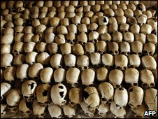
Some 800,000 Tutsis and moderate Hutus were killed in 1994
A government statement named the suspect as Gregoire Ndahimana, who is wanted by the International Criminal Tribunal for Rwanda (ICTR).
He was detained by Congolese soldiers in the eastern province of North Kivu.
They were taking part in UN-backed operations against ethnic Hutu rebels, many of whom fled to DR Congo in 1994.
Some 800,000 ethnic Tutsis and moderate Hutus were slaughtered in 100-day genocide.
Bulldozed church
"He was discovered by our units operating in North Kivu... He was hiding among the FDLR [Hutu rebels]," Congolese Information Minister Lambert Mende was quoted as saying by Reuters news agency.
According to his ICTR indictment, Mr Ndahimana is responsible for the deaths of at least 2,000 Tutsis, most of whom were killed when a church in which they had sought refuge was bulldozed.
The ICTR, which is based in Arusha, Tanzania, has completed 45 cases.
It was initially due to complete its prosecutions by the end of 2008, but the UN Security Council has given the court until the end of 2010 to finish the trials.

