DR Congo: Prominent Human Rights Defender Killed
by Human Rights Watch
3 June 2010
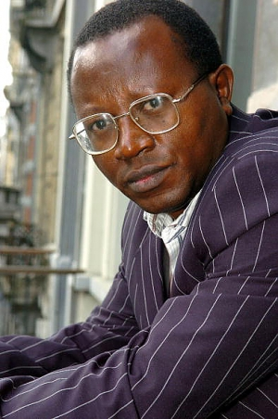
Floribert Chebeya Bahizire
© 2005 AFP
Floribert Chebeya's shocking death is a serious blow for human rights in the Congo. The announced police investigation needs UN help if it is to be credible and transparent and bring all those responsible to justice.
- Anneke Van Woudenberg, senior Africa researcher
(New York) - The government of the Democratic Republic of Congo should urgently open a credible and transparent investigation with United Nations assistance into the death of the prominent human rights defender, Floribert Chebeya Bahizire, Human Rights Watch said today.
Chebeya's body was found on June 1, 2010, soon after he had visited police headquarters in Kinshasa. On June 2, the Kinshasa police chief, Jean de Dieu Oleko, announced that Chebeya's death resulted from a criminal act and that the police were investigating. Chebeya's driver, Fidèle Bazana Edadi, is still missing.
"Floribert Chebeya's shocking death is a serious blow for human rights in the Congo," said Anneke Van Woudenberg, senior Africa researcher at Human Rights Watch. "The announced police investigation needs UN help if it is to be credible and transparent and bring all those responsible to justice."
Chebeya was the executive director of one of Congo's largest and most respected human rights organizations, the Voix des Sans Voix (Voice of the Voiceless), based in Kinshasa, the capital. He was among Congo's most vocal human rights defenders, regularly exposing abuses by the country's security services and the government over many years.
Over the years, Chebeya had been threatened and intimidated repeatedly by Congolese authorities as a result of his work. In recent weeks, he had reported that he believed he again was under surveillance by the security services.
On June 1, Chebeya received a telephone call requesting his presence at the office of the inspector general of the national police, Gen. John Numbi, his colleagues told UN officials. He left his office at 5 p.m. to attend the meeting. A few hours later he contacted his family and said he was still waiting at the police inspectorate, but after 9 p.m. all communication stopped.
On June 2, the police said that Chebeya had been found dead in his car in the Mont Ngafula area of Kinshasa. By midday on June 2, a police account implying that Chebeya's body had been found in the back seat of his car with used condoms and a sexual stimulant was circulated to journalists and others in Kinshasa, though no investigation had begun.
The authorities initially refused requests by Chebeya's family and UN human rights officials for access to the body. Today a family member, a colleague, and UN representatives were allowed to visit the morgue on the condition that they could not touch the body. They identified Chebeya and noticed a medium-size bandage on his forehead, apparently covering a wound. The rest of his body was covered with a sheet, which was not removed during the visit.
"The Chebeya family's very limited access to his body and conflicting police statements about the cause of death raise serious concerns about what really happened," said Van Woudenberg. "These irregularities indicate there may already be an attempt to cover up the truth."
Human rights defenders and journalists in Congo have faced increasing risks as a result of their work. Previous assaults and killings have rarely been properly investigated or those responsible brought to justice.
On July 31, 2005, Pascal Kabungulu Kibembi, a human rights defender, was shot dead at his home in Bukavu, in eastern Congo. His death was followed by the killing of two well known Radio Okapi journalists, Serge Maheshe in June 2007 and Didace Namujimbo in November 2008, also in Bukavu. In November 2005, Franck Ngyke, a journalist, and his wife, Hélène Mpaka, were murdered outside their home in Kinshasa. The investigations and subsequent trials into each of these killings were led by the Congolese military authorities and were marred by serious irregularities.
Human Rights Watch urged the minister of justice and human rights to create a commission of inquiry immediately, including Congolese and UN officials, as well as a representative from the Congolese human rights community, to investigate the death of Chebeya.
"The Congolese authorities should take every possible step to bring Chebeya's killers to justice and not repeat the botched investigations of the past," Van Woudenberg said. "UN and Congolese human rights officials should play a role to ensure that the government investigation is genuine and not merely for show."
Also available in: Français

Copyright 2010 Human Rights Watch

