U.S. Engages With an Iron Leader in Equatorial Guinea

By Adam Nossiter, The New York Times

30 May 2011
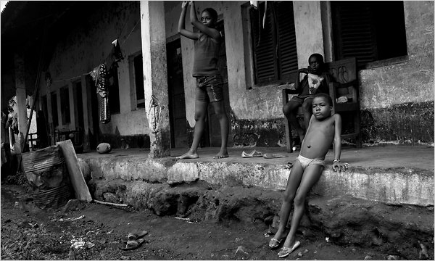

Credit: Tyler Hicks/The New York Times
Cocoa field workers outside Malabo, Equatorial Guinea's capital. Little oil wealth reaches the destitute population.
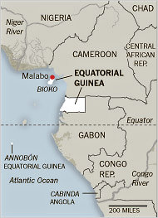

Credit: The New York Times
MALABO, Equatorial Guinea — While the United States has turned its back on some authoritarian rulers in North Africa and the Middle East, its attitude toward strategically placed autocrats in less restive corners of Africa is more ambiguous, and perhaps nowhere more so than in this oil-rich speck of a nation in the Gulf of Guinea.
Officially and unofficially, Americans do business with one of the undisputed human rights global bad boys, Equatorial Guinea, Africa’s fourth biggest oil exporter. Its widely criticized record on basic freedoms has offered little barrier to broad engagement by the United States, commercially or diplomatically.
American oil companies have billions of dollars invested here. One American diplomat, using language that makes human rights advocates fume, praised the “mellowing, benign leadership” of the dictator in power for more than 30 years, Teodoro Obiang Nguema Mbasogo, in 2009 cables released by WikiLeaks. And a leading American military contractor with strong Pentagon ties has a multimillion-dollar contract to protect his shores and help train his forces.
The contractor, Military Professional Resources Inc., or M.P.R.I., led by a top aide to former Defense Secretary Donald H. Rumsfeld, works on maritime security and human rights training for Mr. Obiang’s police forces. But even with the training, the United Nations, human rights groups and local dissidents say torture by the nation’s authorities remains systematic. And maritime security touches on the most sensitive aspects of personal defense for Mr. Obiang, especially in an island capital where coup attempts have come from the sea.
Until March, President Bill Clinton’s former special counsel, Lanny J. Davis, had a million-dollar-a-year contract to help Mr. Obiang with an image makeover. “He feels very vulnerable, without any friends,” Mr. Davis said in an interview late last year.
Mr. Obiang’s government could be considered a tough sell. Freedom House, the watchdog group, has ranked Equatorial Guinea among the nine most repressive “Worst of the Worst” nations in the world, along with Libya, Turkmenistan and Myanmar. It called the country’s government “a highly corrupt regime with one of the worst human rights records in Africa.”
Decades of repression and “systematic” torture, according to the United Nations, have created a culture of fear in this former Spanish colony of 670,000 people, Africa’s only Spanish-speaking country.
“They don’t even hide the torture instruments,” said Manfred Nowak, until recently the United Nations’ special rapporteur on torture. “It was just on the table.”
Interviewed at the presidential palace here, Mr. Obiang, sub-Saharan Africa’s longest-serving ruler, rejected such assertions. “We don’t have torture,” he said, adding: “International organizations have accused our police of mistreatment of prisoners. That’s why I hired M.P.R.I., to train our police. And our police are acting appropriately.”
Mr. Nowak found otherwise. “I’m deeply convinced it is a governmental policy,” he said. “They know exactly what is going on.”
Citizens who are audacious enough to talk about the political climate here joke behind closed doors about North Korea as a role model. Last month, opposition leaders were arrested for putting up a poster calling for a demonstration against Mr. Obiang, who overthrew his notoriously brutal uncle in a 1979 coup and won the last election here in November 2009 with more than 95 percent of the vote.
Strolling in the wrong neighborhood lands you at the police station. A visit to Parliament’s lone opposition member in his crumbling downtown walk-up is quickly known to the security services, bringing stern warnings from the information minister. The government publishes the only newspaper, and it is five months out of date at the leading hotel, a former torture center.
“Any policeman can arrest any citizen, at any time,” said Plácido Micó, a lawyer who is the only opposition deputy, and has been arrested numerous times. Torture is a “current thing, current,” Mr. Micó said, recalling his own beating in the presence of high officials late one night in 1992.
Gonzalo Ndong Sima, a pharmacist in the center of town here, recounted his recent encounter with the police over a simple traffic mishap, saying, “They beat me like an animal.”
Onderkant formulier
Still, American officials have called for a far rosier vision of the country. The United States Embassy here, in 2009 cables, advised that it was “time to abandon a moral narrative” about Equatorial Guinea and dismissed reports of corruption that have been widely documented by the United States Senate and others.
“Things are clearly looking up,” one cable concluded.
The current American ambassador here defended Mr. Obiang’s government against the statistics of the World Bank and human rights groups that show a huge gap between the country’s oil wealth — largely accruing to the Obiang family — and the widespread poverty of the population. Infant mortality, for instance, has actually increased since the discovery of oil here in the 1990s, the World Bank said, adding that Mr. Obiang holds “absolute executive power.”
“You can have a debate about every one of the statistics,” Ambassador Alberto M. Fernandez said.
The American presence here is discreet but vital, and Mr. Obiang professes great love for the United States. Chevron, Marathon Oil and Noble Energy have substantial interests in Equatorial Guinea, onshore and off, and American oil workers are easily spotted at the diminutive airport at the edge of town. The sea around Bioko Island, where Malabo, the capital, is located, is dotted with telltale flares from oil company installations.
The presence of M.P.R.I., the Virginia military security company led by the retired general Bantz J. Craddock, the former supreme allied commander in Europe, has raised eyebrows among human rights groups and local dissidents. The State Department vetoed the company’s work here because of Equatorial Guinea’s poor human rights record , but finally acceded under President Bush in 2005 amid promises of reform by Mr. Obiang’s government, according to Human Rights Watch.
Despite M.P.R.I.’s work with the country’s police, Mr. Nowak, the former United Nations torture investigator, found that guards and soldiers took turns administering electric shocks to political prisoners at the Playa Negra, or Black Beach, prison adjacent to the presidential palace in downtown Malabo.
Mr. Nowak discovered these practices in November 2008, at least a year after M.P.R.I. had begun its human rights training here, according to the government’s chronology. He and dissidents here contend that torture continues to be an ingrained government policy, though there is no evidence that M.P.R.I. either condones it or takes part.
Still, Mr. Nowak said, “if I were a trainer, I would leave the country because I would feel I was being used. It’s a fig leaf operation.”
M.P.R.I. declined to comment, except to confirm, through a spokesman last November, that it had recently received a contract from Equatorial Guinea to “in an overall, generic way, to provide security for the coastline, some coastal surveillance,” a domain touching on Mr. Obiang’s security concerns. In the most recent coup attempt, on Feb. 17, 2009, the presidential palace was attacked by gunmen who arrived at the dock below in boats. M.P.R.I.’s contract is worth $250 million, according to a press release.
Despite the government’s oil wealth, little has trickled down to the impoverished population. “The interest of the Americans here is money,” said Marcial Abaga Barril, a member of an opposition party.
On paper, in per-capita income, the citizens are nearly as well off as those of Spain and Italy, thanks to oil. But in reality, nearly 77 percent of the population lives below the poverty line, according to Human Rights Watch. The sprawling, muddy slums of Campo Yaoundé and Fiston — with their dirt streets, wooden shacks and scarce electricity — have nothing to do with the prim, tropical-Gothic cathedral that is the public face of the subdued island capital, where even critics of Mr. Obiang feel obligated to put his portrait on the wall for fear of the security services.
“The oil money hasn’t come here,” said Rosa Loka Moubake, a resident of Fiston.
Mr. Obiang, who turns 70 next month and received military training in the early 1960s Spain of the military dictator Francisco Franco, insisted that the United States was his ally, placing the blame for recent summary executions of accused coup plotters on the unwanted persistence of “Spanish colonial justice” codes in his country.
The interview broke up in a crackle of radio traffic on the walkie-talkies of Mr. Obiang’s extensive security detail. Outside, the Spanish colonial plaza was dead quiet in the noonday heat.
“Nobody here wants to talk because everybody is afraid,” said Mr. Barril, the opposition party member. “Everybody shuts his mouth.”
Copyright 2011 The New York Times

