Why I took up arms against Ethiopia
By Yannick Demoustier and Jonathan Alpeyrie
BBC Focus on Africa magazine
July 1, 2009

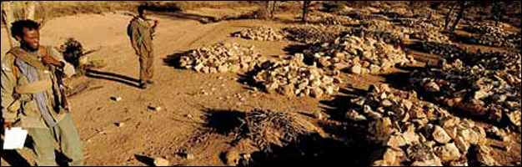
The ONLF says these rocks conceal mass graves

Ahmed, 35, is a member of the Ogaden National Liberation Front (ONLF), one of a number of separatist groups fighting for independence of the Somali-speaking Ogaden region in the east of Ethiopia.
The previous evening, he had participated in an attack against Ethiopian troops near the town of Babile.
"The assault lasted only a few minutes but we managed to kill nine government soldiers," he said.
"We are no match for direct combat, so we must rely on quick surprise attacks."
The armed resistance began in 1994 after the ONLF, then a political organisation, broached the idea of splitting from Ethiopia.
The central government responded by imprisoning Ogaden leaders and, according to academics and human rights groups, assassinating others.
'Point of no-return'
"In 1994, as a student in Dire Dawa, I was not allowed take the final examinations because I was an Ogadenian," said Ahmed.
"I was arrested two years later on false charges of belonging to the ONLF, they kept me there for four years and I was beaten repeatedly, sometimes even subjected to electric torture. While in detention, my father was killed by government soldiers."
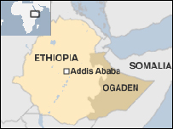
On his release in 2001, he immediately joined the rebellion but his mother remains in jail in Jijiga.
Fearing for his family, Ahmed convinced his wife to flee with their two daughters.
"They are refugees in Kenya, I haven't seen them for three years.
"There comes a point of no-return when you know you don't belong in this country," he said.
'Human shields'
Over the past two years the conflict has escalated following the ONLF's April 2007 attack on a Chinese-run oil exploration field.
This resulted in the death of 74 people, including Ethiopian guards and Chinese workers.
The central government calls the rebels "terrorists", however watchdogs have accused the government of human rights violations.
"This is a complete fabrication and these are unfounded allegations," said Berhanu Kebede, Ethiopia's ambassador to the UK.
In this village, they crushed babies' heads with stones and in another, they cut up bodies and scattered the parts to prevent remaining villagers from burying the dead

Ahmed
"The Ethiopian government has no intention of harming civilians, it is the ONLF that use civilians as human shields."
Near the deserted village of Galashe, which Ethiopian troops allegedly stormed in January 2009, Ahmed explains what lies beneath the numerous piles of rocks.
"There are about 50 bodies under each pile.
"The Ethiopian soldiers stayed here for a couple of months, they terrorised inhabitants, killing as many as 1,500 people."
In Galashe and across Ogaden, civilians attest to the same horrors, the gang-raping of women, the burning of huts and killing of livestock.
But the Ethiopian ambassador denied this claim.
"This was recently the subject of an independent investigation and this has made it clear that no such crimes were committed.
"This is a vast area with a population of 4.5 million, who are mostly nomadic and you won't see graveyards because people bury their relatives anywhere they can," said Mr Berhanu.
The government has closed off all access to the Ogaden region.
Ahmed believes the Ethiopian government is trying to cut them off from the local population which supplied the rebels with food
Rebel alert
One of Ahmed's main tasks is to train the younger recruits.
"They are very angry but it is important that they remember to stay organised, especially when things appear calm," he said.
The Ethiopian government has been trying to find a political solution to the problem.
The rebels say that they cannot live under Ethiopian rule but we are a federal state.

Berhanu Kebede
"We are approaching them through their elders to explain that the constitution provides enough political space for a peaceful resolution of the problem but they must renounce the armed struggle and wage their political agenda peacefully," said Mr Berhanu.
"The rebels say that they cannot live under Ethiopian rule but we are a federal state."
Ethiopia remains one of the world's most aid-dependent countries, receiving more than $2bn in foreign assistance every year.
Evidently, no aid reaches the Ogaden region despite the government's insistence that hostilities have ceased.
"Why does the international community remain silent?" said Ahmed.
"The UN must come to the Ogaden to see what [Prime Minister]Meles is doing to us."
Yannick Demoustier is a French journalist for Rue des Pommiers news agency and Jonathan Alpeyrie is an independent photojournalist.
Copyright 2009 BBC

