Tracking Africa's people smugglers
By Brian Hungwe, BBC News
1 August 2009
Harare
Human smugglers are running a complex multi-million dollar network, fleecing distressed Somalis seeking a way out of their war-torn country and desperate Ethiopians caught up in vicious cycles of hunger, floods and political repression.
Thousands of people leave their countries every year, trekking thousands of miles through eight countries from the Horn of Africa, via East Africa down to South Africa.
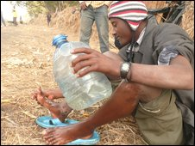
The migrants have to walk for thousands of miles
Bribes oil their journeys across the region by air, overland and sea.
And immigration and police are complicit. The state of the airports and the corruption that goes on there mirrors the body politic of the countries involved. And this has security implications for the countries involved.
In a recent report on smuggling in the region, the International Organization for Migration (IOM) noted that "guardians of national border integrity... are deeply compromised, creating a threat to national security".
The next five to 10 years, Somalia will have nobody there
Ismail, Somali truck driver in Malawi
It says their complicity is keeping the smuggling business afloat and that they "should be considered part of the illegal and abusive enterprise" where "cupidity appears to be the foremost and only visible motivation".
Huge sums
IOM's Tal Raviv, based in Nairobi, acknowledges that the smuggling ring is "sophisticated."
"Tens of thousands of people are able to move from Somalia and Ethiopia, all the way down to South Africa, and they arrive successfully," she said.
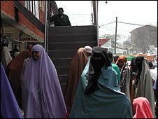
Nairobi's Eastleigh district is the region's smuggling hub, the IOM says
"All the borders are porous, it's just that," points out Mokotedi Mpshe, who heads South Africa's National Prosecuting Authority.
Mr Mpshe knows the extent to which corruption has permeated his society.
"Some government officials can let you down. We may try to fight human trafficking, but at the same time there may be elements amongst ourselves that are working against us," he said.
Cash-strapped governments can't match the huge sums smugglers pay immigration and police officers to ease the path of illegal immigrants en route to South Africa.
Expanding business
I found that immigrants pay smugglers on average $1,500 - $2,000 before the journey begins.
The IOM also estimates the smuggling business generates annual revenue of about $40m. Along the way the immigrants lose much more to robberies.
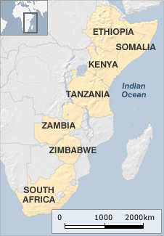
And rape and other abuse is common.
Over the years, the flow of Somalis has been growing, and thus, according to the IOM, "providing smugglers an expanding and lucrative business opportunity".
"The next five to 10 years, Somalia will have nobody there," said Ismail, a Somali truck driver living in Malawi.
"There is no peace which is coming, there is nobody who is fighting for Somalia."
Lions and snakes
Salma left Somalia with her son Nasir, 3, six years ago, when she was 23. She left her mother and brother behind, and has no clue where they are.

From her flat in Cape Town, South Africa, she says that everyone in Somalia is trying to flee the fighting there.
Sometimes [smugglers] ask the women to sleep with them. You sleep with them, otherwise they leave you behind
Salma, Somali migrant
She says she walked on foot for 24 days during the journey.
In Kenya, Salma met Amina, a smuggler linked into a network that carried her across several countries.
Nairobi's Eastleigh district is, according to IOM, the smuggling hub of the region.
It is a little Mogadishu in the heart of Nairobi, whose life runs 24 hours, hosting a close-knit Somali community that keeps itself to itself.
Money transfers are done with ease, and anything goes. Vehicles with tinted windows are a common sight, and haulage trucks move goods in and out every hour.
It is here that Salma gave $1,000 to the smuggler, Amina, who accompanied her and a small party of migrants on the first half of their journey.
Police bribed
In Tanzania, six members of the party were arrested.
Salma says the smuggler bribed the police to secure their freedom.
She says they had similar experiences in Zambia and Zimbabwe.
"[Smuggler] paid some money and we came out."
Six years later, Salma's journey is still vivid for her, as she recounts how she was terrified of lions and snakes as she trudged through the bush.
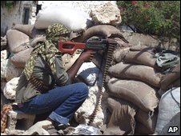
Thousands are trying to flee Somalia's never-ending conflict
"Sometimes [smugglers], they ask the women to sleep with them," Salma remembers.
"You sleep with them, otherwise they leave you behind... they do that."
The IOM's Tal Raviv confirmed that almost all smuggled women get raped, and her organisation has also received reports of the same thing happening to men.
Salma's journey was even tougher than usual because she was travelling with a child, so the smugglers told her they could not give her accommodation.
"I was struggling too much," she remembers.
Nasir, now nine, vividly recalls sleeping in the forest, his mother walking long distances, and sometimes going for days without food.
"I never ever, I don't want to do again that journey."
To listen to Brian Hungwe's full investigation, tune in to African Perspectiveon the BBC World Service.The program is first broadcast on Saturday 1 August at 1106 GMT. It will be available online from 2106 GMT, for one week.

