**Ethiopia: Ogaden Somalis seek Ethiopia abuse inquiry**

**By Al Jazeera**

**15 February 2012**

The Ogaden Somali Community in South Africa says it has filed a complaint with the country’s top prosecutor and the International Criminal Court (ICC), urging an investigation into the actions of the Ethiopian government against the Ogaden people.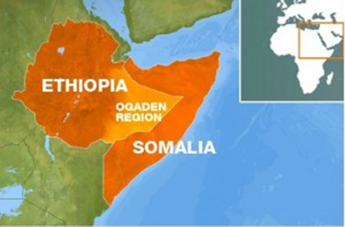

In a statement released on Tuesday on behalf of the community, a South African media advocacy group, Media Review Network, called on ICC authorities to probe complaints of alleged crimes in the Ogaden region of Ethiopia.

The crimes include extrajudicial killings, arbitrary detention, rape, torture, disappearances, the destruction of livelihood, the burning of villages and the destroying of life stock, the statement said.

“South Africa is the best place in Africa to file this complaint, especially in terms of law and and human respect; we believe that South Africans still remember what they underwent during Apartheid, just as how we are under minority rule in our region,” Mohamed Fadel Abdullahi, a Somali Ogaden activist based in Johannesburg, told Al Jazeera.

The complaint, comprising 700 pages of evidence, was also lodged with the director of public prosecutions.

Mursan Oumer, from the Ethiopian government communication affairs office, however, told Al Jazeera that he was not yet aware of the complaint.

The International Criminal Court has received thousands of complaints since it was established. According to its founding statute, the court’s prosecutor must analyze each complaint and decide whether the case falls within the jurisdiction of the court and whether there is reasonable evidence for an inquiry.

Ethiopia is not currently a signatory to the International Criminal Court.

‘**Open justice system’**

Abdullahi said that the Somali Ogaden community would “not only bring more awareness of the injustice taking place in the region, but bring those offenders to justice, and help us stop the genocide and crimes against humanity in Ogaden”.

“South Africa has an open justice system which allows us to exercise our right to search for international justice,” he said.

The Somali-speaking Ogaden region in eastern Ethiopia, bordering Kenya, Djibouti and Somalia, is considered the principle source of tension between Ethiopia and Somalia.

While the region legally belongs to Ethiopia, the inhabitants are primarily ethnic Somali. The Ogaden region has been a site of struggle and separatist activity ever since Ethiopia gained the territory in 1954.

Somalia’s descent into civil war in 1991 gave birth to a second wave of armed resistance from the Ogaden National Liberation Front (ONLF), which was formed in 1984.

Since 2007, thousands have been killed, many of whom have been civilians, as Ethiopian armed forces battled the ONLF.

With the discovery of oil, the region’s strategic and economic value has only increased.

**‘Enormously appalling’**

The Ogaden community alleges that the Ethiopian army forcefully displaced Ogaden civilians, cleared large swathes of land and discouraged civilians from returning to the area by confiscating their livestock as they embarked on oil expeditions.

Speaking on condition of anonymity, a Somali journalist based in Nairobi told Al Jazeera that the people in the region had “been living under oppression and a bloody regime”.

“Many of Ogadenian descent are in prison, tortured and even sentenced to death. Their plight is enormously appalling.

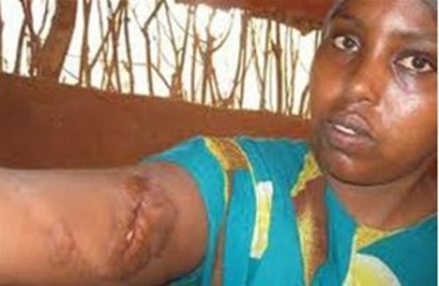

“There is a semi-autonomous government in place that is fully backed by the Ethiopian government. But, sadly, the vast majority of Ogden’s – mainly diasporas – regard this government as a puppet to the regime and [is] quite unpopular,” he said.

The press statement, released on Tuesday, alleges that around 20,000 Ogaden citizens are now languishing in 200 different jails, most of them in unknown Ethiopian military detention camps.

The group further claims that the International Committee of the Red Cross has not been allowed access to prisons holding Ogaden prisoners.

“The Ethiopian authorities use torture, rape and disappearances as a weapon of war. Women are routinely raped while in custody or at home, even sometimes in front of their husbands or relatives. Rape and torture are used simultaneously in prisons and pregnancies are very common,” the statement read.

Human rights groups have raised concerns about alleged abuses in Ethiopia. Human Rights Watch reported last month that hundreds in the country had been arbitrarily arrested and detained during 2011 and remained at risk of torture and ill-treatment.

“Human Rights Watch continues to receive credible reports of arbitrary detention and serious abuses of civilians alleged to be members or supporters of ONLF. These civilians were being held in detention facilities in Ethiopia’s Somali region,” it said in its 2012 world report.

**Journalists sentenced**

According to the human rights group Amnesty International, reports of severe human rights violations being committed by the Ethiopian government troops and allied armed groups continue to emerge from the Somali region. Access to the region is also significantly restricted by the Ethiopian government.

In December 2011, two Swedish journalists were found guilty and handed two 11-year-jail terms for charges of “supporting terrorism” and violating Ethiopian territorial and political sovereignty after they entered the Ogaden region clandestinely and met with the ONLF rebel group.

An Ethiopian court ruled that Swedish journalists Johan Persson and Martin Schibbye should serve “rigorous imprisonment”, and said the verdict “should satisfy the goal of peace and security”, the AFP news agency reported.

“There is nothing to suggest that the two men entered Ethiopia with any intention other than conducting their legitimate work as journalists. The government chooses to interpret meeting with the ONLF as support of that group and therefore a terrorist act,” Claire Beston, Amnesty International’s Ethiopia researcher, said.

“Amnesty International believes there is no evidence that the men were supporting the objectives of the ONLF, or were guilty of any criminal wrongdoing. We believe that these men are prisoners of conscience, prosecuted because of their legitimate work,” she added.

Three Ethiopian journalists are also currently facing trial on terrorism offences, and the human rights group believes that they are also being prosecuted for their legitimate work.

“This wave of arrests and prosecutions constitutes an assault on freedom of expression by a government determined to gag the reporting of stories it doesn’t want told,” Beston said

***Copyright © 2012 Al Jazeera***