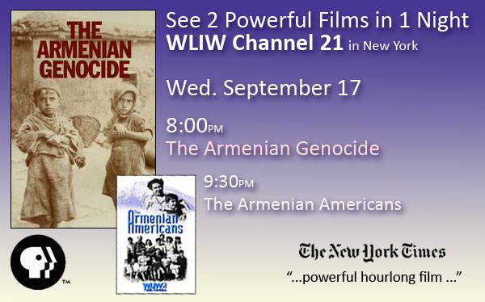
WLIW 21 in New York will be presenting THE ARMENIAN GENOCIDE on Wednesday, September 17 at 8:00pm, followed by THE ARMENIAN AMERICANS at 9:30pm.
For this special occasion, the Director of the Film, Andrew Goldberg will be in the studio to be interviewed.
ABOUT THE FILMS:
The Armenian Genocide is the complete story of the first genocide of the 20th century — when over a million Armenians died at the hands of the Ottoman Turks during World War I. This unprecedented and powerful one-hour documentary was written, directed, and produced by Emmy Award-winning producer Andrew Goldberg of Two Cats Productions. Featuring interviews with leading experts in the field such as Pulitzer Prize-winning author Samantha Power and New York Times best-selling author, Peter Balakian, this film features never-before- seen historical footage of the events and key players of one of the greatest untold stories of the 20th century. The Armenian genocide is narrated by Julianna Margulies and includes historical narrations by Ed Harris, Natalie Portman, Laura Linney, and Orlando Bloom.
The Armenian Americans captures the spirit of this amazing culture and its legacy of inspiration, achievement, perseverance, and survival. Personal recollections from three generations of proud Armenians – including tennis champion Andre Agassi, author Peter Balakian, actor Mike Connors, actor/writer Eric Bogosian, actress/writer Andrea Martin, NCAA basketball coach Jerry Tarkanian, historians, musicians, politicians, religious leaders, and corporate executives – pay warm tribute and celebrate why there has never been a better time to be an Armenian American.
Critical praise for THE ARMENIAN GENOCIDE
NEW YORK TIMES: "Powerful… honors the victims of the Armenian genocide and also pays tribute to dissidents in Turkey who are brave enough to speak out despite government censorship." – Alessandra Stanley
THE STAR-LEDGER: "Serious, literate and ultimately heartbreaking. .. [made with] intelligence and precision..." – Matt Zoller Seitz
WALL STREET JOURNAL: "Armenia, Revisited" – Sam Schechner
THE ARMENIAN REPORTER: "A Genocide Documentary That Will Resonate" – Aris Sevag

