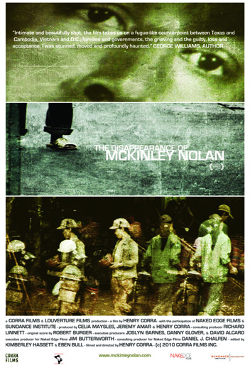

Silverdocs tickets are now available online - click here to get yours right now!

Screening times:
Thursday, June 24th, 9:30 p.m. (theater 2)
Saturday, June 26th, 5:00 p.m. (theater 1)

AFI Silver Theater, 8633 Colesville Rd., Silver Spring, MD

For more information, please check out www.mckinleynolan.com.

CORRA FILMS | 197 GRAND ST., #7W, NEW YORK, NY, 10013 | WWW.CORRAFILMS.COM | T 212.965.8600

