Fratricide and Fraternité:

Understanding and Repairing Neighbourly Atrocity

Mellon Sawyer Seminar Series

Bystanders? Poland and the Holocaust

Jan T. Gross (Princeton University)
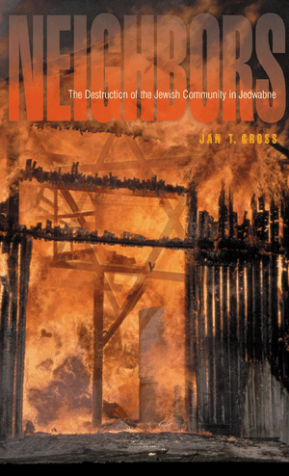

26 June 2010 (10:30 am -12:00 pm)

G35, Senate House, University of London

This seminar forms part of a series organized by the Human Rights Consortium, School of Advanced Study, University of London.The events are free and open to all. Registration recommended. For further information go to www.sas.ac.uk/fratricide.html or email kirrily.pells@sas.ac.uk


