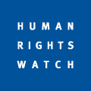 | 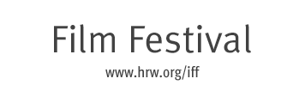
ENEMIES OF THE PEOPLE
Opening in New York July 30, 2010
at The Quad Cinema
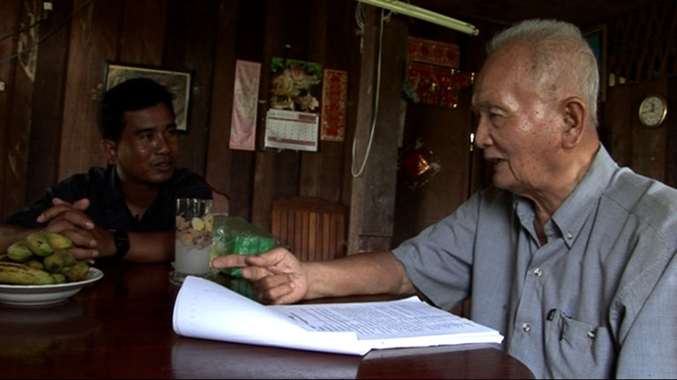

Winner of the 2010 Sundance World Cinema Documentary Special Jury Prize, Enemies of the People follows the project of Thet Sambath, whose parents were among the approximately two million people who perished under the Khmer Rouge regime in the late 1970s. With unprecedented access and groundbreaking confessions from the notorious “Brother Number Two,” Nuon Chea, and from numerous grassroots killers, he uncovers terrifying personal explanations for the genocide by allowing the perpetrators to speak for themselves. Find out more
Winner: 2010 Human Rights Watch Film Festival Nestor Almendros Award for Courage in Filmmaking
“Stunning. One of the most gripping and moving films I have ever seen.”
- Andrew Marr, BBC Radio
“Inspiring. A testament to one man’s persistent search for the truth.”
– Stephen Holden, New York Times
“This heart-wrenching documentary presents shocking unprecedented testimony straight from the mouths of killers, and begins to answer how such a tragedy could have happened. Compelling.”
– Dave D’Arcy, Screen International
TICKETS:
For advanced tickets please click here.
All screenings are at The Quad Cinema
34 West 13th Street, (bet. 5th & 6th Ave) 212-255-2243
Find out more on www.hrw.org/iff
Would you like to receive occasional updates on special film events for the Human Rights Watch Film Festival? Sign up for our e-mailing list

