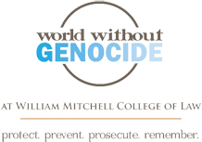
World without genocide
Film screening
"Ghosts of Rwanda" is a compelling documentary about the 1994 genocide during which nearly a million people were killed in a hundred days - and the world stood by and did nothing. Join us on Tuesday, August 24, 7:00 pm at the Guthrie Theater, 818 Second Avenue South, Minneapolis, to see this film and to hear an update on the situation in Rwanda today.
The event is free, open to the public, and no reservations are necessary. There is a small charge to park in the adjacent Guthrie parking ramp and on city streets. For additional information contact info@worldwithoutgenocide.org.

