While Europe Sleeps, Bosnia Seethes
By NICHOLAS KULISH, The New York Times
September 6, 2009

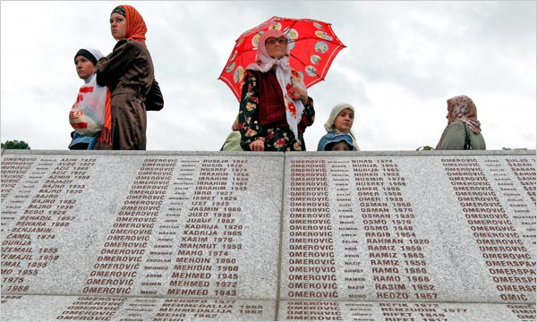
MEMORIAL The names of Bosnian Muslim men massacred at Srebrenica in 1995. (Fehim Demir/European PressPhoto Agency)

BERLIN-- Nearly 14 years after peace for Bosnia was hammered out in Ohio, the hills rising up around Sarajevo can still lead a visitor to uncomfortable thoughts about sightlines for snipers.

As I stood there in person on a visit back in May with Vice President Joseph R. Biden Jr., the violence of the ’90s didn’t feel so far away. Mr. Biden barnstormed through the Balkans on Air Force 2, also stopping in Serbia and Kosovo, with the goal of trying to draw flagging attention back to the region, delivering his sternest lecture to the Bosnian Parliament, warning against falling back onto “old patterns and ancient animosities.”

Mr. Biden is not alone in his warnings. In the latest issue of Foreign Affairs, under the headline “The Death of Dayton,” Patrice C. McMahon and Jon Western write that because of ethnic divisions that refuse to heal, widespread corruption and political deadlock, “the country now stands on the brink of collapse” and “unless checked, the current trends toward fragmentation will almost certainly lead to a resumption of violence.”

Whether or not that happens, the peacekeeping force meant to crack down on any outbreaks now has fewer than 2,000 troops. And the American contingent, a promise and a deterrent to those who justifiably doubt the European Union’s resolve if force is needed, has left entirely.

These circumstances might be cause for widespread alarm, if anyone had noticed them in the first place. It didn’t used to be that way. It used to be that you didn’t have to shout to get heard on the subject of Bosnia. The name alone was enough to evoke the rape, torture, burned-out homes and mass graves that marked a three-and-a-half-year war in which roughly 100,000 people were killed, a majority of them Muslims.

But that was a long time ago. For much of the Western world Bosnia is an all-but-forgotten problem, far down the list of priorities after countries like Iraq, Iran and North Korea. As if to drive the point home, the chief architect of the Dayton peace accords in the Clinton administration, Richard C. Holbrooke, now a special envoy in the Obama administration, has his hands full with the war in Afghanistan and the even more complex situation in neighboring, nuclear-armed Pakistan. Mr. Holbrooke has complained in recent years of a “distracted international community.”

If the drift of public attention away from Bosnia is a result of more pressing issues in an age of terrorism and rogue nuclear states, it is also a function of the simple fact that this ethnically divided country finds itself in the middle of a far more united, stable and at times downright boring Europe than in the days of the civil war.

Bosnia could well return to violence, but it has lost a large measure of what might be called its Franz Ferdinand threat. For all of the moral and humanitarian arguments for getting involved in the violent dissolution of Yugoslavia, there was also the severe lesson from Archduke Ferdinand’s assassination in 1914, which provided the spark for World War I. That lesson was simple: conflicts start in the Balkans, but they do not necessarily stay there.

The end of the cold war brought elation but also trepidation. In hindsight, the march of countries like Poland, Hungary and Romania from the Warsaw Pact into NATO and the European Union may appear steady and all but predestined, but the paths of those newly freed countries were anything but certain at the time. Bosnia was a starkly destabilizing factor in a far more unstable continent. The fighting that began in the spring of 1992 was not quite three years after the fall of the Berlin Wall, and less than a year after the attempted coup of August 1991 in Russia, and came hard on the heels of the collapse of the Soviet Union.

Today, the picture has changed again. Now that Europe is no longer the fault line of a divided world, it looks ever more like a retirement community with good food and an excellent cultural calendar. Spies cut from the George Smiley cloth could really come in from the cold, retiring with legions of their countrymen to the Spanish coast, with no more to worry about than the decline of the pound against the euro and the sinking value of their condos.

The European Union has its share of problems, including a rapidly graying population projected to shrink by 50 million people by 2050 and deep troubles in integrating the immigrants — particularly from Muslim countries — it so drastically needs to reverse the demographic slide. And the union’s energy security depends on its often capricious and at times menacing neighbor to the east, Russia.

Russia’s invasion of Georgia last summer served as a stern reminder that things can still get rough outside of the gated community, and certainly made newer members like Poland and Estonia nervous about the sturdiness of the fence.

Renewed fighting in Bosnia may not launch World War III, but it could well spread to other parts of the former Yugoslavia, including Kosovo. Kosovo declared independence last year, and the United States Embassy in the Serbian capital, Belgrade, burned at the hands of angry rioters. I walked the streets in the aftermath, interviewing Serbs, and found rage, sadness and desperation even among the most pro-Western elements of society.

It was something of a pleasant surprise, then, to return with Mr. Biden this year and find average Serbs on the same streets sounding deeply pragmatic about the visit by an American politician who not only represented the superpower that had bombed them but was personally an early and staunch supporter of Muslims in both Bosnia and Kosovo. While there were holdouts, most said that jobs and freedom to travel trumped old enmities.

With any luck the sentiment will find more traction in neighboring Bosnia too, drowning out the extreme voices and their loose talk of war. Given how far the world’s attention has wandered, supporters of peace in the Balkans will have to hope they find their own path to moderation. Otherwise the crack of snipers’ bullets and the whistle of mortar shells could herald the terrible spectacle of a preventable return to bloodshed.

Copyright 2009 The New York Times Company

