Bosnian Serb cleared of genocide
by BBC News
6 May 2010
A Bosnian appeals court has acquitted a former wartime commander who was sentenced to 40 years for involvement in the Srebrenica genocide.
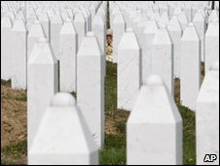
Up to 8,000 Bosnians were killed in one week at Srebrenica
The Sarajevo-based court ruled that there was not sufficient evidence to convict Milos Stupar.
The retrial found that Mr Stupar took command of the Bosnian Serb unit the day after the massacre he had been been accused of aiding.
Up to 8,000 Bosnian Muslims were killed in one week in Srebrenica in 1995.
Mr Stupar, 46, was found guilty at a Sarajevo war crimes court in 2008 of failing to prevent the systematic murder of more than 1,000 Bosnians in one day, along with six others.
But he appealed against the conviction, prompting a new trial.
The judge said on Wednesday that Mr Stupar could not have prevented the killings as he replaced an injured commander a day after the incident.
"The evidence does not indicate that Milos Stupar was a commander who had effective control over those who allegedly executed the crime," judge Azra Miletic said.
Mr Stupar was cleared of playing a role in the separation of more than 1,000 men from their families, telling them they would be taken to safety.
Instead they were taken by bus or on foot to a warehouse in the village of Kravica and murdered.
It was part of a week-long massacre by Bosnian Serb forces after their capture of the UN-protected enclave in July 1995.
Copyright 2010 British Broadcasting Corporation.

