Serbian Official Convicted of War Crimes
by J. David Goodman, The New York Times
6 September 2011
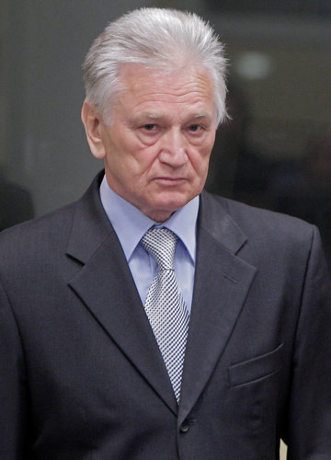
Momcilo Perisic was known as a principal architect of the Balkan conflict in the 1990s. (Peter Dejong/Associated Press)
The former head of the armed forces in Serbia was convicted on Tuesday of crimes against humanity and war crimes by an international tribunal at The Hague.
The former official, Momcilo Perisic, was the army chief of staff of Yugoslavia in the 1990s when that crumbling nation was reduced to just Serbia and Montenegro, and he was a principal architect of the ethnic war in the breakaway republic of Bosnia and Herzegovina. He was charged in connection with attacks on civilians by soldiers under his command in Bosnia and Croatia, including in the cities of Sarajevo and Srebrenica, and he was sentenced on Tuesday to 27 years in prison.
The conviction of Mr. Perisic, 67, was the first by the tribunal against a Serbian official for crimes committed in Bosnia and Herzegovina, the court said.
For years, the tribunal has been investigating cases of war crimes and genocide committed by Serbian commanders during the Balkan wars of the 1990s, including the massacre of some 8,000 unarmed Muslim men and boys at Srebrenica in July 1995.
Mr. Perisic, the court found, “knowingly aided and abetted the crimes of murder, inhumane acts and attacks on civilians” during a campaign of shelling and sniper attacks against Sarajevo and abetted the “persecution and extermination” of people in the city of Srebrenica in 1995. The court also found Mr. Perisic responsible for the 1995 shelling of Zagreb, the capital of Croatia.
The Serbian state that emerged from the breakup of Yugoslavia tacitly sheltered war crimes suspects for years under the nationalist leadership of Slobodan Milosevic. The current government broke with that policy and handed over war crimes suspects to the tribunal.
One suspect arrested this year, Ratko Mladic, served under the command of Mr. Perisic, who personally signed his promotion orders in 1994. Even so, the tribunal said on Tuesday that it had seen no evidence that Mr. Perisic directed Mr. Mladic’s alleged actions during the 1995 massacre.
“Even though General Perisic had a collaborative relationship with Mladic and substantially aided his operations, the evidence does not establish that he exercised effective control over him or any other Yugoslav Army officer,” the presiding judge, Bakone J. Motolo, said in a statement after the verdict was announced.
Mr. Perisic’s trial lasted nearly three years, with more than 100 witnesses and thousands of exhibits, including minutes of meetings in which he discussed military matters with top officials including Mr. Milosevic, who was himself indicted and tried by the tribunal; he died in 2006 before that trial could be completed.
In July, Serbia arrested Goran Hadzic, the last Serbian fugitive wanted by the war crimes tribunal. The arrests of Mr. Hadzic and Mr. Mladic angered some nationalists in Serbia, but they removed an obstacle to Serbia’s bid to join the European Union.
This article has been revised to reflect the following correction:
Correction: September 6, 2011
An earlier version of this article referred incorrectly to a statement by the United Nation's war crimes tribunal on the conviction of Momcilo Perisic. The court said his conviction was the first for war crimes committed in Bosnia and Herzegovina; it did not say it was the first against any former Yugoslav official.
Copyright 2011 The New York Times Company.

