Ugandan Gay Rights Group Sues U.S. Evangelist

By Laurie Goodstein, The New York Times

14 March 2012
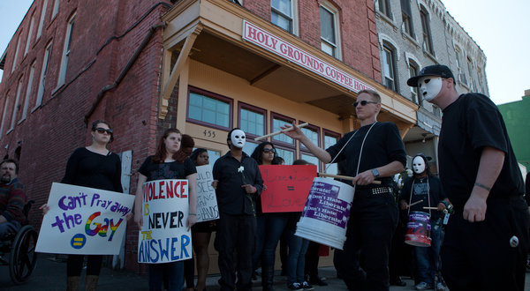
Credit: Ilana Panich-Linsman for The New York Times
Dozens marched Wednesday in Springfield, Mass., to the coffee shop of an evangelist accused of inciting persecution in Uganda.

A Ugandan gay rights group filed suit against an American evangelist, Scott Lively, in federal court in Massachusetts on Wednesday, accusing him of violating international law by inciting the persecution of gay men and lesbians in Uganda.
The lawsuit maintains that beginning in 2002, Mr. Lively conspired with religious and political leaders in Uganda to whip up anti-gay hysteria with warnings that gay people would sodomize African children and corrupt their culture.
The Ugandan legislature considered a bill in 2009, proposed by one of Mr. Lively’s Ugandan contacts, that would have imposed the death sentence for the “offense of homosexuality.” That bill languished after an outcry from the United States and European nations that are among major aid donors to Uganda, but was reintroduced last month.
Mr. Lively is being sued by the organization Sexual Minorities Uganda under the alien tort statute, which allows foreigners to sue in American courts in situations asserting the violation of international law. The suit says that Mr. Lively’s actions resulted in the persecution, arrest, torture and murder of gay men and lesbians in Uganda.
Reached by telephone in Springfield, Mass., where he runs Holy Grounds Coffee House, a storefront mission and shop, Mr. Lively said he did not know about the lawsuit. Nevertheless, he said: “That’s about as ridiculous as it gets. I’ve never done anything in Uganda except preach the Gospel and speak my opinion about the homosexual issue.”
Mr. Lively is the founder and president of Abiding Truth Ministries. He is also the author of “The Pink Swastika: Homosexuality in the Nazi Party,” which says that Nazism was a movement inspired by homosexuals, and “Seven Steps to Recruit-Proof Your Child,” a guide to prevent what he calls “pro-homosexual indoctrination.”
He has traveled to Uganda, Latvia and Moldova to warn Christian clergy members to defend their countries against what he says is an onslaught by gay rights advocates based in the West.
Pamela C. Spees, a lawyer for the Ugandan group, works with the Center for Constitutional Rights, a legal advocacy group based in New York City. Ms. Spees said that since gay men and lesbians in Uganda have little support, the suit “brings the fight” to those in the United States who she says fomented the anti-gay legislation in Uganda. She says that the suit is targeted at Mr. Lively’s actions, not his beliefs. “This is not just based on his speech,” she said. “It’s based on his conduct. Belief is one thing, but actively trying to harm and deprive other people of their rights is the definition of persecution.”
Mr. Lively is one of many conservative American evangelicals who were active in Uganda. He and others tried to distance themselves from the legislation after the international outcry over the death penalty provision. Ms. Spees said the lawsuit singled him out because “his role was critical.”
Mr. Lively posted a report after his visit to Uganda in 2009 describing how he addressed groups of lawyers, members of Parliament, universities, secondary schools and Christian leaders about “the ‘gay’ agenda,” and spoke at a three-day conference.
Frank Mugisha, of Sexual Minorities Uganda, the plaintiff in the lawsuit, said Wednesday in a conference call that before these events in 2009, gay men and lesbians were “looked at as different,” but that “no one bothered them.”
But after Mr. Lively’s speeches, Mr. Mugisha said, “People were being reported to the police as homosexuals, were thrown out by their families or thrown out by the church.”
The lawsuit names four Ugandan co-conspirators: Stephen Langa and Martin Ssempa, evangelists active in the anti-gay movement; David Bahati, the legislator who sponsored the bill; and James Buturo, the former minister of ethics and a proponent of the legislation.
Informed of the lawsuit against Mr. Lively, Mr. Buturo said Wednesday in an interview, “I don’t know that person at all.” Nevertheless, Mr. Lively said in his report that he had a half-hour meeting with Mr. Buturo in 2009.
Copyright 2012 The New York Times

