June 29, 2008
Heads Up | Darjeeling, India

Unrest in India’s Hill Country
By SOMINI SENGUPTA
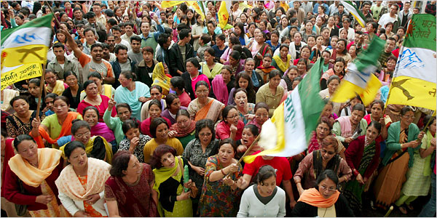
European Pressphoto Agency
Supporters of a separatist group demonstrating in a Darjeeling hill town. Tourists have been told to leave the area.
A long-brewing separatist movement in the Darjeeling hills had, until recently, receded into the past so thoroughly that it became fodder for fiction, setting the backdrop for Kiran Desai’s 2006 Booker Prize-winning novel, “The Inheritance of Loss.” Earlier this month, it burst out into the open again, chasing away tourists, signaling the prospect of ugly ethnic clashes and prompting the Indian government to send in paramilitary forces.
By Indian standards, the violence has been limited, with sporadic clashes between the Nepali-speaking ethnic Gurkhas, who seek an autonomous state in the hills of West Bengal, and Bengali-speakers, who dominate the plains. In early June, the separatist group Gorkha Janamukti Morcha called for a strike in Darjeeling and told tourists to leave. An official in Siliguri, an ethnically mixed town and an important transport hub in the plains, told The Press Trust of India wire service that 10,000 tourists had done so as of mid-June.
To make matters worse, groups representing Bengalis called for a retaliatory strike, shutting down Siliguri for several days this month. The Indian government deployed the Central Reserve Police Force to try to quell the ethnic conflict, while the governor of West Bengal, Gopalkrishna Gandhi, the grandson of Mohandas K. Gandhi, called for both sides “to maintain communal harmony.” The Gurkha group, though, resumed its strike in Darjeeling, shutting businesses and schools.
(Identity politics temporarily crippled another state, the tourist mecca of Rajasthan, in western India, where a community called the Gujjars, agitating for an expansion of affirmative-action benefits, blocked roads and trains and clashed violently with police, leaving about 40 dead. In mid-June, the Gujjars said their demands had been met, and called off their protest.)
The unrest in the Darjeeling area comes at the peak of the tourist season, when travelers flock to area hill stations to escape the steamy heat of the plains. Sikkim, just north of Darjeeling, has also been embroiled in the unrest.
Anil Punjabi, a travel agent in Calcutta and the chairman of the Travel Agent Federation for Eastern India, said the area usually draws more than 150,000 tourists in May and June. He estimated a loss of 20 percent of business for the season. “To revive will not be easy,” he said. “People will be apprehensive. Suddenly anything can happen.”
The latest Gurkha agitation represents a resurrection of old grievances. The Gurkhas, under the leadership of Subhash Ghisingh, fought for a separate state in the 1980s, only to settle for greater regional autonomy within West Bengal and the promise of better jobs and education. Disaffection with Mr. Ghisingh’s political leadership and complaints over a lack of economic development led to his resignation earlier this year and revival of the separatist call.
Ms. Desai’s 2006 novel, set in a neighboring hill station called Kalimpong, chronicles the transformation of a young Nepali-speaking math tutor who gets drawn into the 1980s Gurkha uprising. Here he is, listening to the speeches of Gurkha movement leaders: “The men sat unbending their rage, learning, as everyone does in this country, at one time or another, that old hatreds are endlessly retrievable.”
Hari Kumar contributed reporting from New Delhi.
Copyright 2008 The New York Times Company

