23 found guilty of murdering Muslims in India's Gujarat state
By Rahul Bedi, The Telegraph
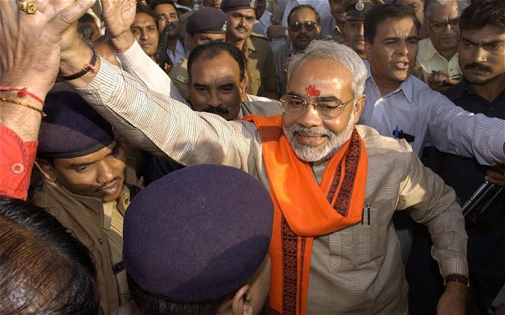
9 April 2012

Credit: AFP
Gujarat state Chief Minister Narendra Modi

An equal number of mostly Hindu defendants were acquitted for their involvement in burning 23 Muslims to death in the small Gujarati village of Ode after bolting the doors of the house where they had taken refuge from marauding mobs and then setting it alight.
Eighteen of the victims were women and children.
Rioting erupted in Gujarat in 2002 after a suspected Muslim mob burned a trainload of 58 Hindu activists at Gujarat's Godhra station, 100 miles from the state capital Gandhinagar.
The victims were returning from the north Indian town of Ayodhya where extremist Hindus had been leading a campaign to build a temple to their warrior god Rama on the site of a 16th century mosque they had demolished in 1992.
Hindus blamed Muslims for the train fire and, seeking revenge, went on a rampage through their neighbourhoods in towns and villages across Gujarat in three days of unrelenting violence following the incident.
Sporadic rioting continued in the state for at least three months in what was considered one of India's worst outbreaks of sectarian violence in recent years and one which activists referred to as 'ethnic cleansing' and an 'anti-Muslim pogrom'.
Gujarat chief minister Narendra Modi from the Hindu nationalist Bharatiya Janata Party that is also the main Opposition to the federal government, was held responsible for failing to stop the violence.
Many activists, backed by media reports and human rights groups accused Modi of actively encouraging the rioting as a consequence of which he was denied entry to the US.
The Ode massacre was one of 10 key incidents being probed by a Supreme Court-appointed special investigation team set up in 2008 after Modi was blamed for interfering with riot cases registered in Gujarat by obstructing investigations.
In November 2011, a court sentenced 31 people for burning, much like in Ode 33 Muslims to death in another village in the state.
Last February, 31 people, many of them Muslims were found guilty of setting fire to the Hindu pilgrim train at Godhra whilst 63 others were ac quitted.
Copyright 2012 The Telegraph Media Group Ltd.

