Jakarta bombings suspect held
Al Jazeera
1 September 2009
Indonesian police have named a blogger as a suspect in July's deadly hotel bombings in Jakarta.
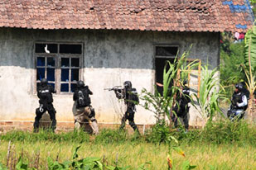
A high-profile televised attempt to arrest Noordin Top in Central Java failed after a 17-hour siege [AFP]

Going by the online name of "Prince of Jihad", Muhammad Jibril was officially declared a suspect on Tuesday, following his arrest a week earlier.
Nanan Soekarna, a police spokesman, said the move allows police to keep him in custody pending possible charges.
"He is alleged to have been involved in terrorism, specifically financing and other offences, including using a false identity. The details of his involvement will all be explained at an appropriate time," Soekarna said.
The 24-year-old, who publishes a radical website, could face charges of conspiracy and aiding terrorism as well as immigration violations and falsifying documents.
Killing seven people and both bombers, the two attacks targeted Jakarta's JW Marriott and Ritz-Carlton hotels on July 17.
Jemaah Islamiya Link?
Police have not said where the money has come from, but are investigating whether it came from Jemaah Islamiya money men in the Middle East or South Asia.
The attack was the first in more than four years and are the suspected work of Malaysian mastermind Noordin Mohammed Top, who leads a violent splinter group of the Jemaah Islamiyah network.
Noordin was allegedly behind a 2003 attack on the Marriott hotel that killed 12 people, as well as the bombing of the Australian embassy in 2004 and tourist restaurants on the holiday island of Bali in 2005.
On the Run
Bambang Hendarso Danuri, the national police chief, told parliament that Noordin was spotted in a safehouse in Central Java, but had narrowly escaped by the time police burst inside in a televised raid.
Noordin was initially reported dead at the end of the 17-hour siege, but the body later turned out to be that of Ibrohim, a florist working in the Marriott and Ritz-Carlton hotel complex who helped plot the attacks from the inside.
Danuri also told parliament that police had documents proving Noordin's group had planned another attack "bigger than the events in other places".
Police say they have killed three members of Noordin's group, Al-Qaeda in the Malaysia Archipelago, and arrested five others since July 17, including a Saudi national who allegedly helped bring in foreign money for the attacks.
Source: | Agencies

